RAMCO INSTITUTE OF TECHNOLOGY
(An Autonomous Institutions)
Rajapalayam – 626117.

SD25C07 – MOBILE APP DEVELOPMENT WITH FLUTTER
(R-25)



DEPARTMENT OF COMPUTER SCIENCE AND BUSINESS SYSTEMS
LABORATORY
III - SEMESTER
NOVEMBER 2026

RAMCO INSTITUTE OF TECHNOLOGY
(An Autonomous Institutions)
Rajapalayam – 626117.

BONAFIDE CERTIFICATE

Certified that this is the bonafide record of work done by Mr./Ms.____________
_________________________________, Register no_____________________,
a student of III Semester B.Tech. Computer Science and Business Systems, in the SD25C07-MOBILE APP DEVELOPMENT WITH FLUTTER LABORATORY during the academic year 2026-2027.The record is submitted for the University Pratical Examination held on____________________.
.

STAFF-IN-CHARGE HEAD OF THE DEPARTMENT

INTERNAL EXAMINER EXTERNAL EXAMINER

INDEX
S.No | Experimeny Code  (Cx.N) | Name of the Experiment | Page No. | Course Outcome  (CO1, CO2,…)

S.No | Experimeny Code  (Cx.N) | Name of the Experiment | Page No. | Course Outcome  (CO1, CO2,…)
INDEX
Experiment Code | Date of Experiment | Rubries(Parameters) |  |  |  |  | Total Mark  ( ) | Signature of the Faculty
 |  | P( ) | V( ) | R( )

EX.NO:1.a INSTALLATION AND CONFIGURATION OF FLUTTER DATE: ENVIRONMENT

AIM:
To install and configure the Flutter development environment, set up the required tools, create an Android emulator, and verify the installation for Flutter application development

PROCEDURE:

STEP 1: INSTALL GIT

Why Git?
Flutter uses Git internally to download packages and manage the SDK.

Procedure
- Open your web browser.
- Visit https://git-scm.com/
- Click Download for Windows.
- Run the installer.
- Keep all default settings.
- Click Next until installation completes.
- Click Finish.

Verify Installation
Open Command Prompt and type: git --version

Expected Output
git version 2.xx.x.windows.x

STEP 2: DOWNLOAD FLUTTER SDK

Procedure
- Open the browser.
- Visit https://flutter.dev
- Select Get Started.
- Choose Windows.
- Download the latest Flutter SDK ZIP.

Extract Flutter

  - Create a folder

C:\src\
  - Extract the downloaded ZIP file. Example
C:\src\flutter
Do not install Flutter inside:
    - Program Files
    - Desktop
    - Downloads
because it may cause permission issues.

STEP 3: CONFIGURE ENVIRONMENT VARIABLES
Flutter commands work only after adding Flutter to the system PATH.

Procedure
- Press Windows Key.
- Search

Environment Variables
- Click

Edit the System Environment Variables
- Click

Environment Variables
- Under User Variables, select

Path
- Click

Edit
- Click

New
- Add C:\src\flutter\bin
- Click

OK
Restart Command Prompt.

STEP 4: VERIFY FLUTTER INSTALLATION
Open Command Prompt.

Execute
flutter --version

Expected Output

Flutter 3.x.x Dart 3.x.x Framework Engine

STEP 5: INSTALL ANDROID STUDIO

Procedure
- Visit https://developer.android.com/studio
- Download Android Studio.
- Install using default settings. During installation ensure
✔ Android SDK
✔ Android SDK Platform
✔ Android Virtual Device are selected.
After installation Open Android Studio.

STEP 6: INSTALL FLUTTER PLUGIN
Inside Android Studio Go to
File
↓ Settings
↓ Plugins Search Flutter Click Install

Android Studio automatically installs
- Flutter Plugin
- Dart Plugin
Restart Android Studio.

STEP 7: INSTALL ANDROID SDK
Open Android Studio. Navigate
More Actions
↓
SDK Manager Verify
Android SDK is installed. If not
Click Install

Recommended SDK
Android API Level 35 (or latest available)

STEP 8: CREATE ANDROID EMULATOR
Open Android Studio. Select
More Actions
↓
Virtual Device Manager Click
Create Device Choose
Pixel 6 Click Next
Select latest Android Version Download if required
Click Finish

Start Emulator Click
▶
Wait until Android starts.

STEP 9: VERIFY EMULATOR
Execute flutter devices
Expected Output
1 connected device Pixel_6_API_35

STEP 10: RUN FLUTTER DOCTOR
- Open Command Prompt.
- Execute
- flutter doctor
- Flutter Doctor checks
- Flutter SDK
- Android SDK
- Android Studio
- VS Code
- Connected Devices
- Chrome
- Visual Studio

Expected Output Doctor summary No issues found! If errors appear,
follow the suggested fixes and rerun: flutter doctor
until all issues are resolved.

STEP 11: ACCEPT ANDROID LICENSES
If prompted, execute:
flutter doctor --android-licenses Type
y
for every license agreement.

STEP 12: INSTALL VISUAL STUDIO CODE (OPTIONAL)
Download from https://code.visualstudio.com Install.
Open Extensions.
Install
- Flutter
- Dart

STEP 13: CREATE FIRST FLUTTER PROJECT
Open Command Prompt. Move to your desired folder.
Example
cd Documents Create project
flutter create hello_flutter Flutter creates the project. Expected Output Creating project...
Running pub get...
Project Created Successfully

STEP 14: OPEN PROJECT
Move inside project cd hello_flutter Open using VS Code code .
or
Open Android Studio File
↓ Open
↓ hello_flutter

STEP 15: RUN FLUTTER APPLICATION
Ensure emulator is running.
Execute flutter run
Compilation starts. After a few minutes,
the default Flutter application appears on the emulator.

STEP 16: TEST HOT RELOAD
Open lib\
↓ main.dart Locate
'You have pushed the button this many times:'
Change it to
'Welcome to Flutter Lab' Save the file.
Flutter performs Hot Reload automatically (or press r in the terminal). The application updates instantly without restarting.

OUTPUT:

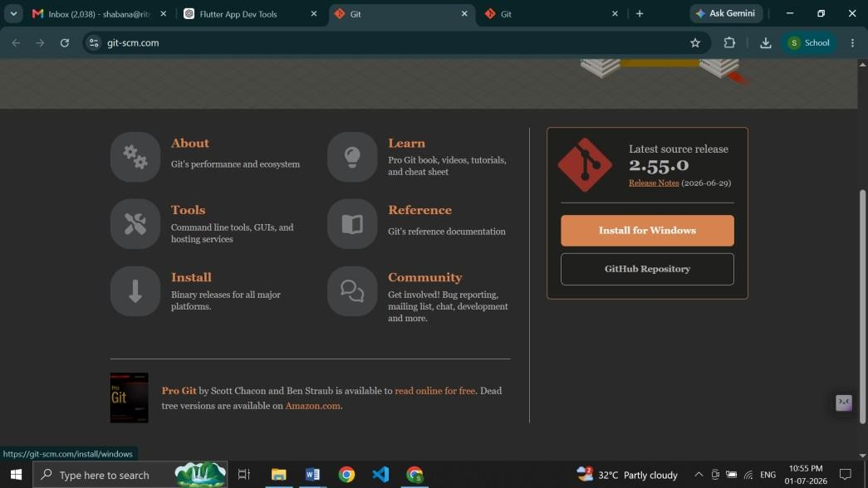

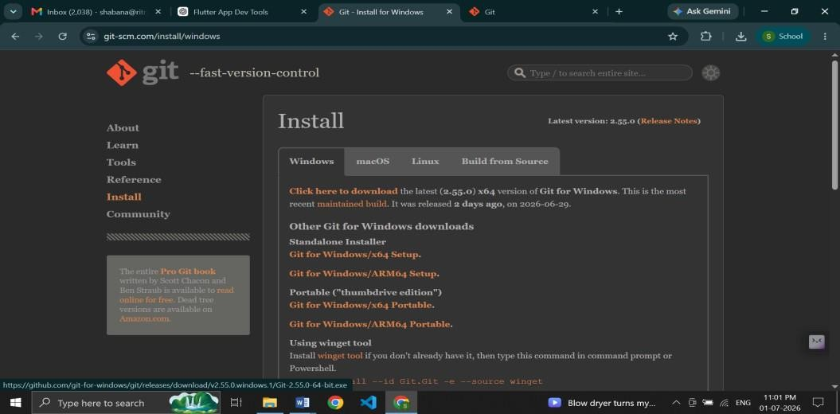

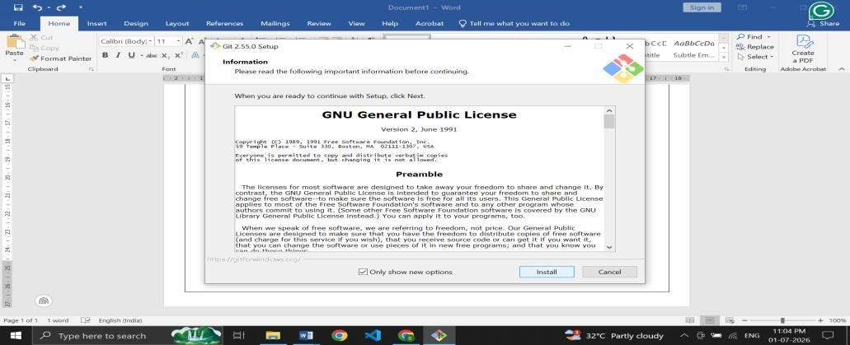

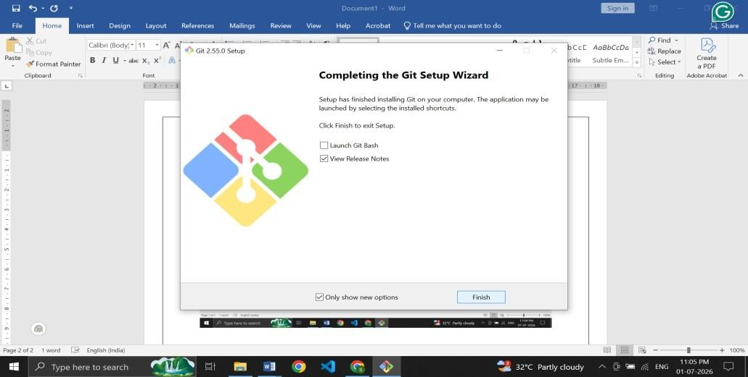

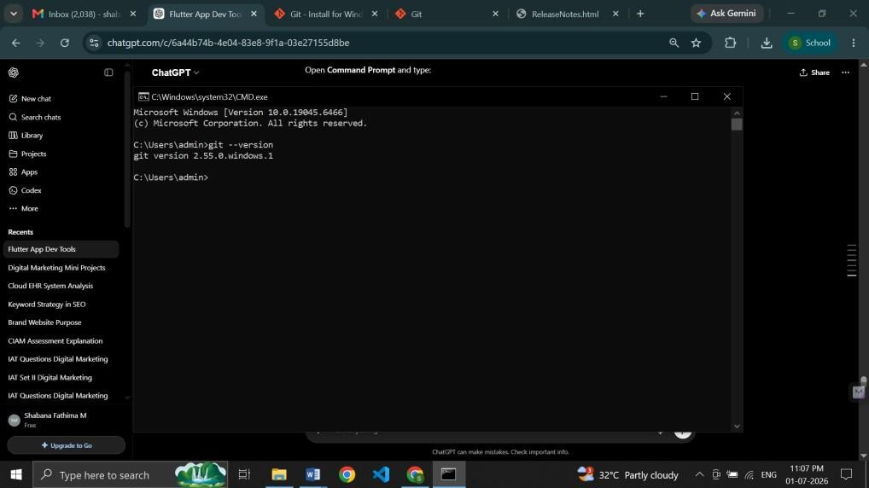

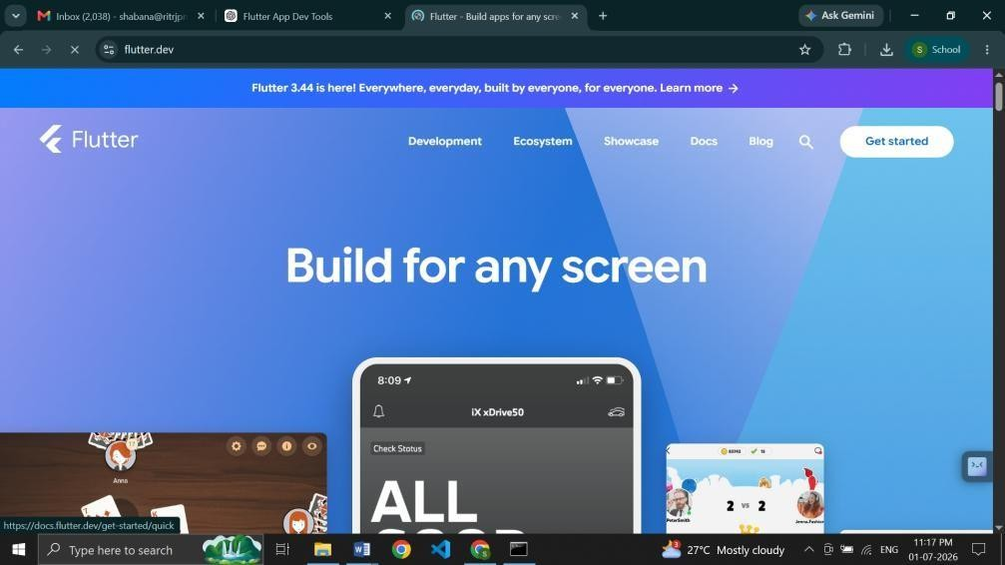

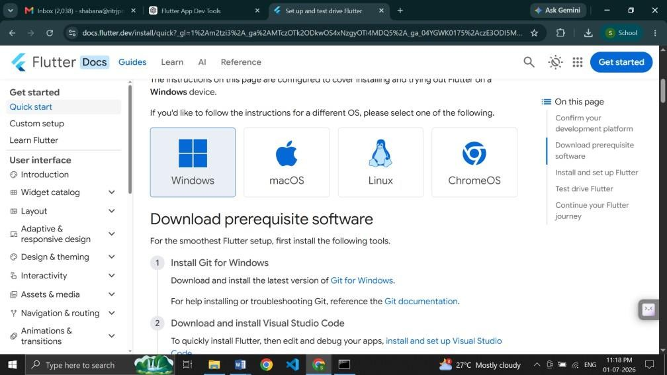

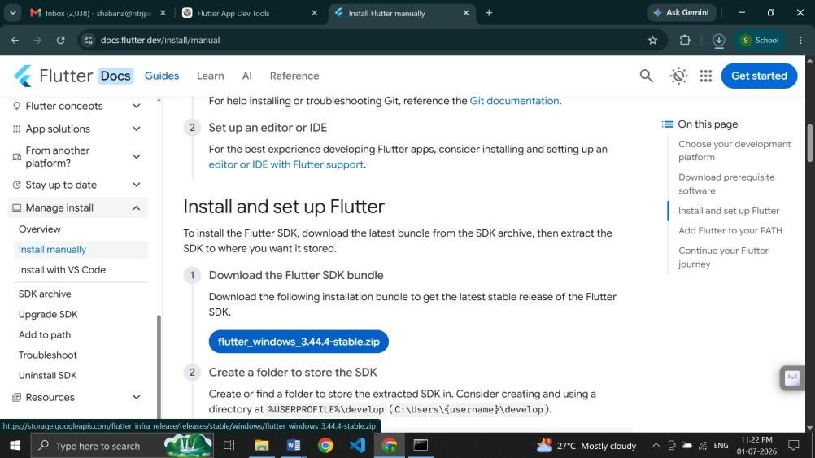

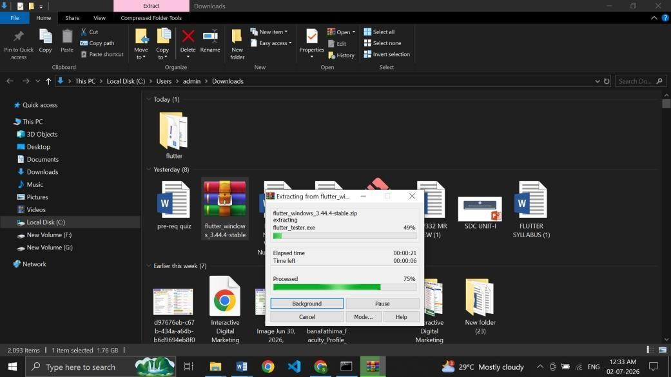

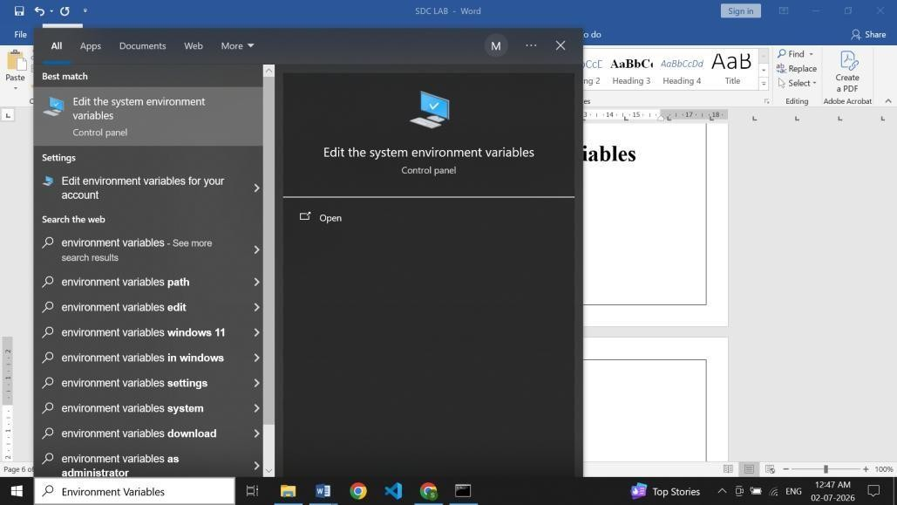

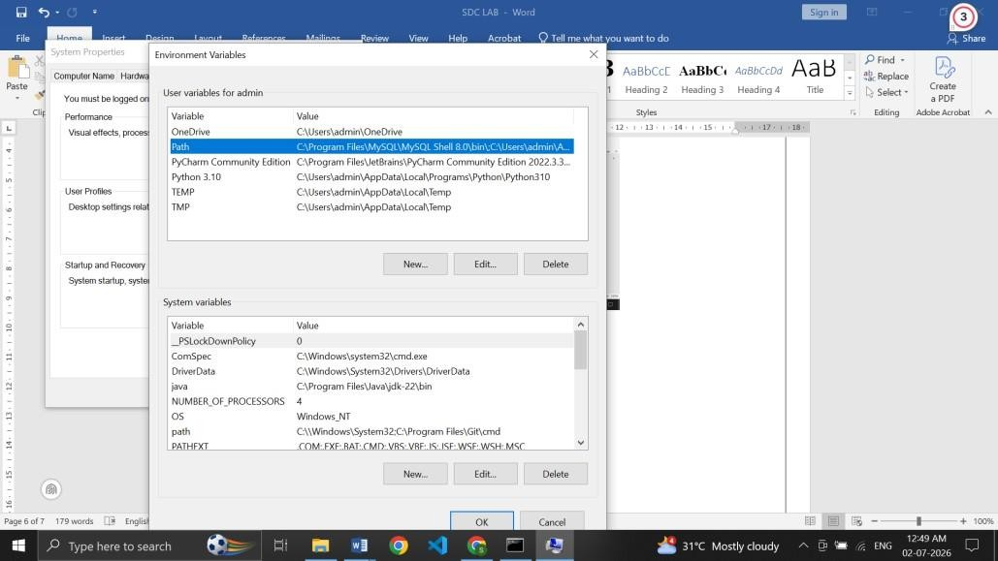

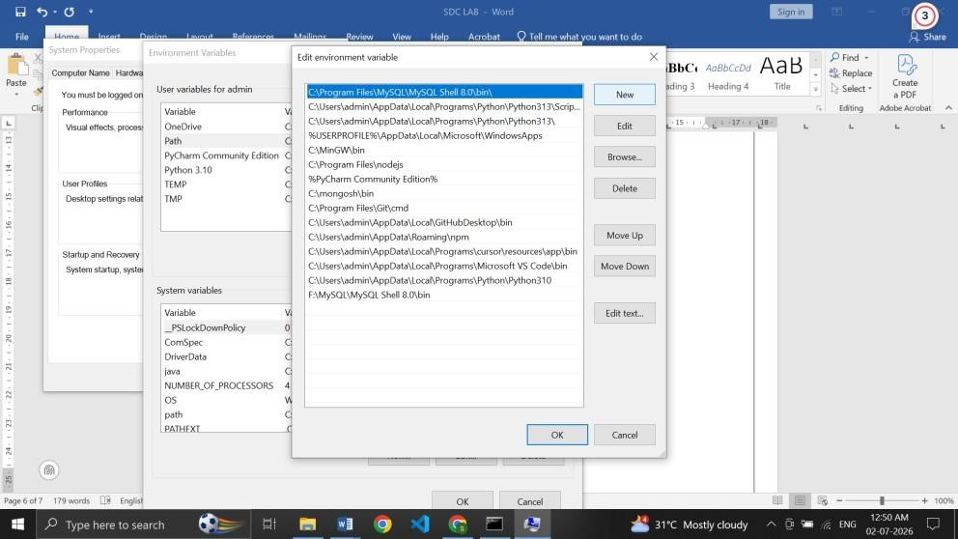

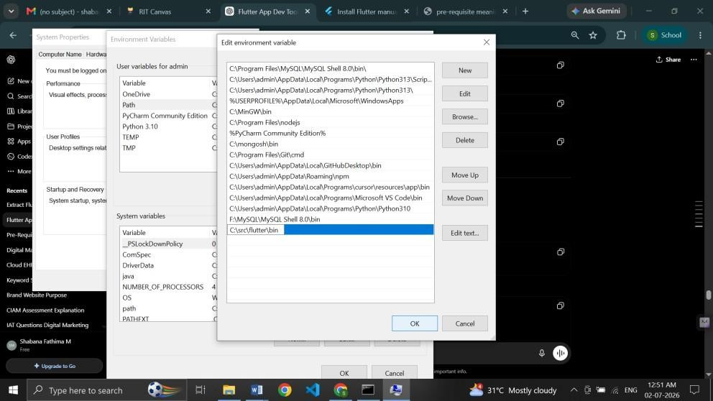

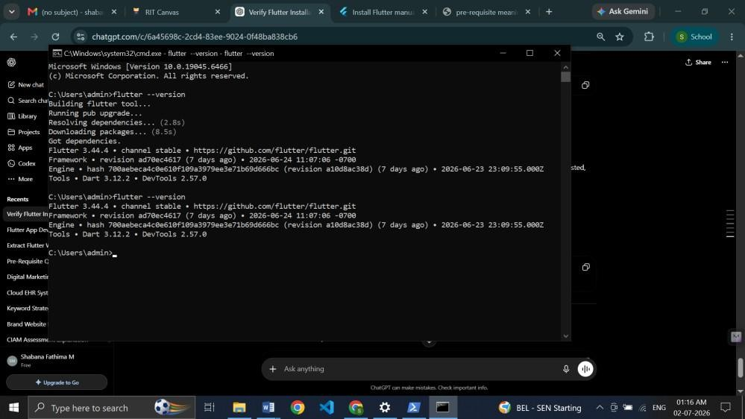

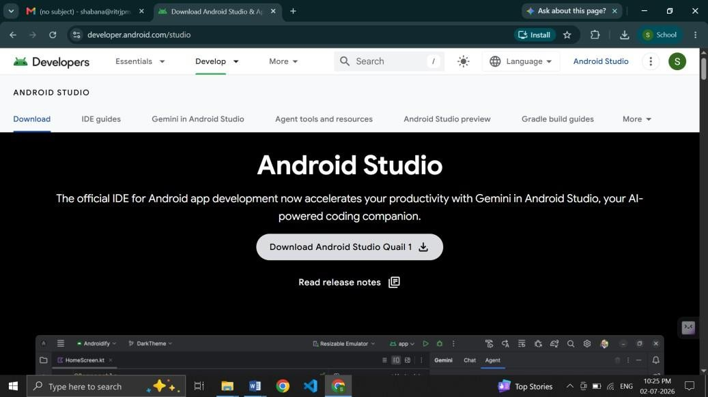

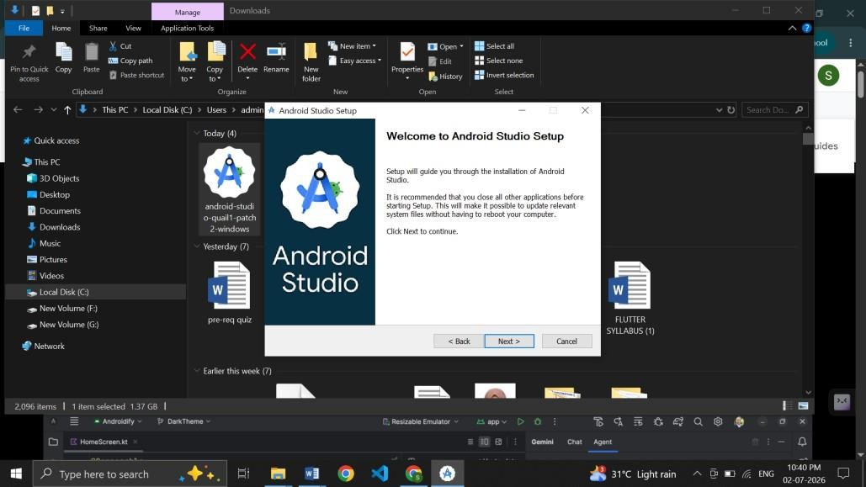

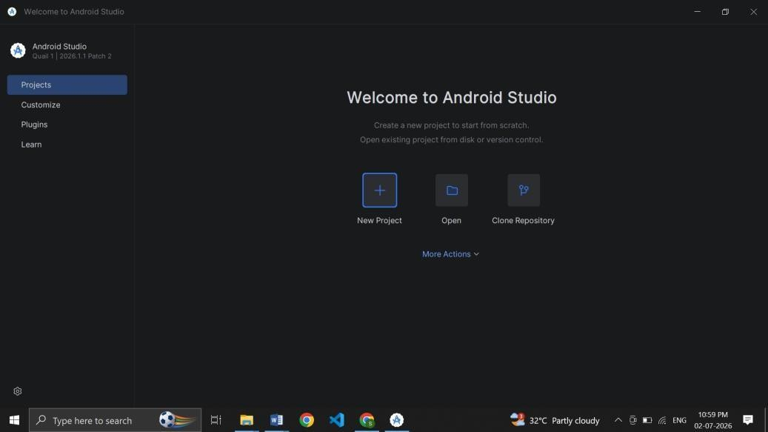

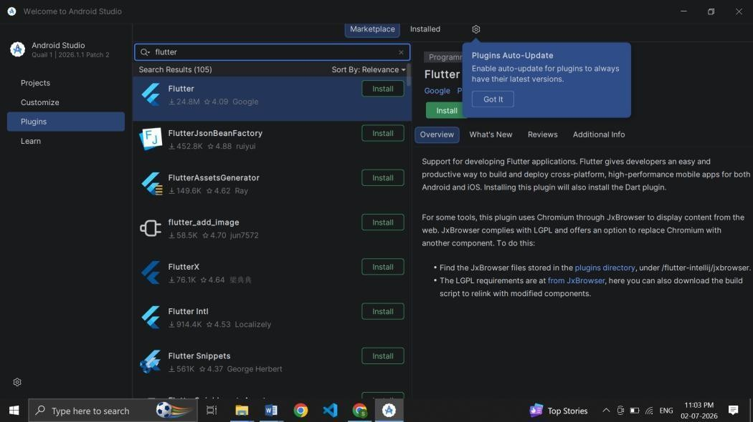

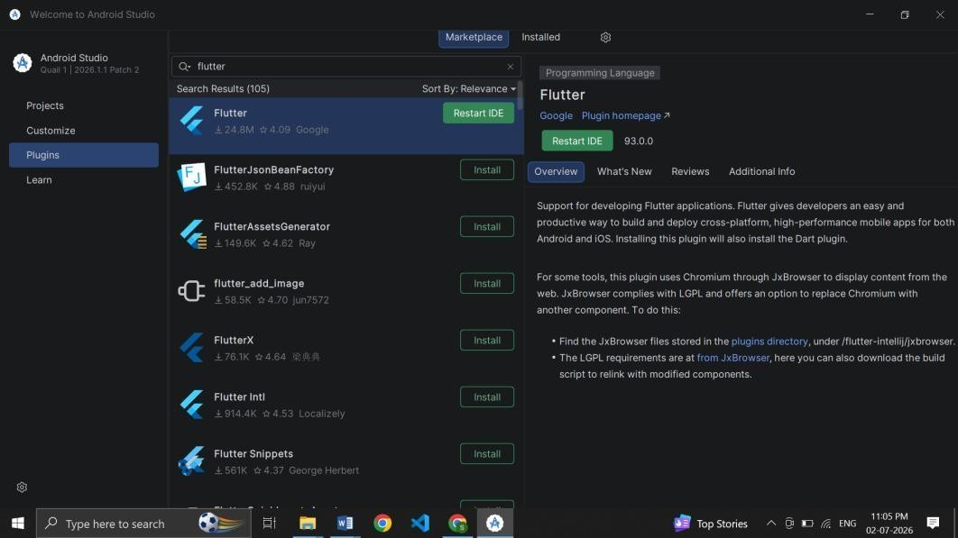

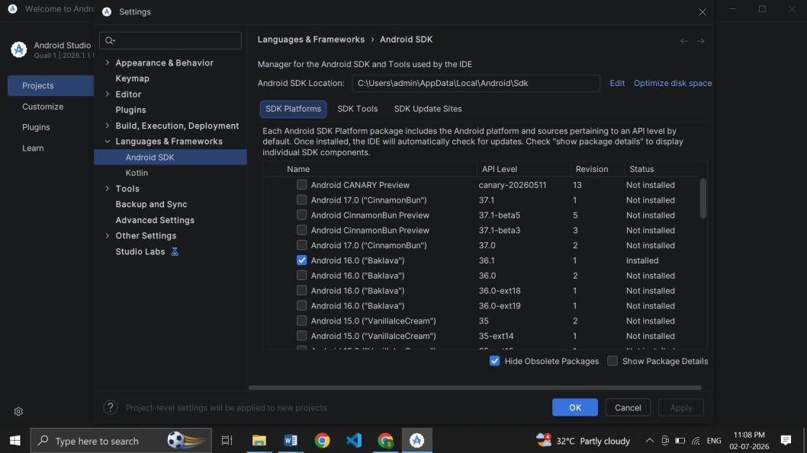
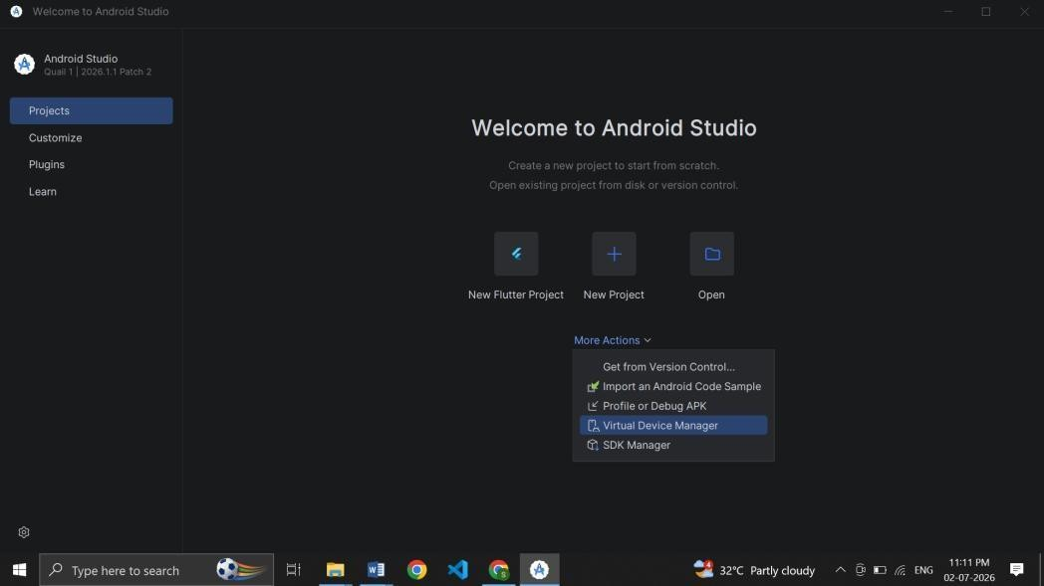

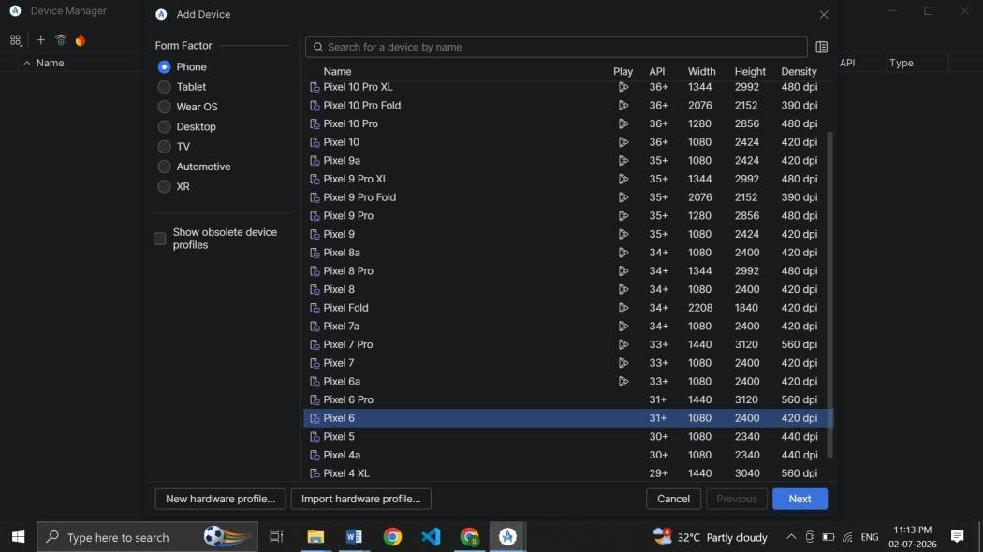

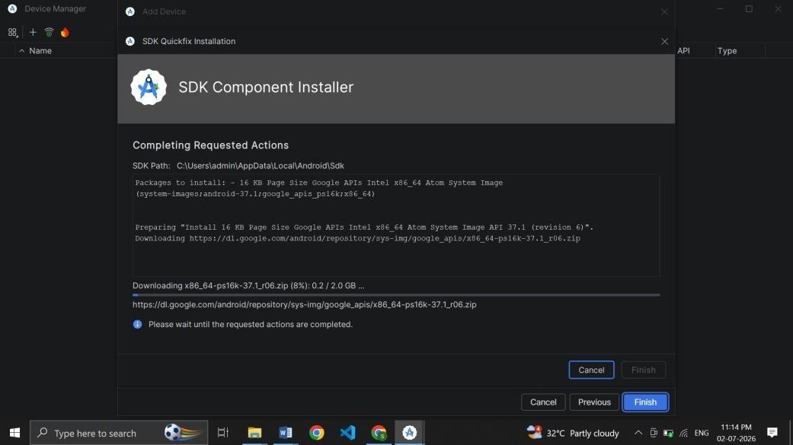
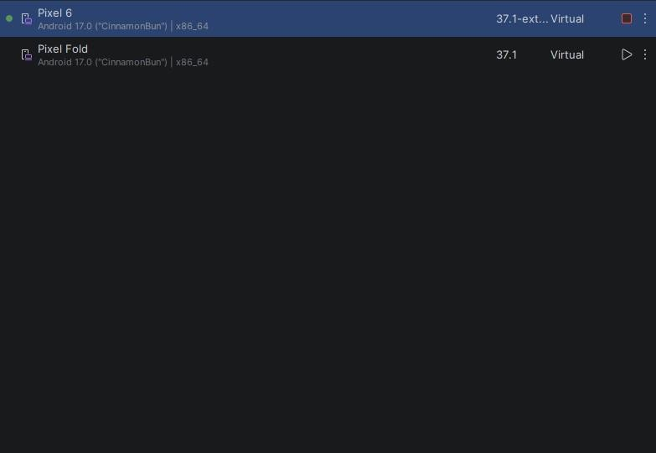

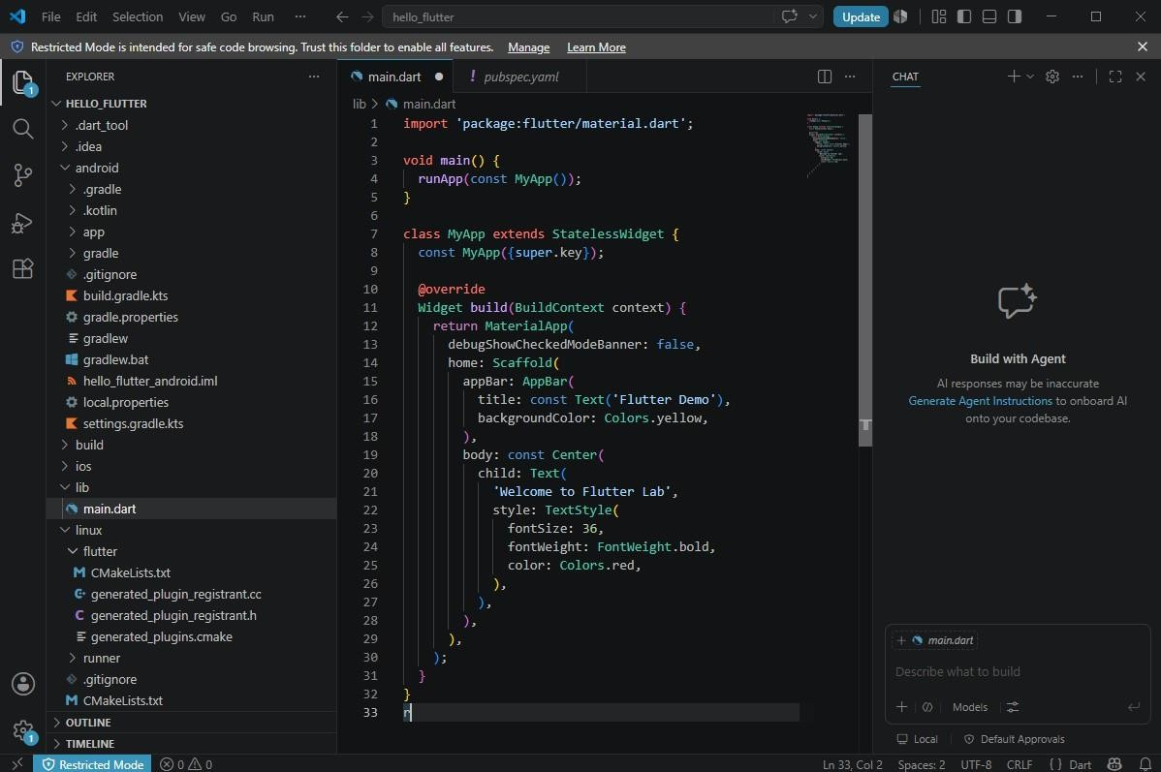

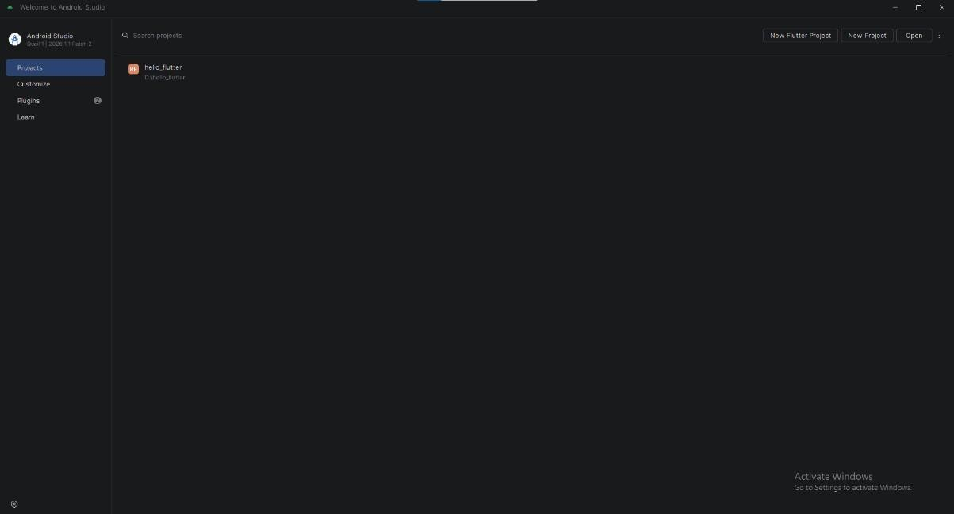

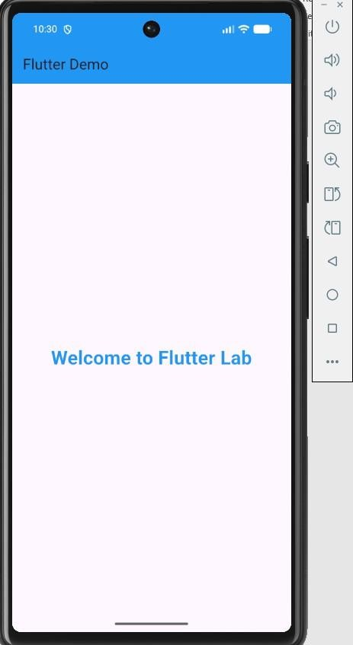

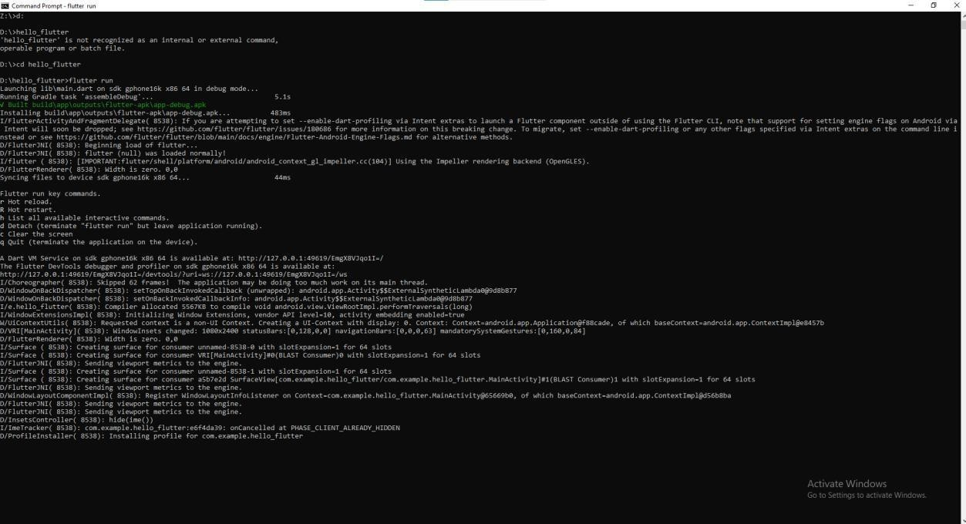

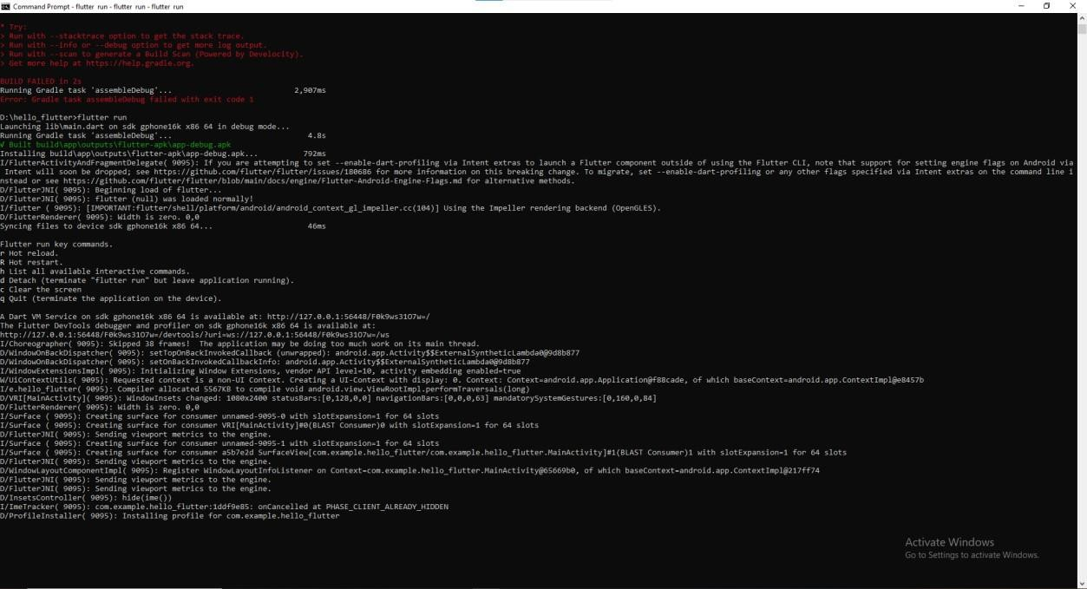

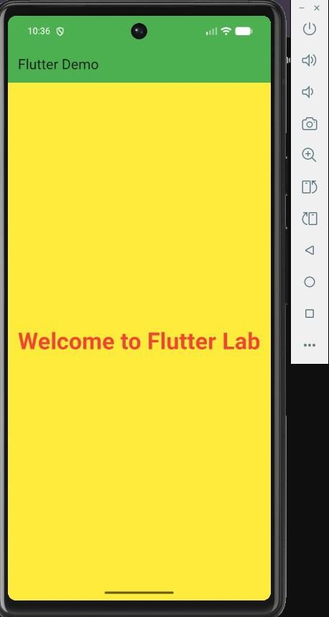

RESULT:
Thus, the installation and configuration of Flutter environment was executed and completed successfully.

EX.NO:1.b CREATING BASIC FLUTTER APPLICATIONS DATE:

AIM:
To create, build, execute, and modify a basic Flutter application using the Flutter framework and understand the structure of a Flutter project.

PROCEDURE:
STEP 1: OPEN ANDROID EMULATOR
Open Android Studio, select Device Manager, start the Android Emulator, and wait for the Android home screen.

STEP 2: OPEN COMMAND PROMPT
Navigate to the desired folder. Example: cd Documents.

STEP 3: CREATE A FLUTTER PROJECT
Execute flutter create hello_flutter. The Flutter tool creates the project and resolves dependencies.

STEP 4: NAVIGATE TO THE PROJECT FOLDER
Execute cd hello_flutter.

STEP 5: OPEN THE PROJECT
Open hello_flutter in Visual Studio Code with code . or in Android Studio using File →Open.

STEP 6: UNDERSTAND THE PROJECT STRUCTURE

Verify android, ios, lib/main.dart, test, web, pubspec.yaml and README.md.

STEP 7: OPEN MAIN.DART

Navigate to lib/main.dart and delete the default code.

STEP 8: TYPE THE PROGRAM

Enter the Flutter program supplied in the experiment sheet.

STEP 9: SAVE THE PROGRAM

Press Ctrl + S.

STEP 10: RUN THE APPLICATION

Execute flutter run. Flutter compiles and installs the application on the emulator.

STEP 11: EXPECTED OUTPUT

The emulator shows a blue AppBar titled Flutter Demo and centered text Welcome to Flutter.

STEP 12: UPDATED OUTPUT

The changed text appears without restarting the application.

STEP 13: PERFORM HOT RESTART

Press R. The application restarts from the beginning.

PROGRAM:

import 'package:flutter/material.dart';

void main() { runApp(const MyApp());
}

class MyApp extends StatelessWidget { const MyApp({super.key});

@override
Widget build(BuildContext context) { return MaterialApp( debugShowCheckedModeBanner: false, home: Scaffold(
appBar: AppBar(
title: const Text('Flutter Demo'), backgroundColor: Colors.blue,
),
body: const Center( child: Text( 'Welcome to Flutter', style: TextStyle(
fontSize: 28,
fontWeight: FontWeight.bold, color: Colors.blue,
),

),
),
),
);
}
}

UNDERSTANDING THE PROGRAM:

Import Statement: Imports Flutter's Material Design widget library.

main(): The entry point of the Flutter application and launches the widget tree through runApp().

MyApp Class: A StatelessWidget that does not change its state after creation.

MaterialApp: Provides Material Design functionality such as themes, navigation, and app configuration.

Scaffold: Provides the basic visual structure, including the AppBar and Body.

AppBar: Displays the title bar at the top of the application.

Center: Aligns its child widget at the center of the screen.

Text Widget: Displays text on the screen with customizable styles.

OUTPUT:
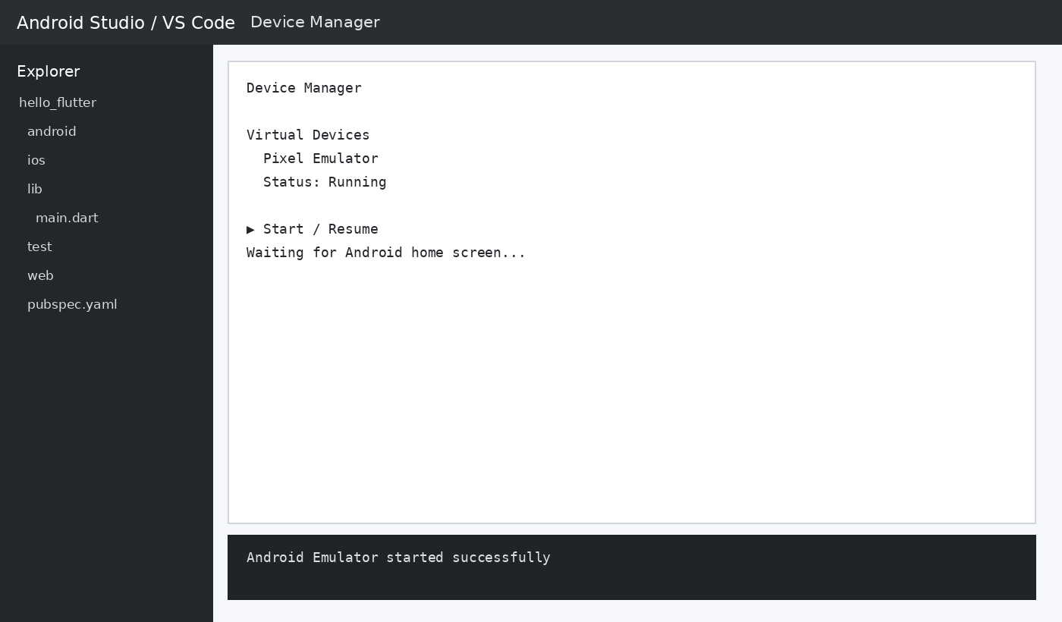

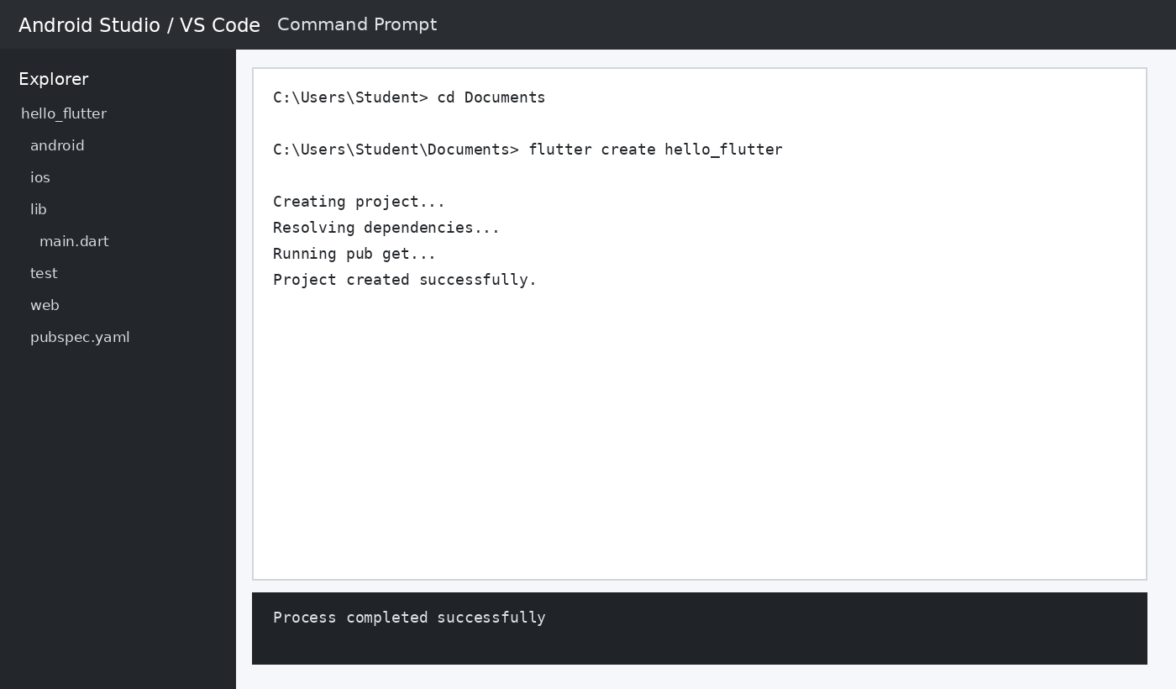

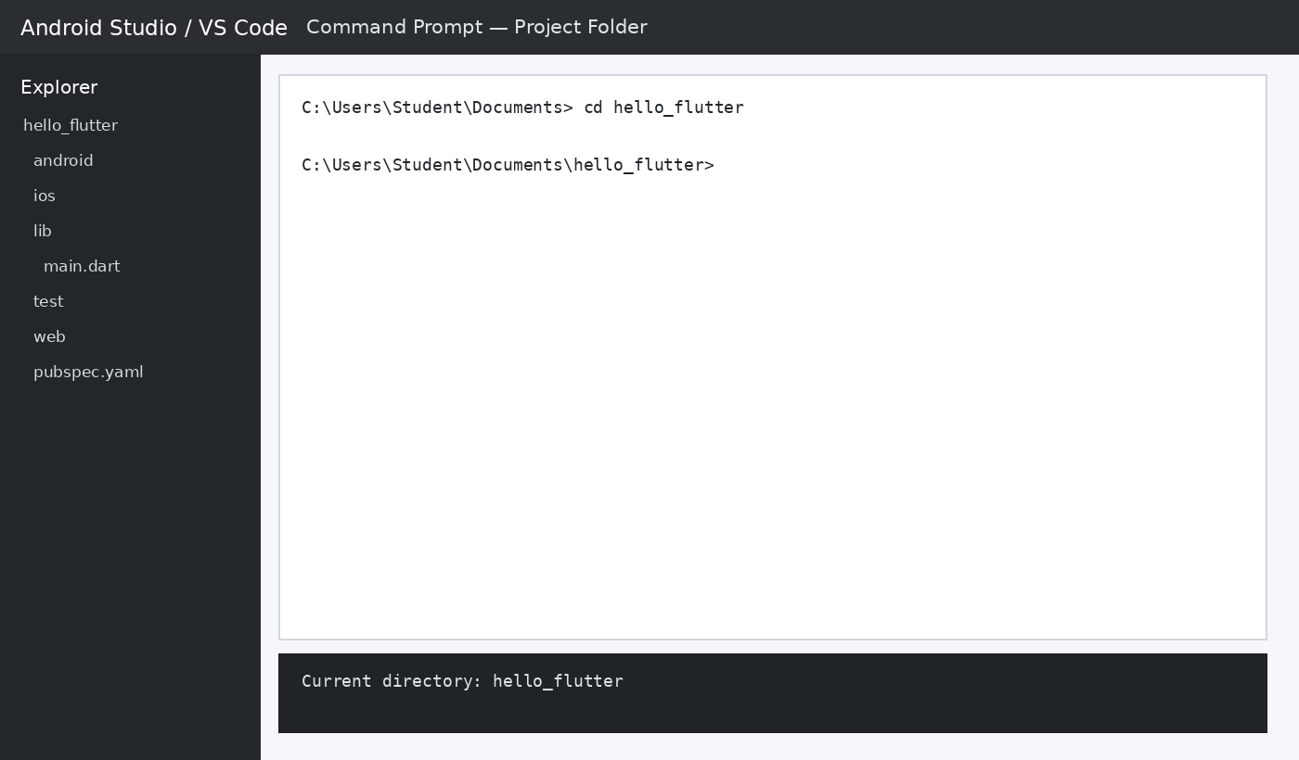
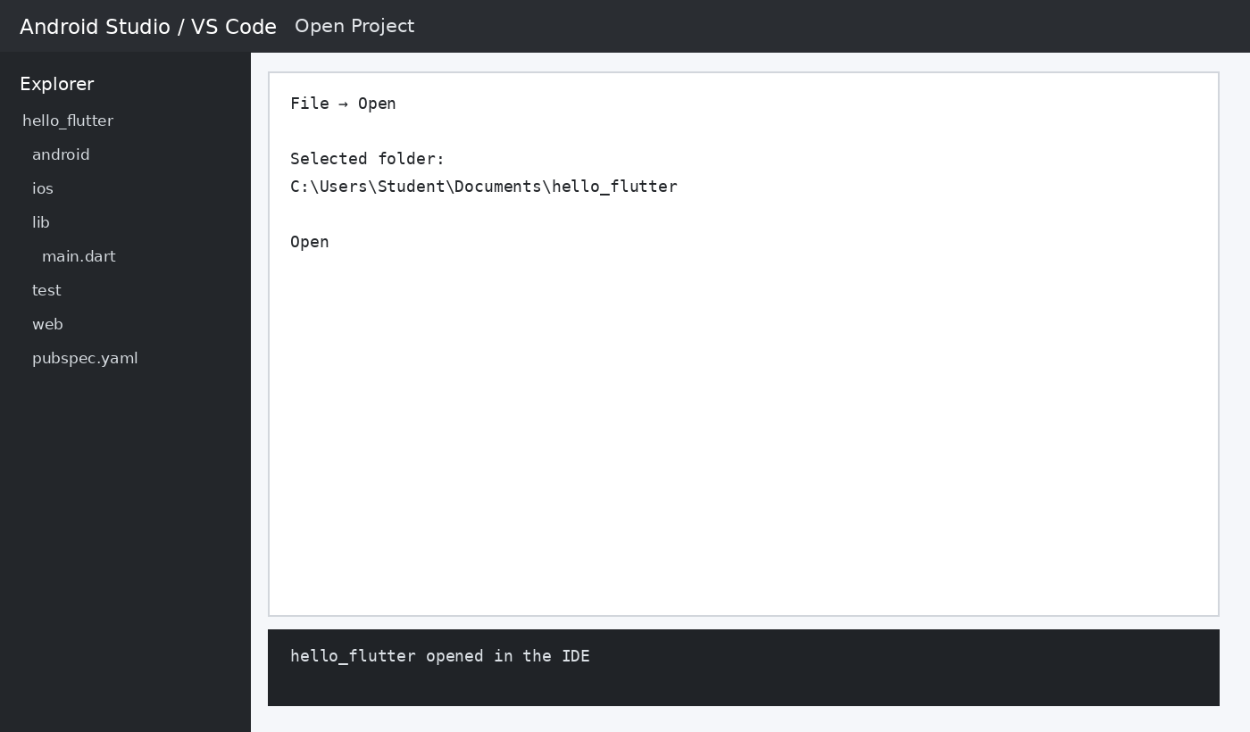

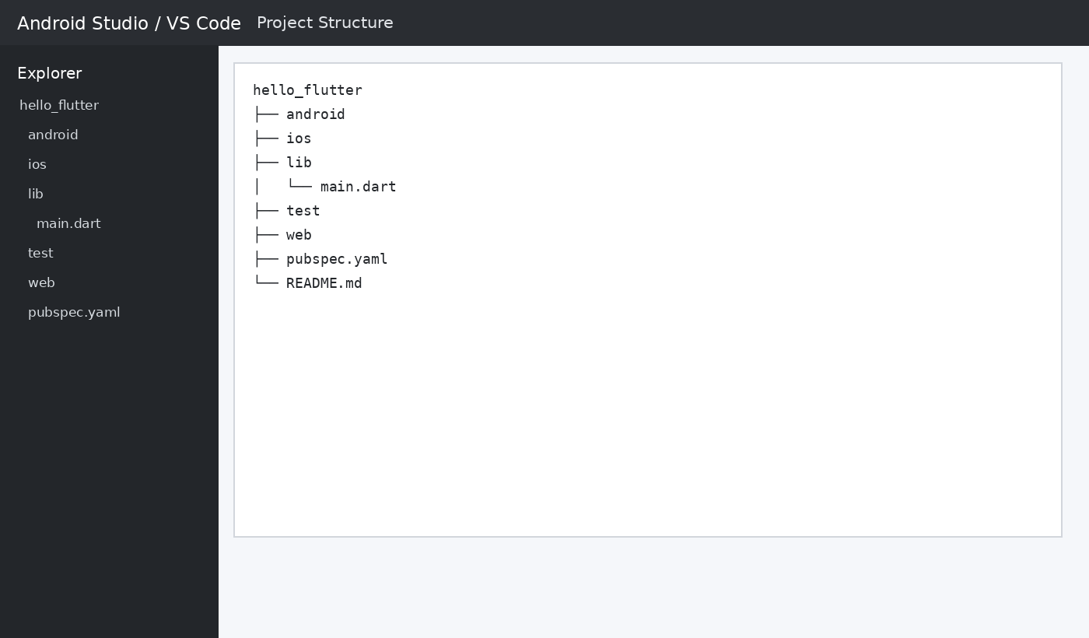
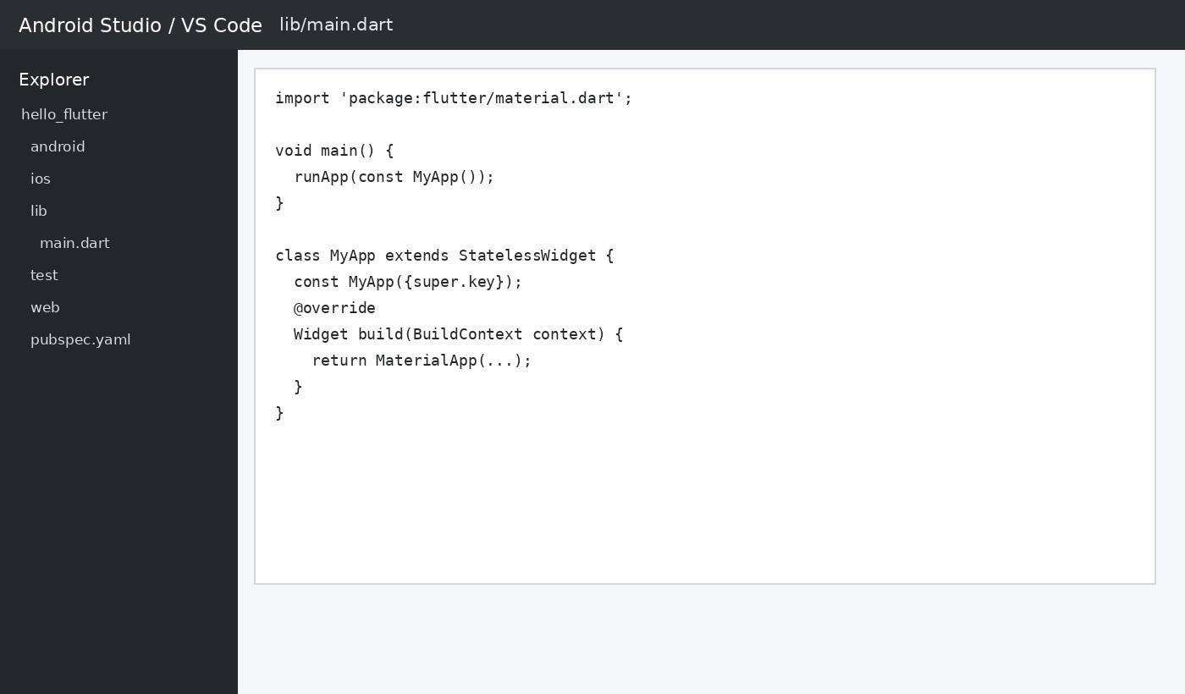

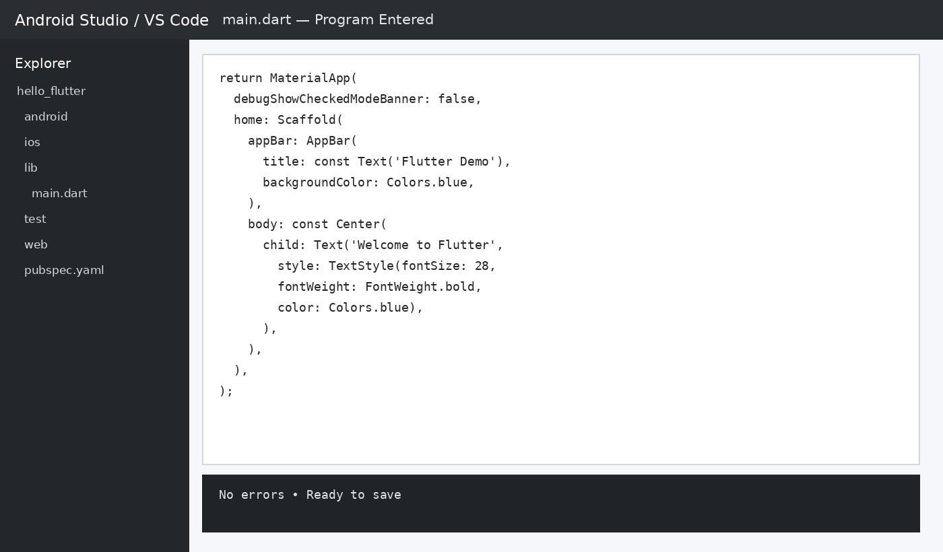
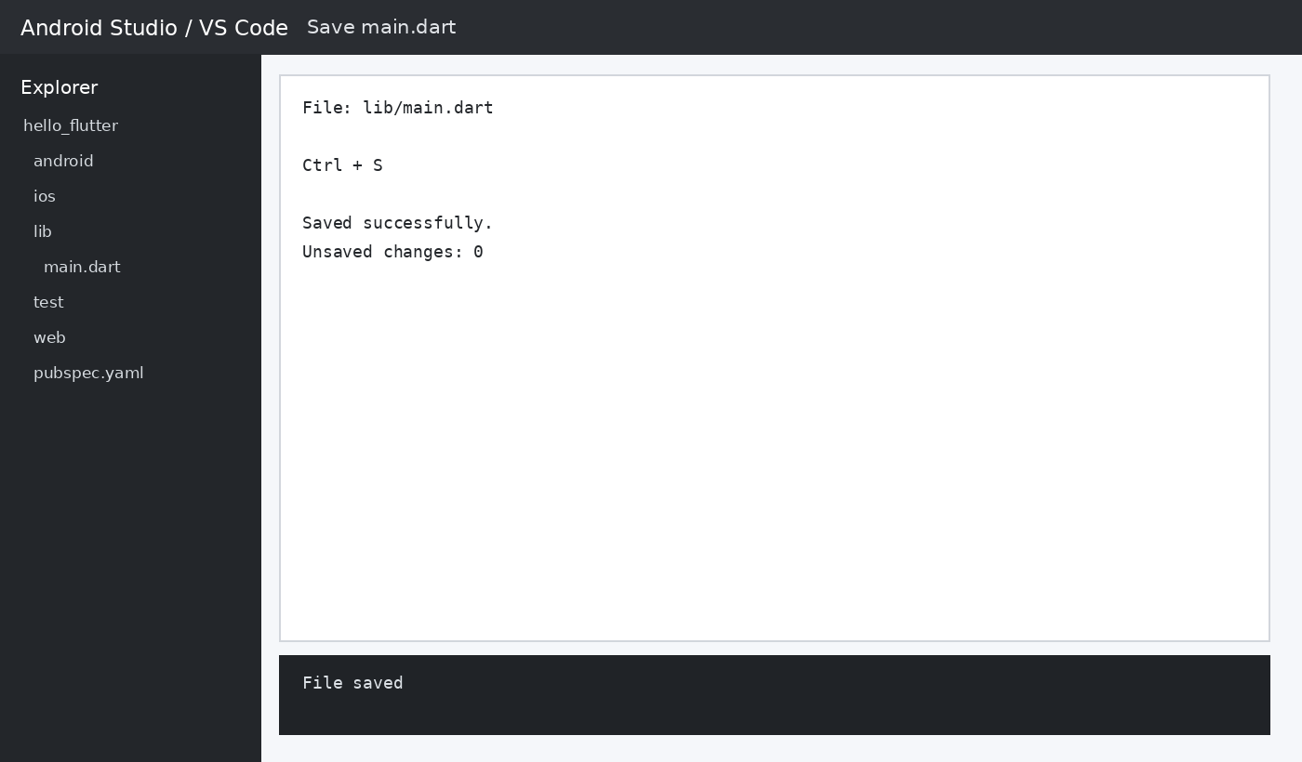

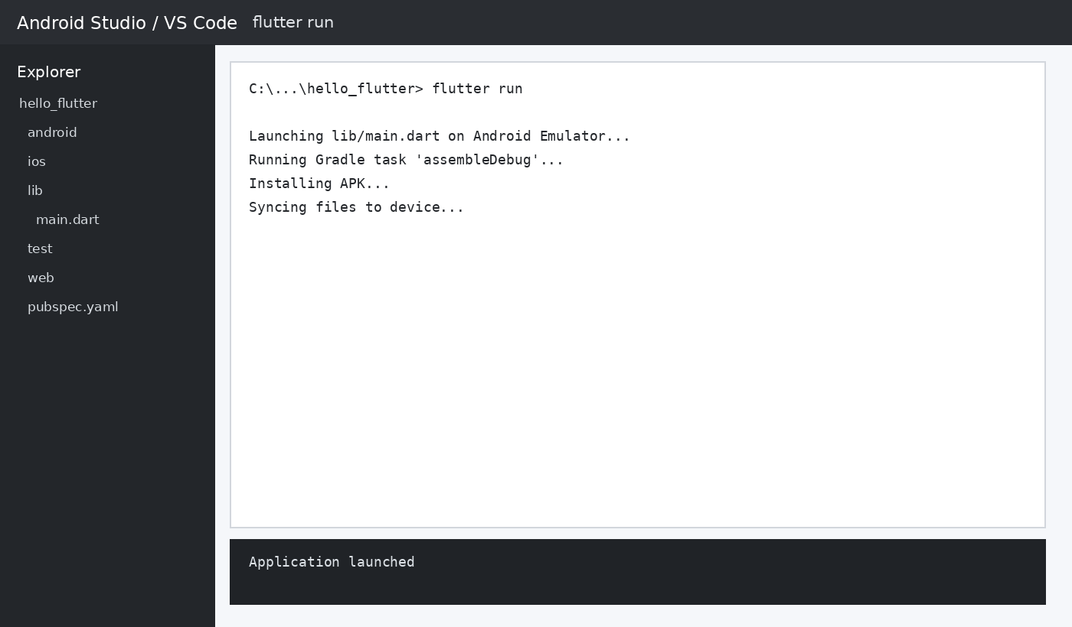
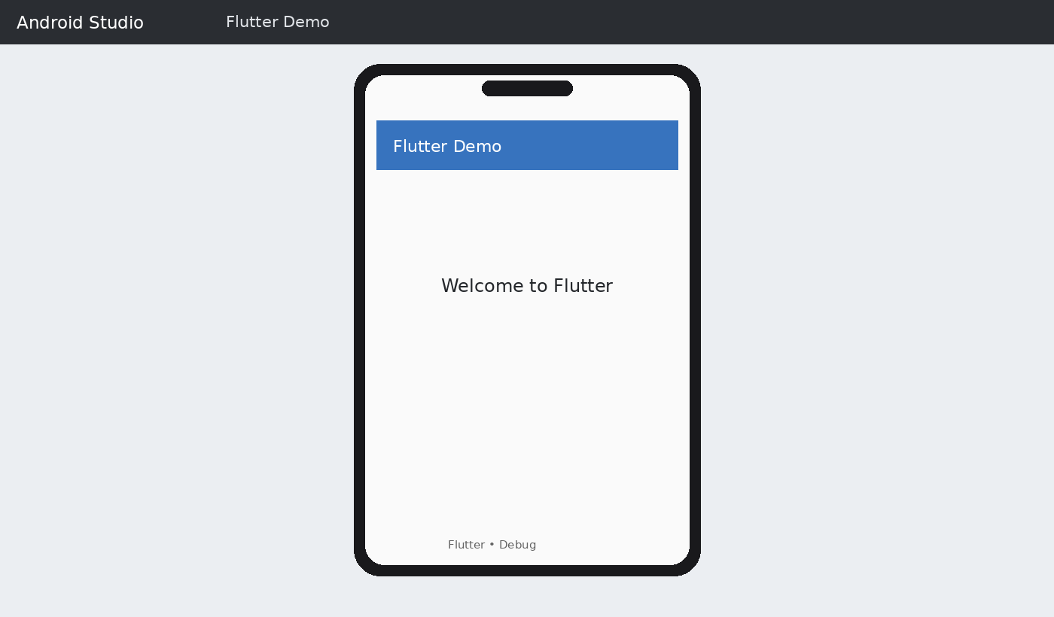

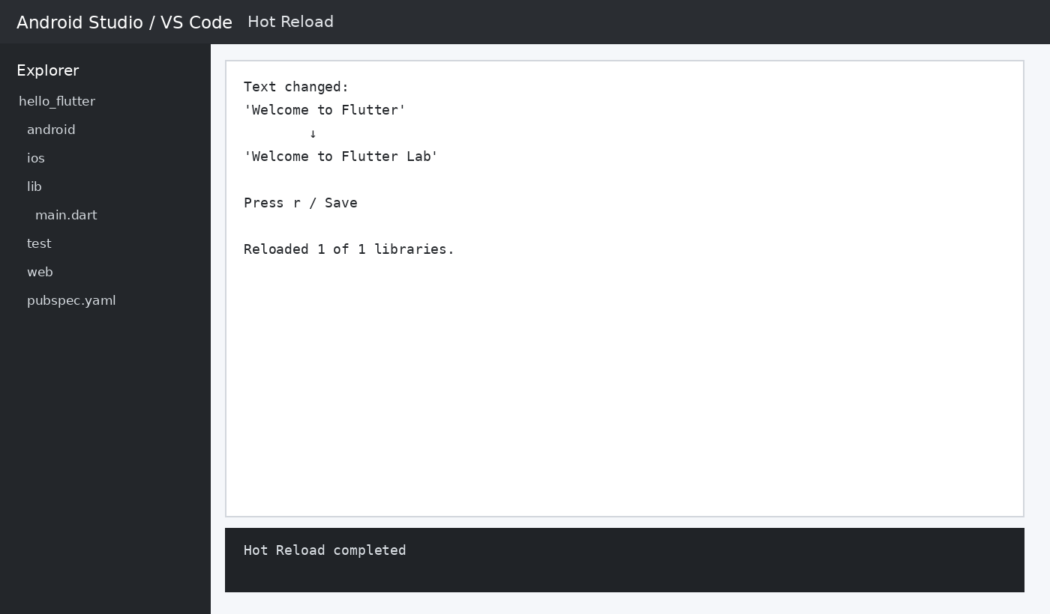
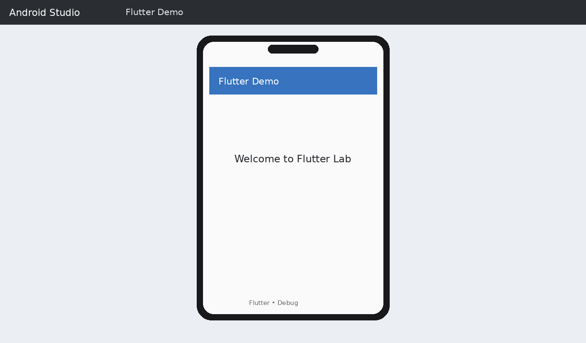

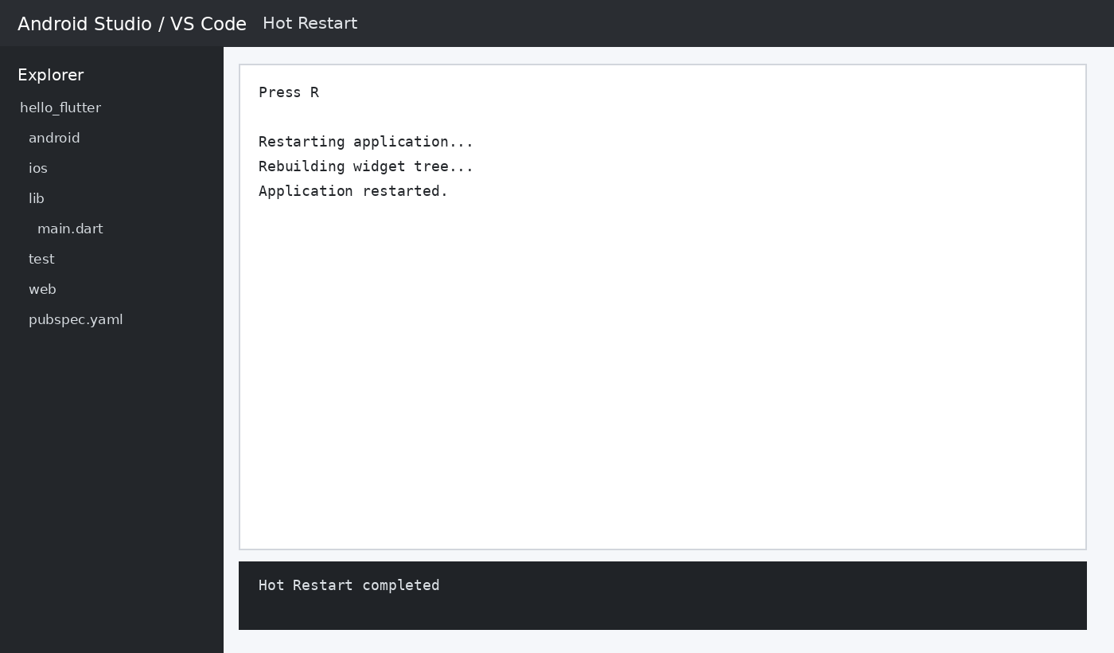

ACTIVITIES AND OUTPUTS

ACTIVITY 1 – CHANGE THE BACKGROUND COLOR

Modify scaffold with backgroundcolor: colors.yellow.
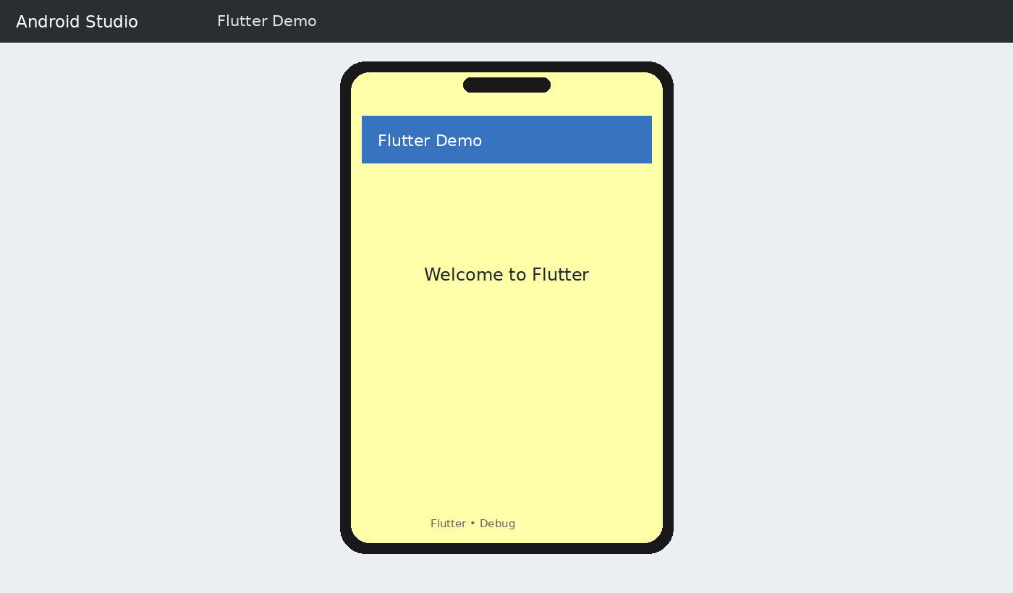

ACTIVITY 2 – CHANGE THE APPBAR COLOR

Modify AppBar with backgroundColor: Colors.green.

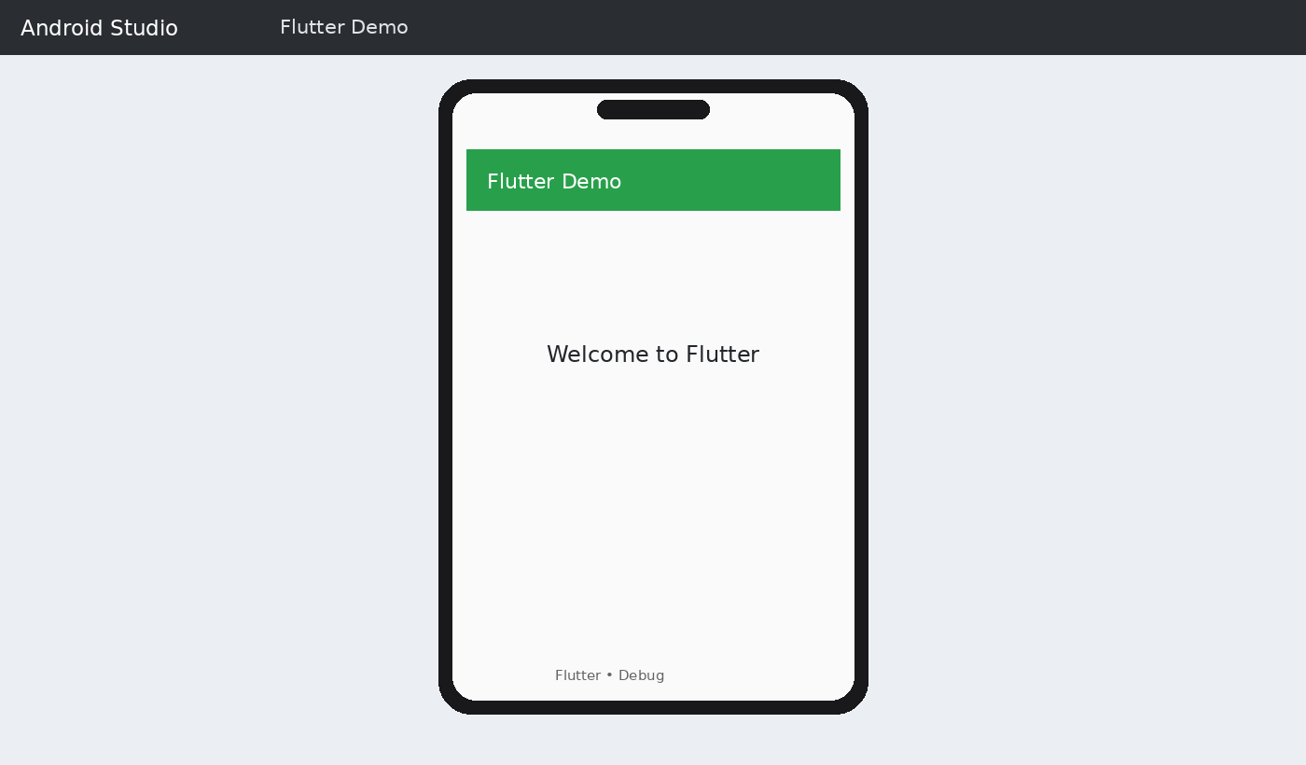

ACTIVITY 3 – CHANGE THE FONT SIZE

Change fontSize to 36.

ACTIVITY 4 – CHANGE THE TEXT COLOR

Change the Text color to Colors.red.

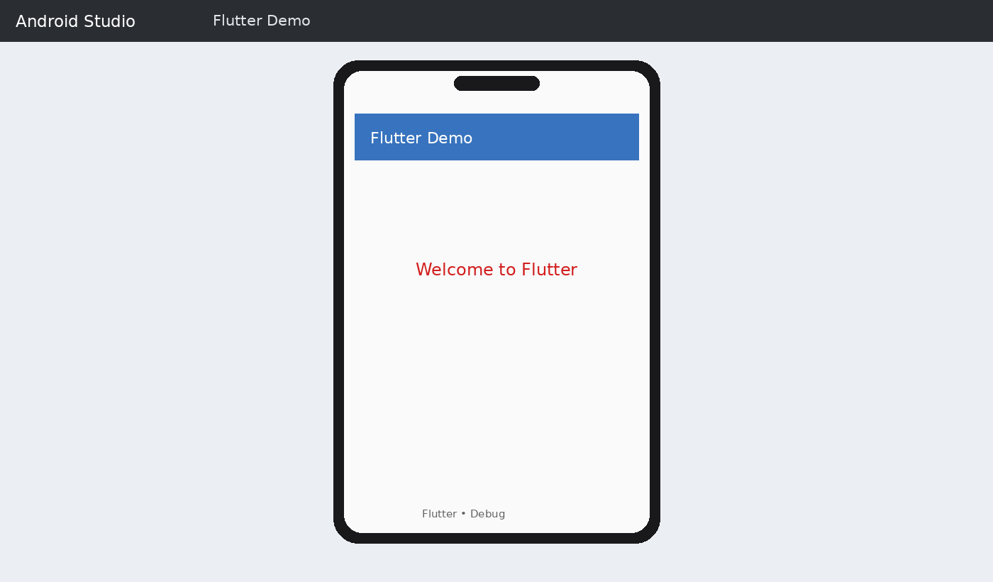

ACTIVITY 5 – DISPLAY YOUR NAME

Replace the text with Welcome Shabana.
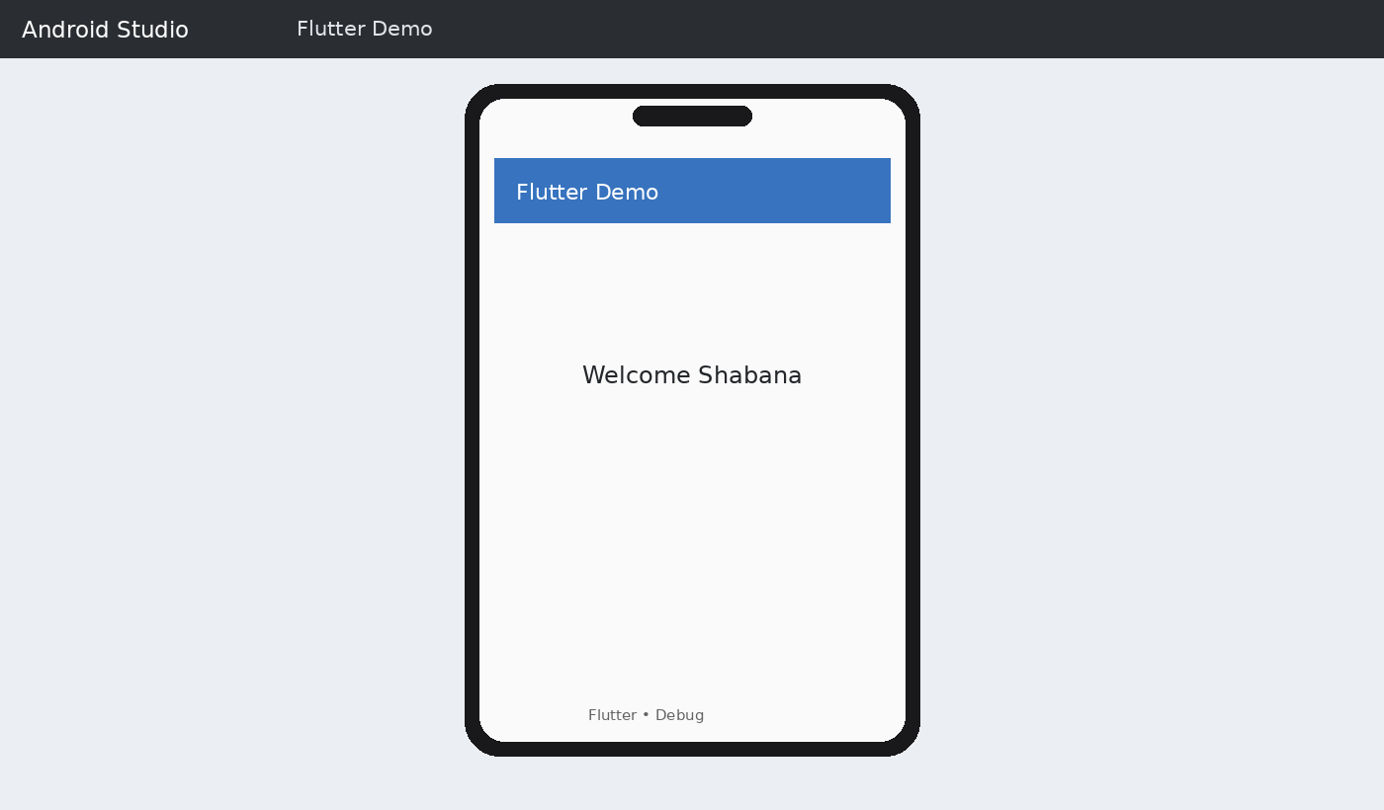

COMMON FLUTTER COMMANDS

flutter doctor — Check installation flutter create appname — Create project flutter run — Run application
flutter devices — Display connected devices

flutter clean — Clean project

flutter pub get — Download dependencies flutter build apk — Generate APK PRECAUTIONS
Ensure the Android Emulator is running before executing flutter run. Save the file before performing Hot Reload.
Do not modify project folders other than the lib folder during this experiment. Verify there are no errors in the terminal before running the application.

RESULT

Thus, a basic Flutter application was successfully created, executed, and modified. The experiment demonstrated the Flutter project structure, execution process, and the use of fundamental widgets such as MaterialApp, Scaffold, AppBar, Center, and Text. Hot Reload and Hot Restart were also demonstrated.

EX.NO:2.a SIMPLE DART PROGRAMMING EXERCISES DATE: VARIABLES AND DATA TYPES

AIM:

To understand the fundamentals of the Dart programming language by creating and executing simple Dart programs – Variables and Datatypes using Android Studio and the Flutter framework.

SOFTWARE / SETUP:

Android Studio with Flutter plugin and Flutter SDK, plus an Android Emulator. The supplied lab sheet specifies a Flutter project named dart_exercises.

PROCEDURE:

STEP 1: LAUNCH ANDROID STUDIO

Open Android Studio and wait for the Welcome screen.

STEP 2: CREATE A NEW FLUTTER PROJECT

Choose New Flutter Project → Flutter, specify the Flutter SDK path, set project name to dart_exercises, and finish project creation.

STEP 3: RESULT – PROJECT CREATED

The project contains the lib folder and main.dart file.

STEP 4: START THE ANDROID EMULATOR

Open Device Manager, select an emulator, press Play, and wait for boot completion.

STEP 5: OPEN MAIN.DART

Navigate to lib/main.dart in the project explorer.

STEP 6: REPLACE THE DEFAULT CODE

Remove the default counter-app code and enter the required Dart program.

STEP 7: SAVE THE PROGRAM

Press Ctrl+S to save the Dart file.

STEP 8: RUN THE PROGRAM

Click Run or choose Run → Run 'main.dart'. Flutter builds and installs the application on the emulator.

STEP 9: OBSERVE OUTPUT

UI output appears on the emulator and print() output appears in the Run/Debug Console.

STEP 10: MODIFY THE PROGRAM

Change values or logic and update the displayed text as required.

STEP 11: PERFORM HOT RELOAD

Use the Hot Reload button ()) so the updated UI is reflected without restarting the application.

STEP 12: REPEAT FOR OTHER DART PROGRAMS

Repeat the edit, save, run, observe-output and hot-reload cycle for the listed exercises.

STEP 13: STOP THE APPLICATION

Click Stop (■) after completing the experiment.

PROGRAMS AND OUTPUTS:

PROGRAM 1: VARIABLES AND DATA TYPES:

Aim: To perform the variables and data types exercise using Dart and Flutter.

import 'package:flutter/material.dart'; void main() {
String name = "Shabana"; int age = 20;
double cgpa = 8.75; bool isStudent = true;

print("Name: $name"); print("Age: $age"); print("CGPA: $cgpa"); print("Student: $isStudent");

runApp(MaterialApp( home: Scaffold(
appBar: AppBar(title: const Text("Variables & Data Types")), body: Center(

child: Text(
"Name: $name\nAge: $age\nCGPA: $cgpa\nStudent: $isStudent", style: const TextStyle(fontSize: 22),
textAlign: TextAlign.center,
),
),
),
));
}

OUTPUT:
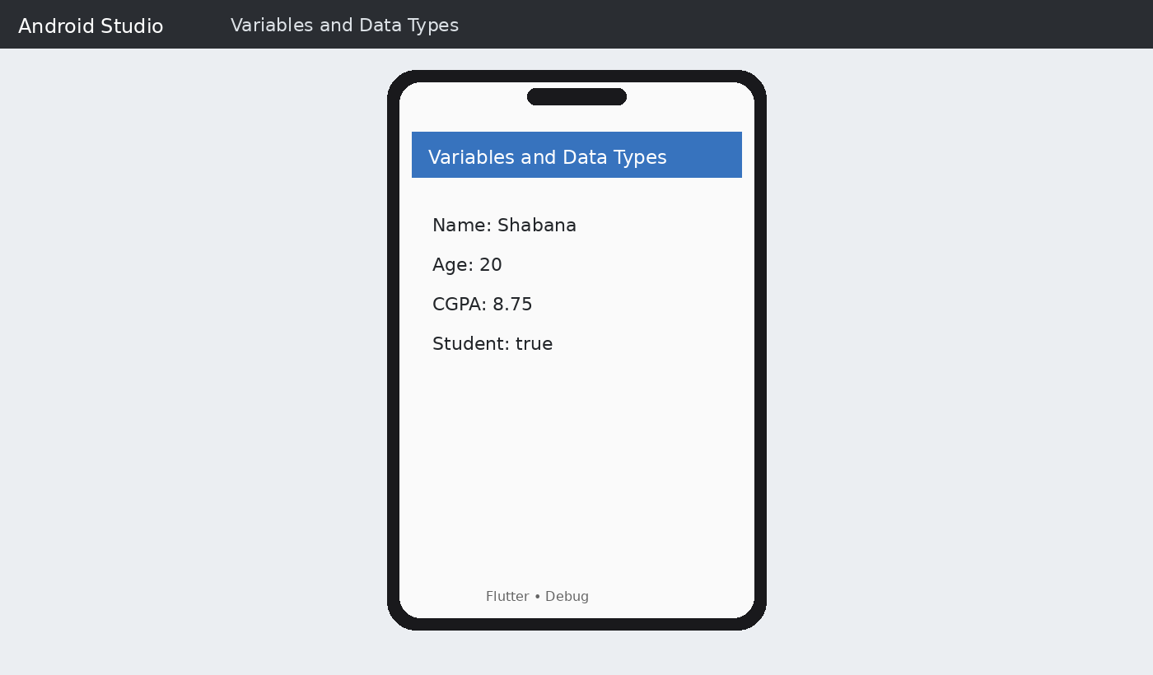

Expected output from the supplied lab sheet: Name: Shabana | Age: 20 | CGPA: 8.75 | Student: true

RESULT:

Thus, The Simple Dart Programming of Variables and Datatypes were Executed and Completed Successfully.

EX.NO: 2.b SIMPLE DART PROGRAMMING EXERCISES – OPERATORS DATE:

AIM:

To understand the fundamentals of the Dart programming language by creating and executing simple Dart programs – Operators using Android Studio and the Flutter framework.

SOFTWARE / SETUP:

Android Studio with Flutter plugin and Flutter SDK, plus an Android Emulator. The supplied lab sheet specifies a Flutter project named dart_exercises.

PROCEDURE:

STEP 1: LAUNCH ANDROID STUDIO

Open Android Studio and wait for the Welcome screen.

STEP 2: CREATE A NEW FLUTTER PROJECT

Choose New Flutter Project → Flutter, specify the Flutter SDK path, set project name to dart_exercises, and finish project creation.

STEP 3: RESULT – PROJECT CREATED

The project contains the lib folder and main.dart file.

STEP 4: START THE ANDROID EMULATOR

Open Device Manager, select an emulator, press Play, and wait for boot completion.

STEP 5: OPEN MAIN.DART

Navigate to lib/main.dart in the project explorer.

STEP 6: REPLACE THE DEFAULT CODE

Remove the default counter-app code and enter the required Dart program.

STEP 7: SAVE THE PROGRAM

Press Ctrl+S to save the Dart file.

STEP 8: RUN THE PROGRAM

Click Run or choose Run → Run 'main.dart'. Flutter builds and installs the application on the emulator.

STEP 9: OBSERVE OUTPUT

UI output appears on the emulator and print() output appears in the Run/Debug Console.

STEP 10: MODIFY THE PROGRAM

Change values or logic and update the displayed text as required.

STEP 11: PERFORM HOT RELOAD

Use the Hot Reload button ()) so the updated UI is reflected without restarting the application.

STEP 12: REPEAT FOR OTHER DART PROGRAMS

Repeat the edit, save, run, observe-output and hot-reload cycle for the listed exercises.

STEP 13: STOP THE APPLICATION

Click Stop (■) after completing the experiment.

PROGRAMS AND OUTPUTS:

PROGRAM 1: ARITHMETIC OPERATORS

Aim: To perform the arithmetic operators exercise using Dart and Flutter.

import 'package:flutter/material.dart'; void main() {
int a = 25; int b = 10;
int add = a + b; int sub = a - b; int mul = a * b; double div = a / b; int mod = a % b;

print("Addition = $add"); print("Subtraction = $sub"); print("Multiplication = $mul"); print("Division = $div"); print("Modulus = $mod");

runApp(MaterialApp( home: Scaffold(
appBar: AppBar(title: const Text("Arithmetic Operators")), body: Center(
child: Text(
"Addition = $add\nSubtraction = $sub\nMultiplication = $mul\n" "Division = $div\nModulus = $mod",
style: const TextStyle(fontSize: 20), textAlign: TextAlign.center,
),
),
),
));
}

OUTPUT:
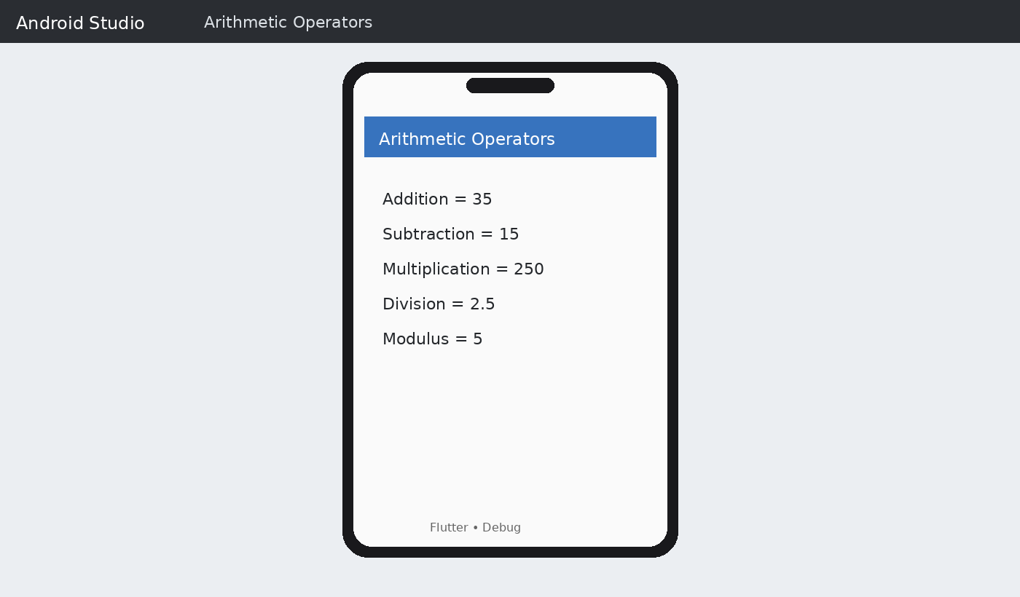

Expected output from the supplied lab sheet: Addition = 35 | Subtraction = 15 | Multiplication = 250 | Division = 2.5 | Modulus = 5

PROGRAM 2: RELATIONAL OPERATORS

Aim: To perform the relational operators exercise using Dart and Flutter.

import 'package:flutter/material.dart'; void main() {
int a = 15; int b = 20;
String result =
"a > b : ${a > b}\n"
"a < b : ${a < b}\n"
"a == b : ${a == b}\n"
"a != b : ${a != b}\n"
"a >= b : ${a >= b}\n"
"a <= b : ${a <= b}"; print(result); runApp(MaterialApp( home: Scaffold(
appBar: AppBar(title: const Text("Relational Operators")), body: Center(
child: Text(result, style: const TextStyle(fontSize: 20), textAlign: TextAlign.center),
),
),
));
}

OUTPUT:
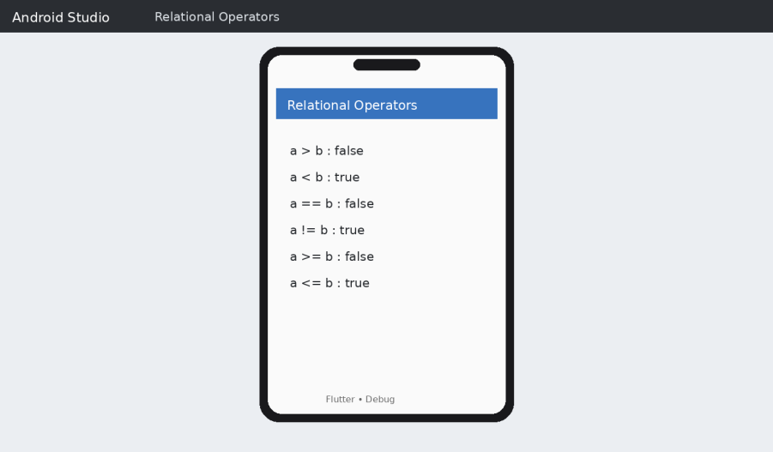

Expected output from the supplied lab sheet: a > b : false | a < b : true | a == b : false | a != b : true | a >= b : false | a <= b : true

RESULT:

Thus, The Simple Dart Programming of Operators were Executed and Completed Successfully.

EX.NO: 3.a SIMPLE DART PROGRAMMING LANGUAGES – CONTROL DATE: STATEMENTS

AIM:

To understand the fundamentals of the Dart programming language by creating and executing simple Dart programs – Control Statements using Android Studio and the Flutter framework.

SOFTWARE / SETUP:

Android Studio with Flutter plugin and Flutter SDK, plus an Android Emulator. The supplied lab sheet specifies a Flutter project named dart_exercises.

PROCEDURE:

STEP 1: LAUNCH ANDROID STUDIO

Open Android Studio and wait for the Welcome screen.

STEP 2: CREATE A NEW FLUTTER PROJECT

Choose New Flutter Project → Flutter, specify the Flutter SDK path, set project name to dart_exercises, and finish project creation.

STEP 3: RESULT – PROJECT CREATED

The project contains the lib folder and main.dart file.

STEP 4: START THE ANDROID EMULATOR

Open Device Manager, select an emulator, press Play, and wait for boot completion.

STEP 5: OPEN MAIN.DART

Navigate to lib/main.dart in the project explorer.

STEP 6: REPLACE THE DEFAULT CODE

Remove the default counter-app code and enter the required Dart program.

STEP 7: SAVE THE PROGRAM

Press Ctrl+S to save the Dart file.

STEP 8: RUN THE PROGRAM

Click Run or choose Run → Run 'main.dart'. Flutter builds and installs the application on the emulator.

STEP 9: OBSERVE OUTPUT

UI output appears on the emulator and print() output appears in the Run/Debug Console.

STEP 10: MODIFY THE PROGRAM

Change values or logic and update the displayed text as required.

STEP 11: PERFORM HOT RELOAD

Use the Hot Reload button ()) so the updated UI is reflected without restarting the application.

STEP 12: REPEAT FOR OTHER DART PROGRAMS

Repeat the edit, save, run, observe-output and hot-reload cycle for the listed exercises.

STEP 13: STOP THE APPLICATION

Click Stop (■) after completing the experiment.

PROGRAMS AND OUTPUTS:

PROGRAM 1: IF-ELSE STATEMENT

Aim: To perform the if-else statement exercise using Dart and Flutter.

import 'package:flutter/material.dart'; void main() {
int number = 18; String result;
if (number % 2 == 0) { result = "$number is Even";
} else {
result = "$number is Odd";
}
print(result); runApp(MaterialApp( home: Scaffold(
appBar: AppBar(title: const Text("If-Else Statement")), body: Center(
child: Text(result, style: const TextStyle(fontSize: 24)),

),
),
));
}

OUTPUT:
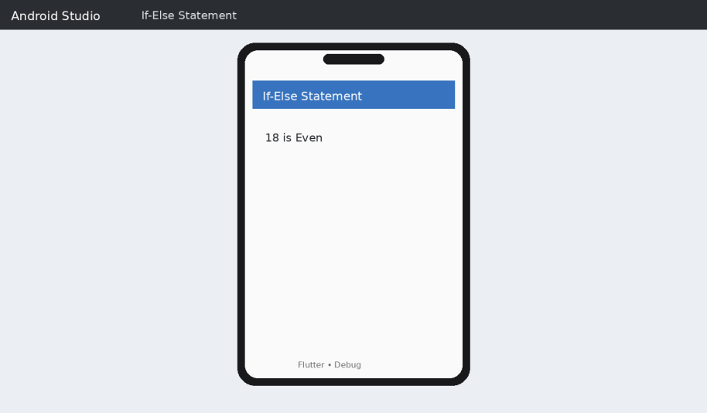

Expected output from the supplied lab sheet: 18 is Even

PROGRAM 2: SWITCH STATEMENT

Aim: To perform the switch statement exercise using Dart and Flutter.

import 'package:flutter/material.dart'; void main() {
int day = 4; String dayName; switch (day) {
case 1: dayName = "Monday"; break; case 2: dayName = "Tuesday"; break; case 3: dayName = "Wednesday"; break; case 4: dayName = "Thursday"; break; case 5: dayName = "Friday"; break; case 6: dayName = "Saturday"; break;
case 7: dayName = "Sunday"; break; default: dayName = "Invalid Day"; } print(dayName); runApp(MaterialApp(
home: Scaffold(

appBar: AppBar(title: const Text("Switch Statement")), body: Center(
child: Text(dayName, style: const TextStyle(fontSize: 24)),
),
),
));
}

OUTPUT:
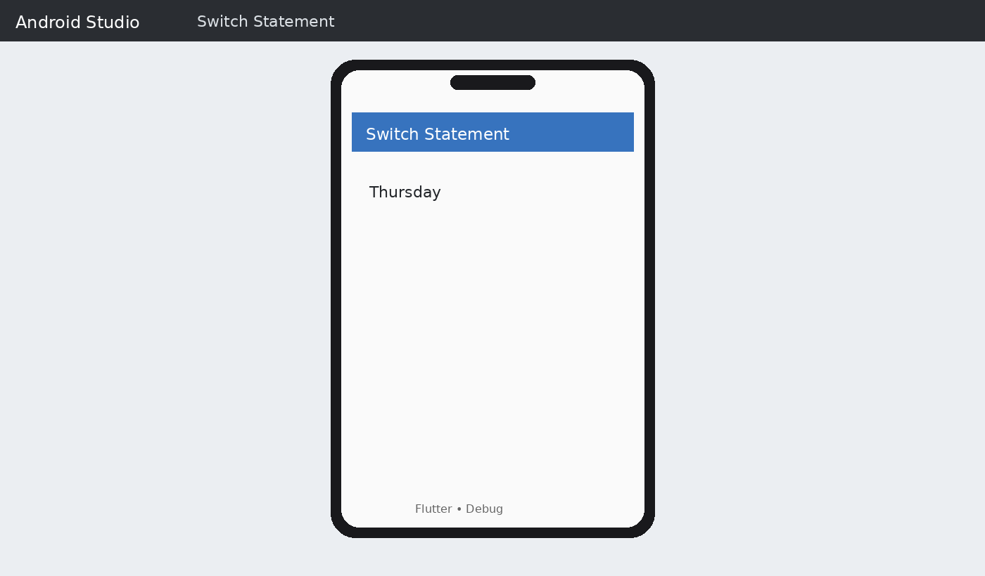

Expected output from the supplied lab sheet: Thursday

PROGRAM 3: FOR LOOP

Aim: To perform the for loop exercise using Dart and Flutter.

import 'package:flutter/material.dart'; void main() {
String result = "";
for (int i = 1; i <= 5; i++) { result += "$i ";
}
print(result.trim()); runApp(MaterialApp( home: Scaffold(

appBar: AppBar(title: const Text("For Loop")), body: Center(
child: Text(result, style: const TextStyle(fontSize: 24)),
),
),
));
}

OUTPUT:
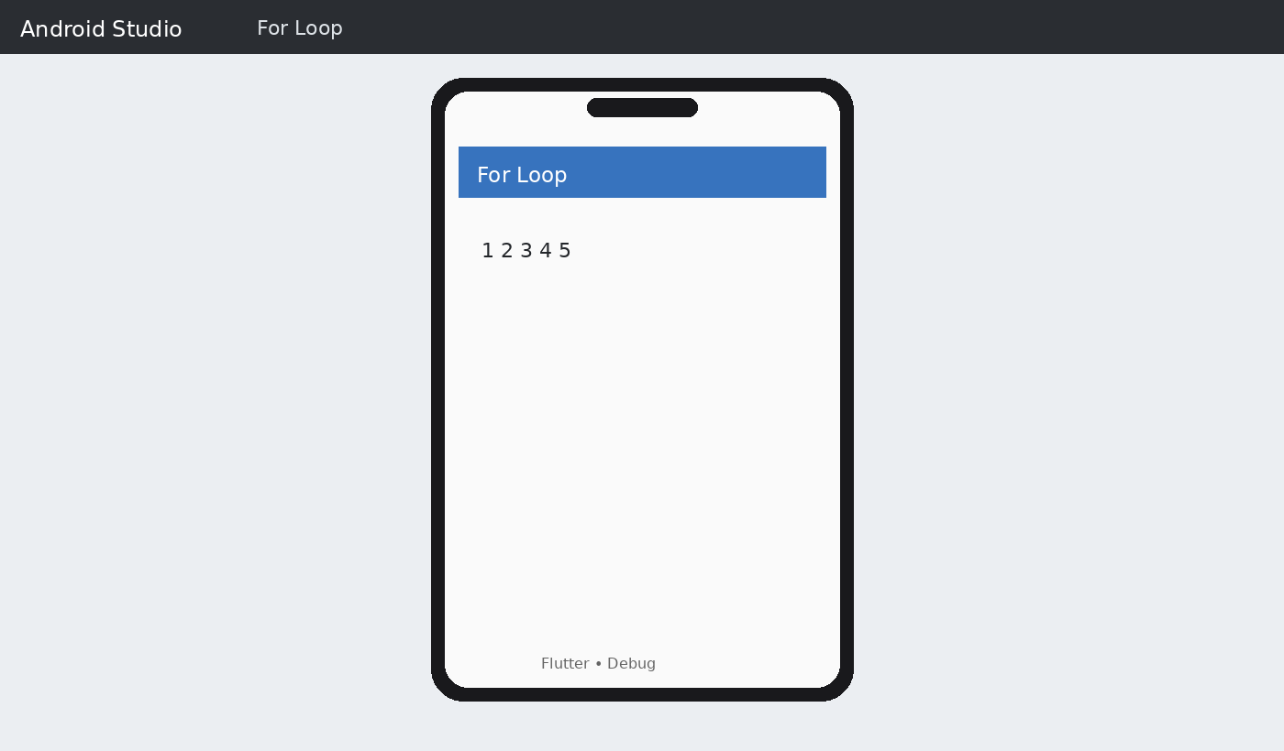

PROGRAM 4: WHILE LOOP

Aim: To perform the while loop exercise using Dart and Flutter.

import 'package:flutter/material.dart'; void main() {
int i = 1;
String result = ""; while (i <= 5) { result += "$i "; i++;
}
print(result.trim());

runApp(MaterialApp( home: Scaffold(
appBar: AppBar(title: const Text("While Loop")), body: Center(
child: Text(result, style: const TextStyle(fontSize: 24)),
),
),
));
}

OUTPUT:
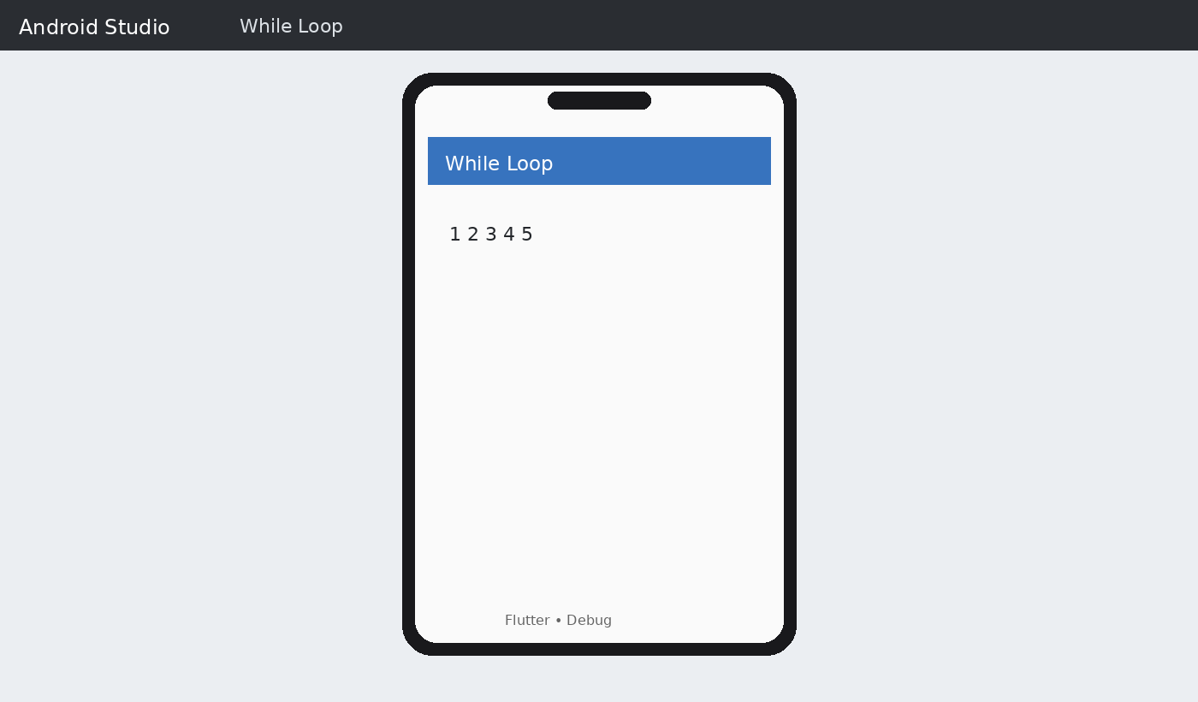

RESULT:

Thus, The Simple Dart Programming of Control Statements were Executed and Completed Successfully.

EX.NO:3.b SIMPLE DART PROGRAMMING EXERCISES – FUNCTIONS DATE: AND WIDGET EXPLORATION

AIM:
To understand and implement functions in Dart and explore commonly used Flutter widgets creating and running small Flutter applications.

REQUIREMENTS:
Flutter SDK, Android Studio or Visual Studio Code, Dart SDK supplied with Flutter, and an Android Emulator or connected device.

PART A – FUNCTIONS IN DART
Functions group reusable instructions into a named unit. They can accept parameters and return values. Dart also supports concise arrow functions and named parameters.

PROGRAM 1: FUNCTIONS — BASIC FUNCTION
Aim: To define and call a basic function.
Procedure: Create/open a Flutter project, replace lib/main.dart with the program, save the file, run it on the emulator, and observe the output.

import 'package:flutter/material.dart'; String greet(String name) { return "Hello, $name!";
}
void main() {
String result = greet("Flutter"); print(result); runApp(MaterialApp(
home: Scaffold(
appBar: AppBar(title: const Text("Basic Function")), body: Center(
child: Text(result, style: const TextStyle(fontSize: 26)),
),
),
));
}

Code screenshot:
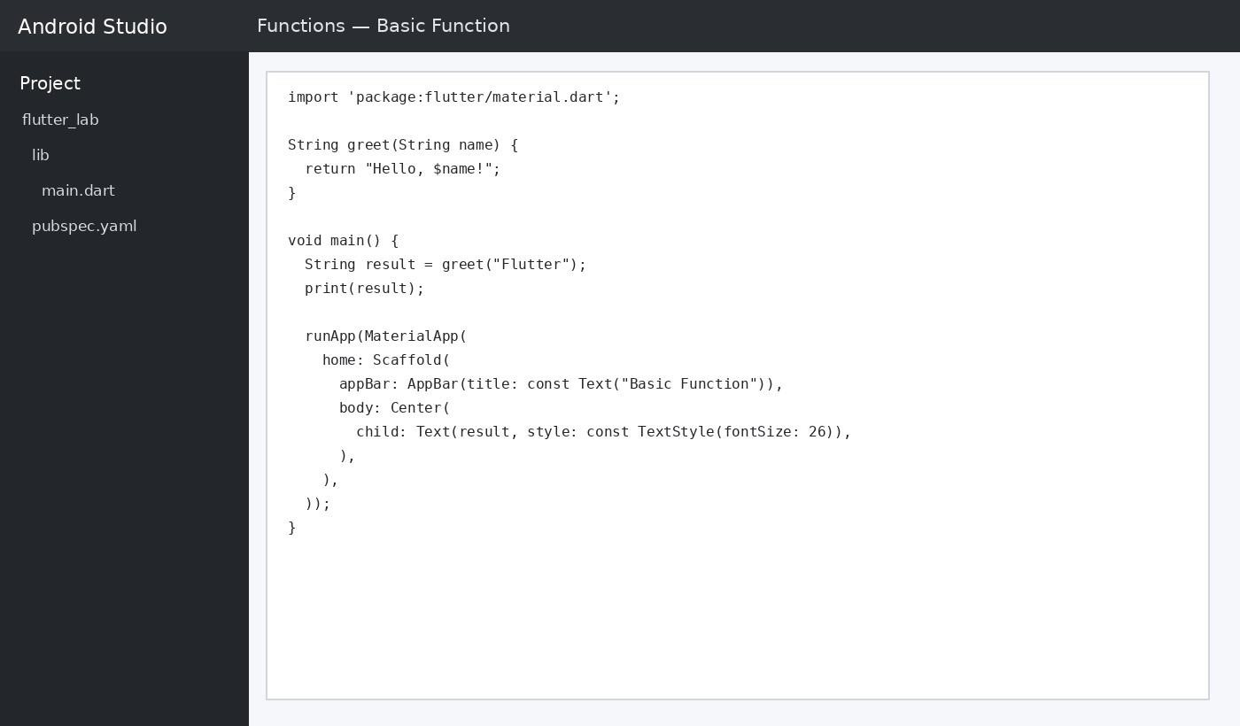

OUTPUT:
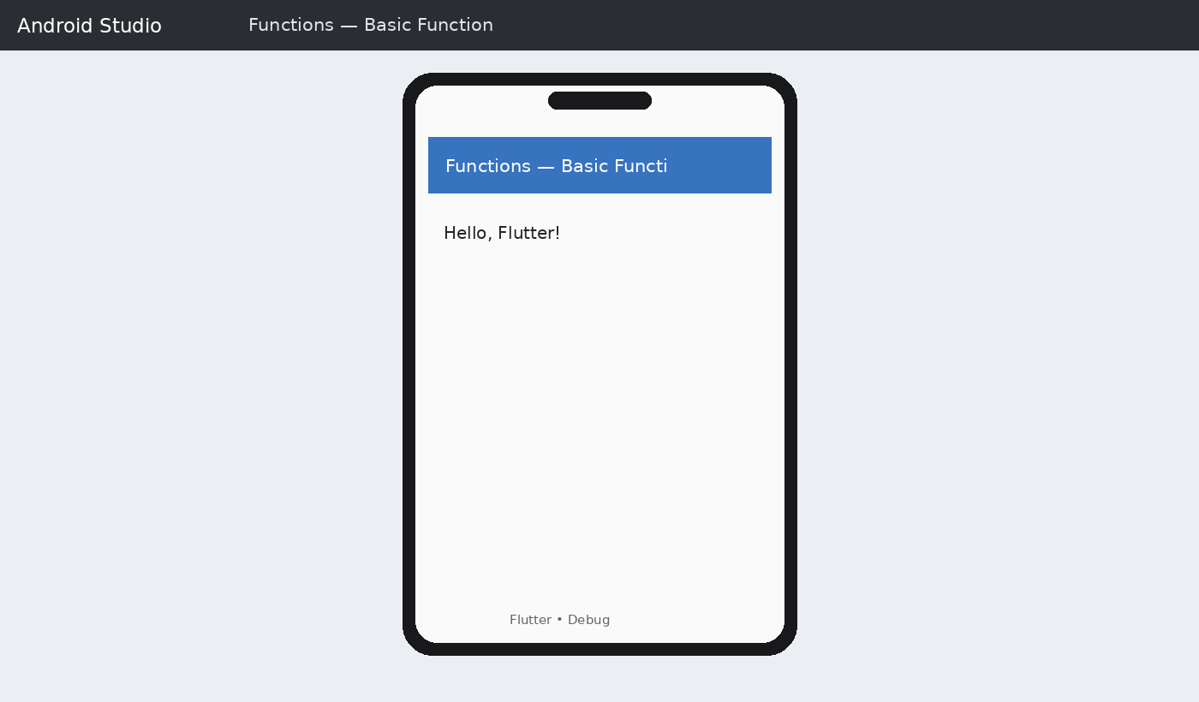

Expected output: Hello, Flutter!

PROGRAM 2: FUNCTIONS — PARAMETERS
Aim: To pass parameters to a function and return a value.
Procedure: Create/open a Flutter project, replace lib/main.dart with the program, save the file, run it on the emulator, and observe the output.

import 'package:flutter/material.dart'; int add(int a, int b) {
return a + b;
}
void main() {
int result = add(15, 25); print("Sum = $result"); runApp(MaterialApp( home: Scaffold(
appBar: AppBar(title: const Text("Function Parameters")), body: Center(
child: Text("Sum = $result",
style: const TextStyle(fontSize: 26)),
),
),
));
}
Code screenshot:
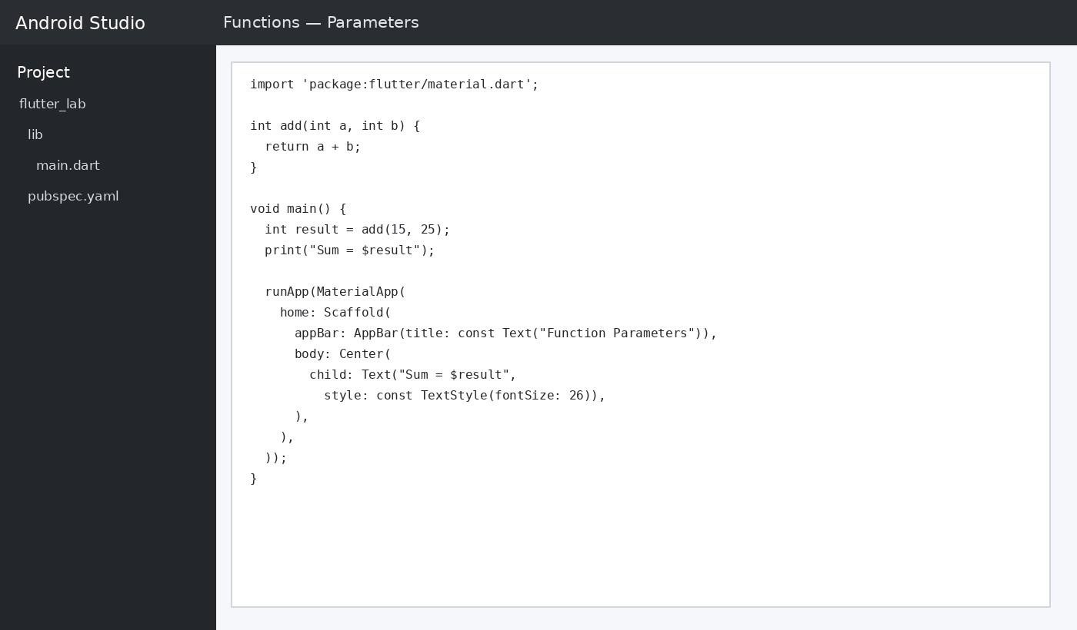

OUTPUT:
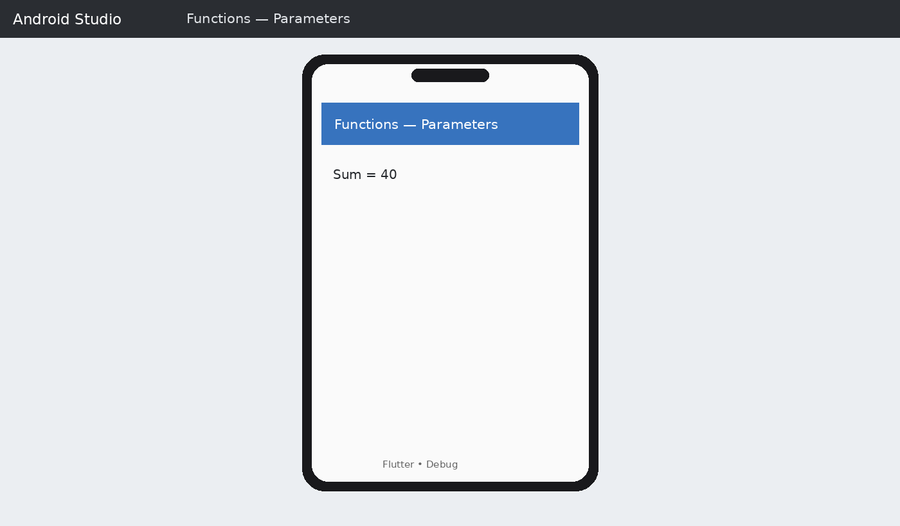

Expected output: Sum = 40

PROGRAM 3: FUNCTIONS — ARROW FUNCTION

Aim: To implement a concise arrow function.

Procedure: Create/open a Flutter project, replace lib/main.dart with the program, save the file, run it on the emulator, and observe the output.

import 'package:flutter/material.dart'; int square(int n) => n * n;
void main() {
int result = square(6); print("Square = $result"); runApp(MaterialApp( home: Scaffold(
appBar: AppBar(title: const Text("Arrow Function")), body: Center(
child: Text("Square = $result",
style: const TextStyle(fontSize: 26)),
),
),

));
}

Code screenshot:
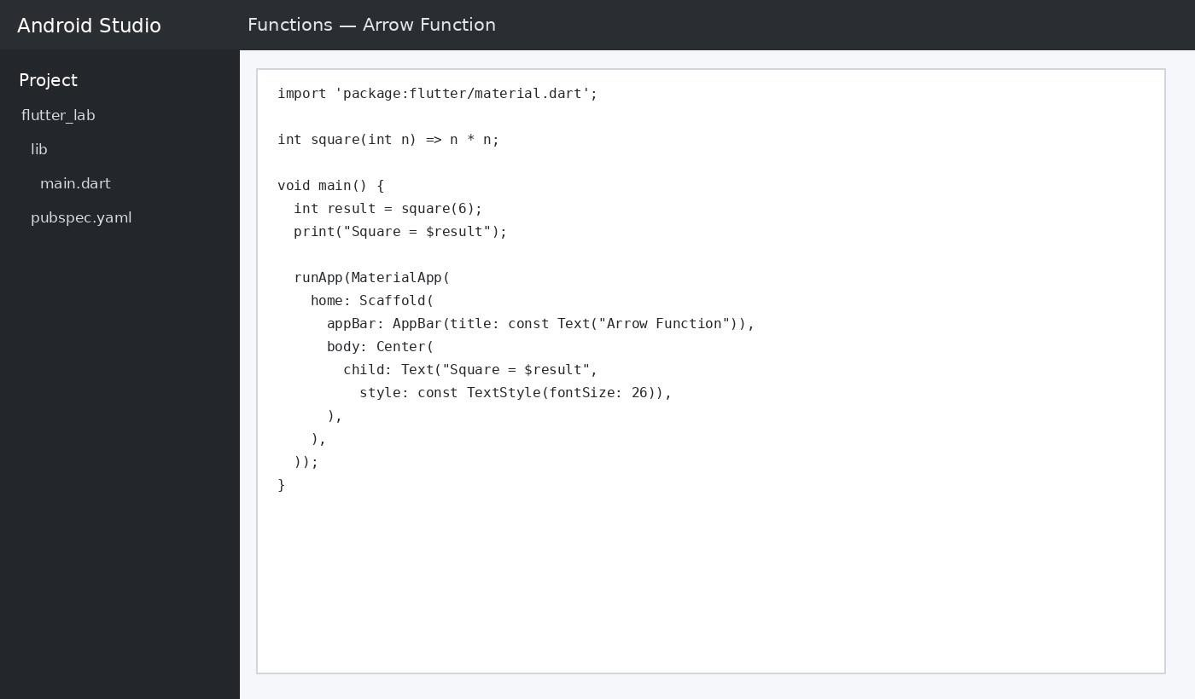

OUTPUT:
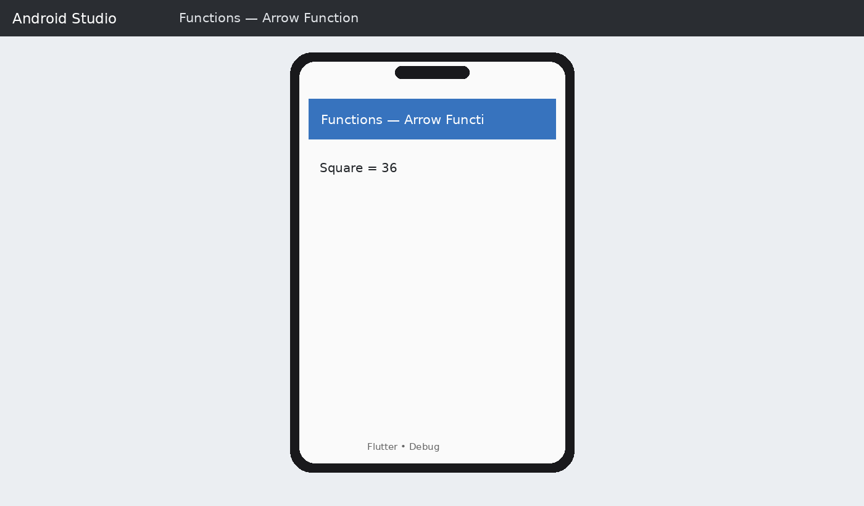

Expected output: Square = 36

PROGRAM 4: FUNCTIONS — NAMED PARAMETERS

Aim: To use named parameters in a Dart function. Procedure: Create/open a Flutter project, replace lib/main.dart with the program, save the file, run it on the emulator, and observe the output.

import 'package:flutter/material.dart';
String student({required String name, required int age}) { return "Name: $name\nAge: $age";
}
void main() {
String result = student(name: "Shabana", age: 20); print(result);
runApp(MaterialApp( home: Scaffold(
appBar: AppBar(title: const Text("Named Parameters")), body: Center(
child: Text(result,
style: const TextStyle(fontSize: 24)),
),
),
));
}

Code screenshot:
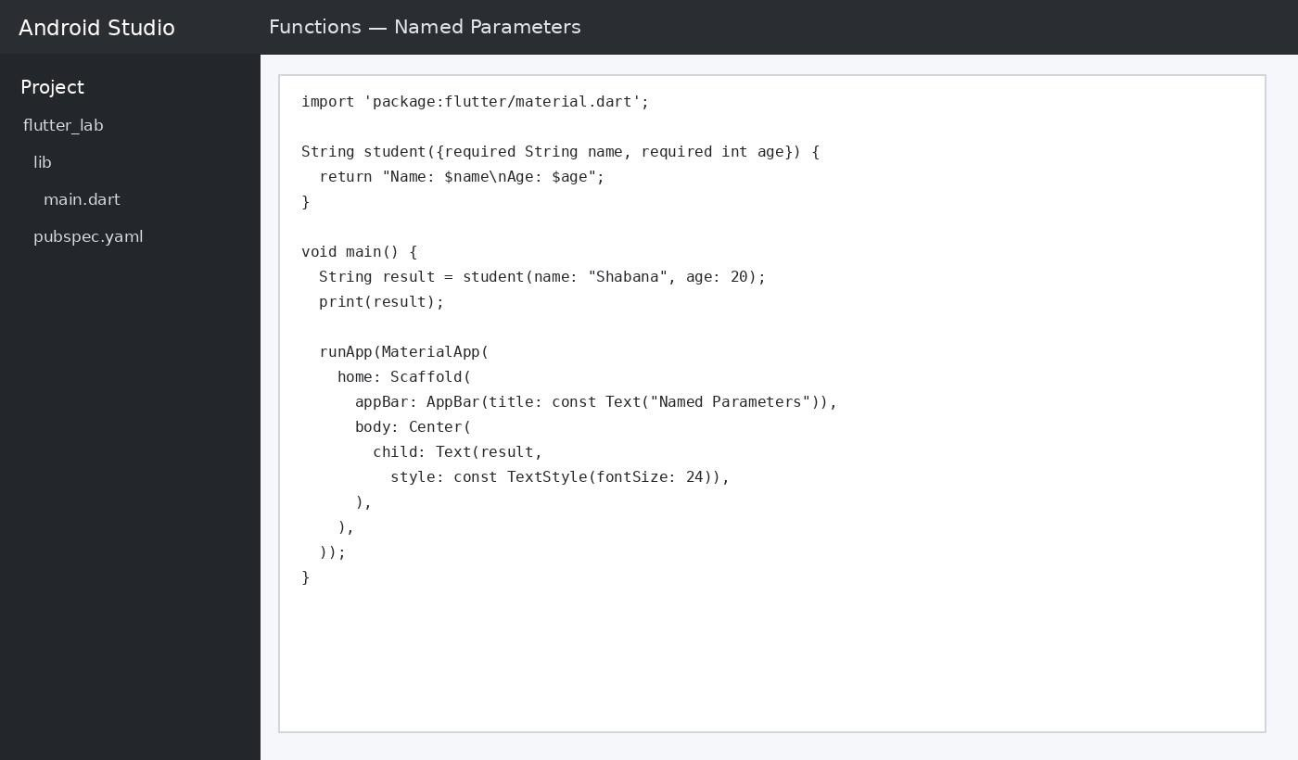

OUTPUT:
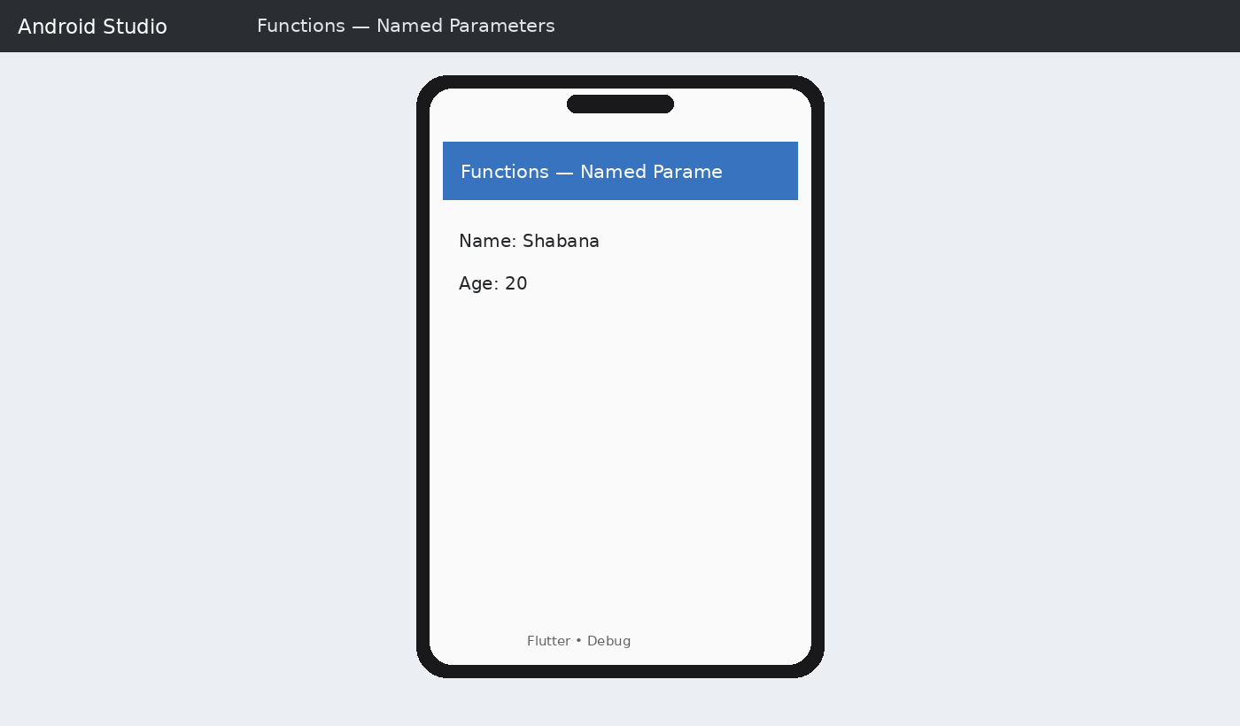

Expected output: Name: Shabana | Age: 20

PART B – WIDGET EXPLORATION IN FLUTTER

Flutter user interfaces are composed from widgets. The following programs demonstrate Text, Container, Row, Column, ElevatedButton, Card, Icon, and a combined widget layout.

PROGRAM 5: WIDGET EXPLORATION - TEXT

Aim: To explore the Text widget in a Flutter application. Procedure: Replace lib/main.dart with the program, save, run the application on the emulator, and observe the rendered widget.

import 'package:flutter/material.dart'; void main() {
runApp(MaterialApp( home: Scaffold(
appBar: AppBar(title: const Text("Text Widget")), body: const Center(
child: Text(
"Welcome to Flutter", style: TextStyle(

fontSize: 28,
fontWeight: FontWeight.bold,
),
),
),
),
));
}

Code screenshot:
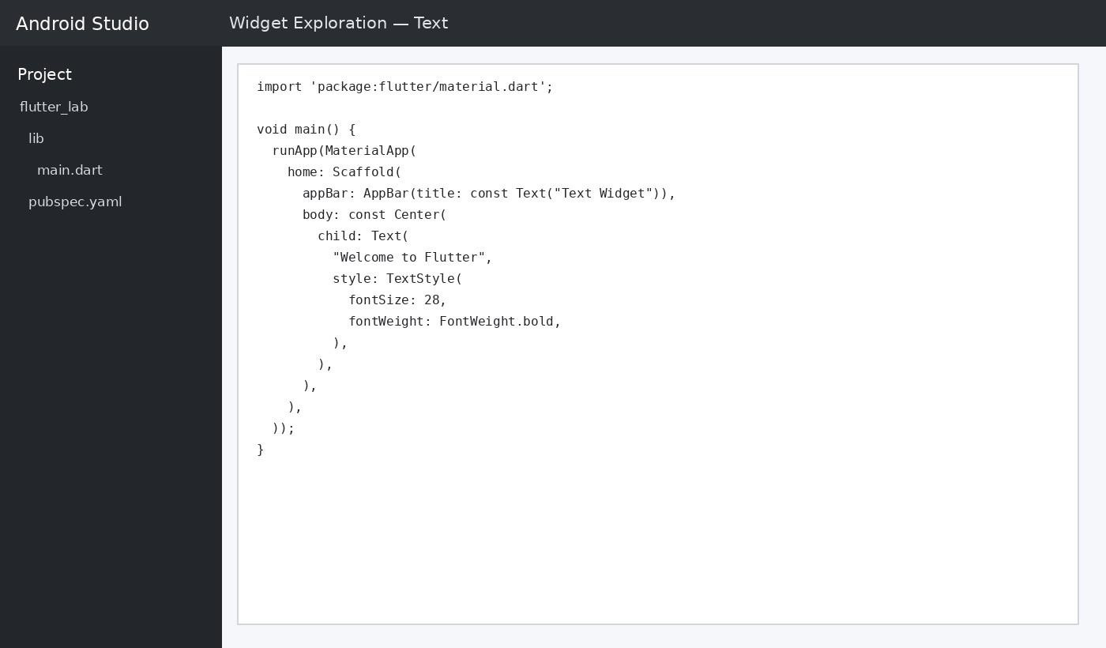

OUTPUT:
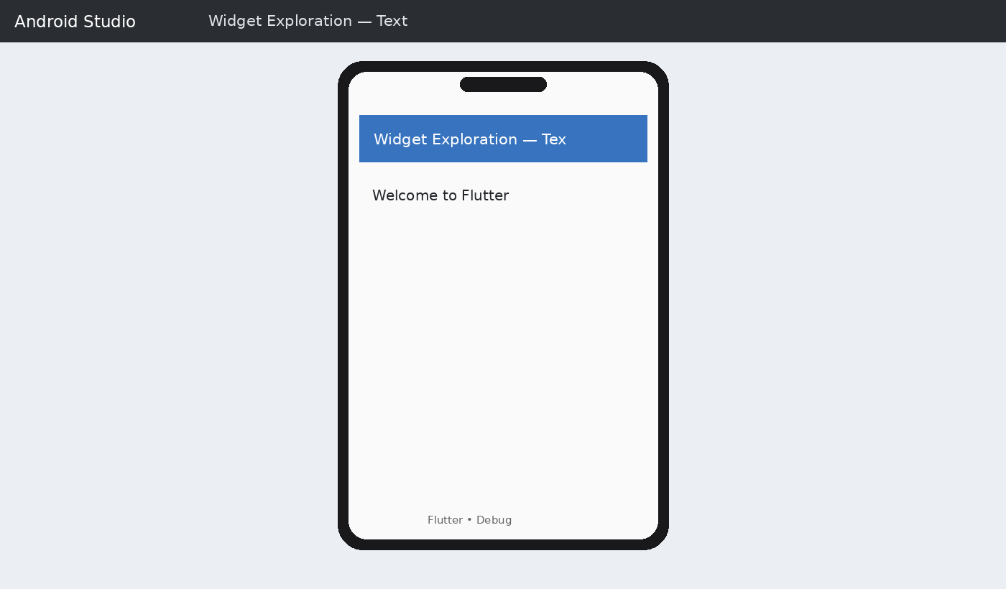

Expected output: Welcome to Flutter

PROGRAM 6: WIDGET EXPLORATION — CONTAINER

Aim: To explore the Container widget in a Flutter application.

Procedure: Replace lib/main.dart with the program, save, run the application on the emulator, and observe the rendered widget.

import 'package:flutter/material.dart'; void main() {
runApp(MaterialApp( home: Scaffold(
appBar: AppBar(title: const Text("Container Widget")), body: Center(
child: Container(
padding: const EdgeInsets.all(20), child: const Text(
"Flutter Container",
style: TextStyle(fontSize: 24),
),
),

),
),
));
}

Code screenshot:
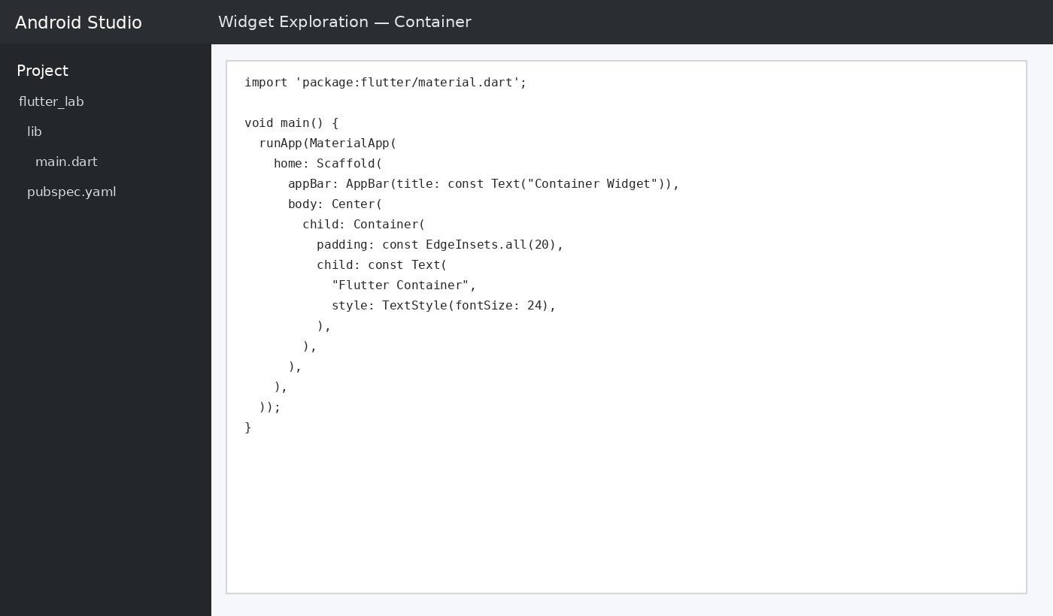

OUTPUT:
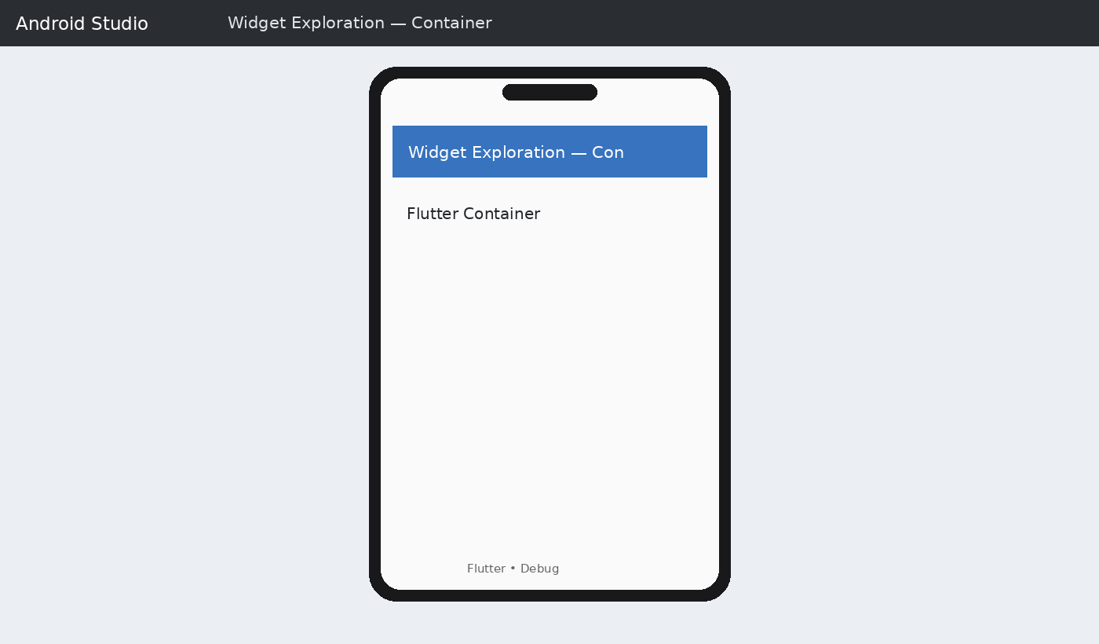

Expected output: Flutter Container

PROGRAM 7: WIDGET EXPLORATION — ROW & COLUMN

Aim: To explore the Row and Column widgets in a Flutter application.

Procedure: Replace lib/main.dart with the program, save, run the application on the emulator, and observe the rendered widget.

import 'package:flutter/material.dart'; void main() {
runApp(MaterialApp( home: Scaffold(
appBar: AppBar(title: const Text("Row & Column")), body: Column(
mainAxisAlignment: MainAxisAlignment.center, children: const [
Text("Column Item 1", style: TextStyle(fontSize: 22)),
Text("Column Item 2", style: TextStyle(fontSize: 22)), Row(
mainAxisAlignment: MainAxisAlignment.center, children: [
Text("Row A", style: TextStyle(fontSize: 22)), SizedBox(width: 25),
Text("Row B", style: TextStyle(fontSize: 22)),
],
),
],
),
),
));
}

Code screenshot:
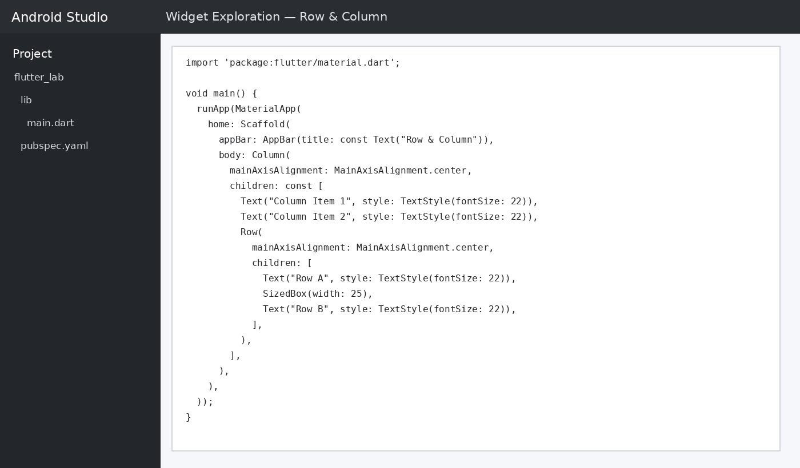

OUTPUT:
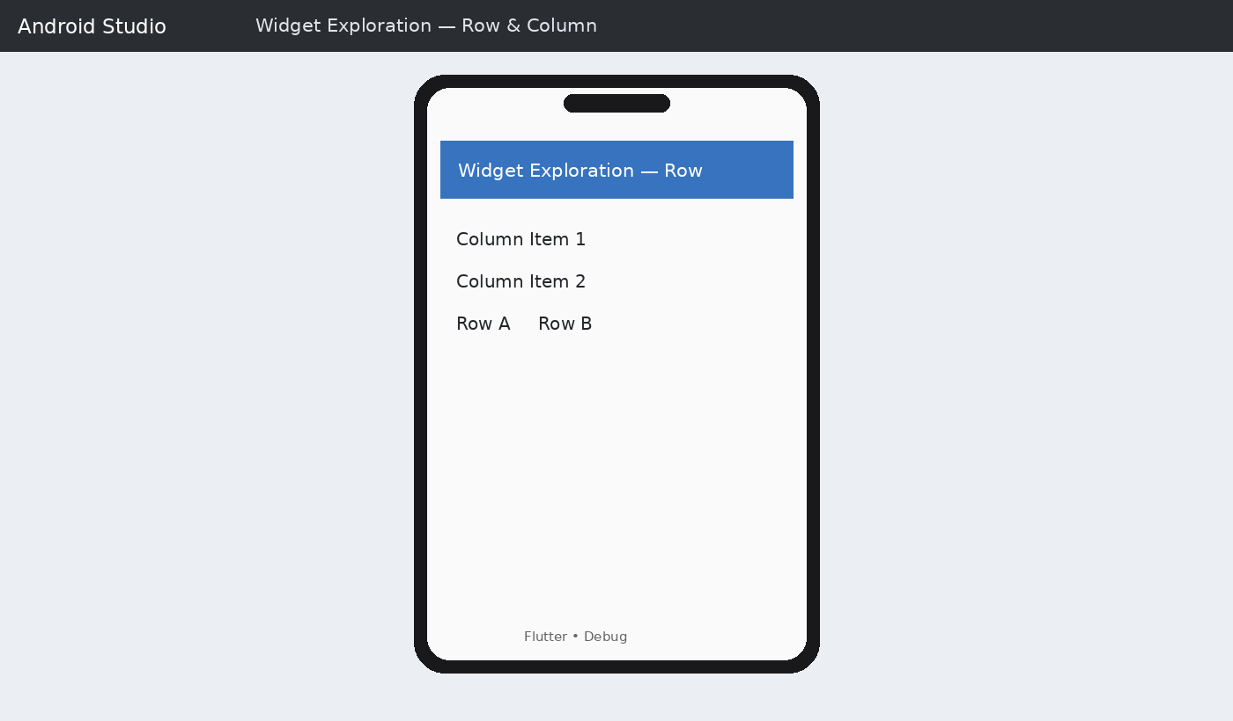

Expected output: Column Item 1 | Column Item 2 | Row A Row B

PROGRAM 8: WIDGET EXPLORATION — ELEVATEDBUTTON

Aim: To explore the ElevatedButton widget in a Flutter application.

Procedure: Replace lib/main.dart with the program, save, run the application on the emulator, and observe the rendered widget.

import 'package:flutter/material.dart'; void main() {
runApp(MaterialApp( home: Scaffold(
appBar: AppBar(title: const Text("Button Widget")), body: Center(
child: ElevatedButton( onPressed: () { print("Button Pressed");
},
child: const Text("Press Me"),
),
),
),
));
}

Code screenshot:
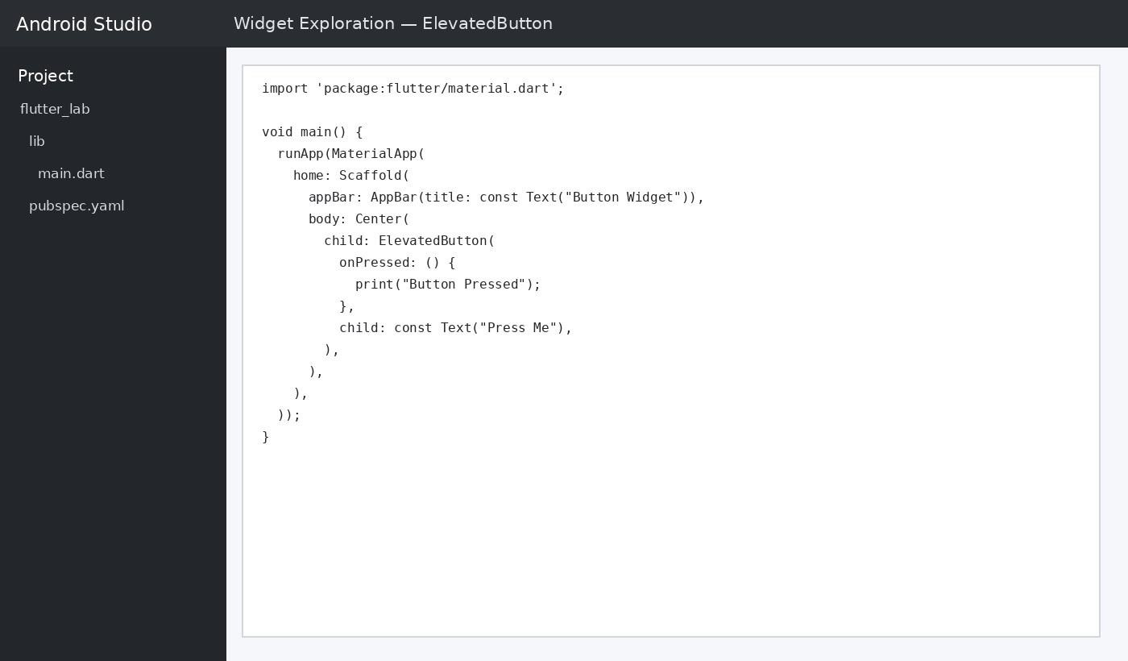

OUTPUT:
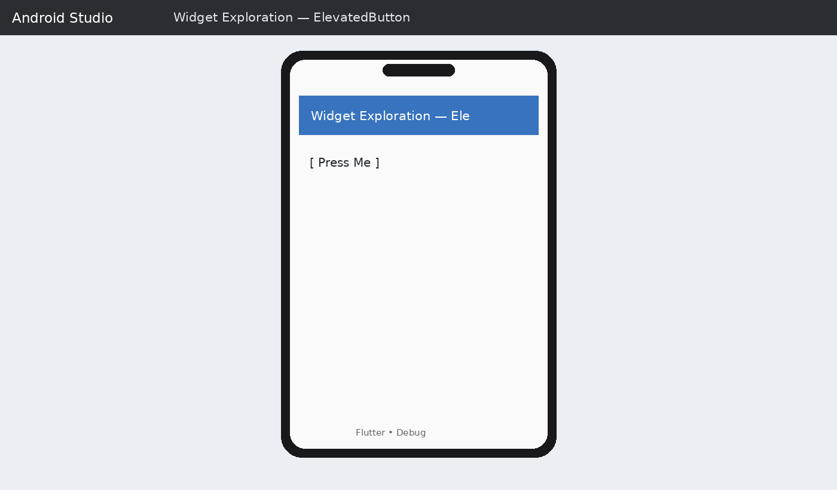

PROGRAM 9: WIDGET EXPLORATION — CARD & ICON

Aim: To explore the Card and Icon widgets in a Flutter application.

Procedure: Replace lib/main.dart with the program, save, run the application on the emulator, and observe the rendered widget.

import 'package:flutter/material.dart'; void main() {
runApp(MaterialApp( home: Scaffold(
appBar: AppBar(title: const Text("Card & Icon")), body: Center(
child: Card( child: Padding(
padding: const EdgeInsets.all(24), child: Column(
mainAxisSize: MainAxisSize.min, children: const [
Icon(Icons.star, size: 50),
Text("Flutter Card", style: TextStyle(fontSize: 24)),
],

),
),
),
),
),
));
}

Code screenshot:
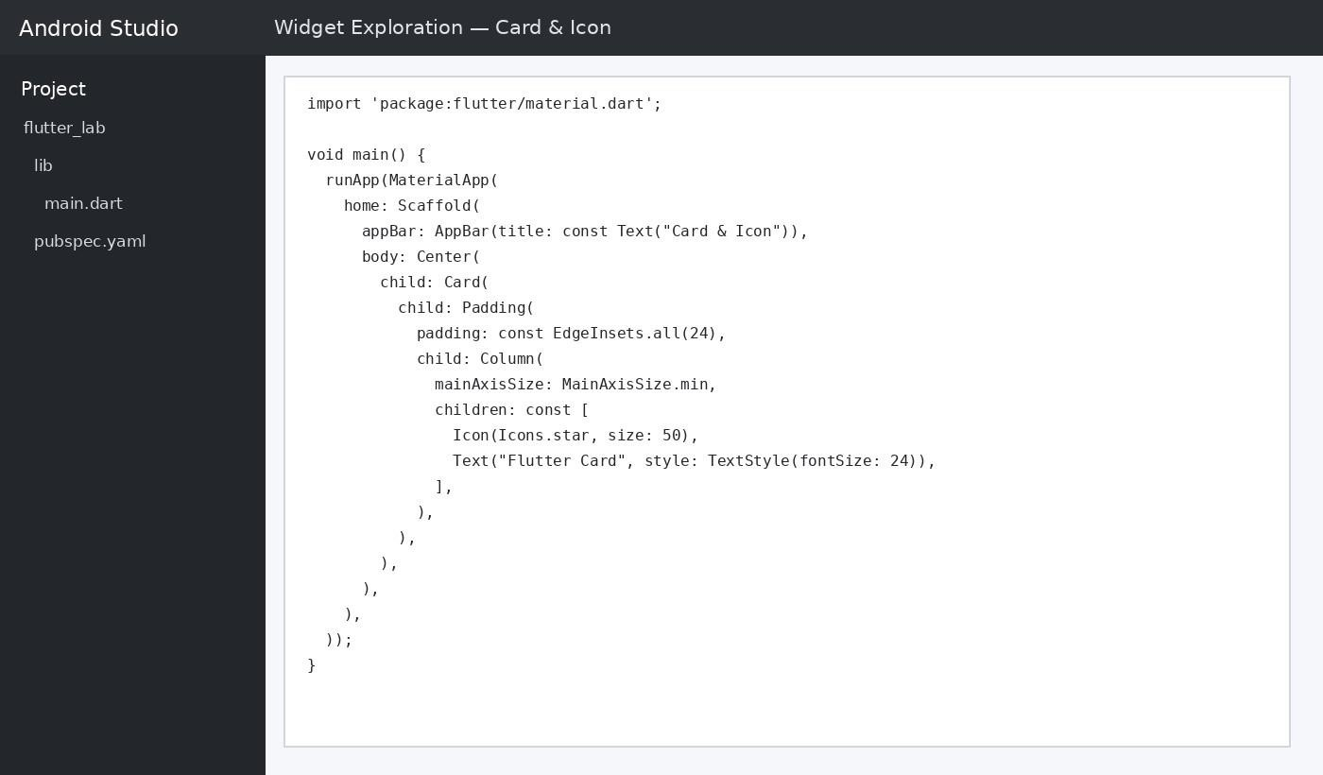

OUTPUT:
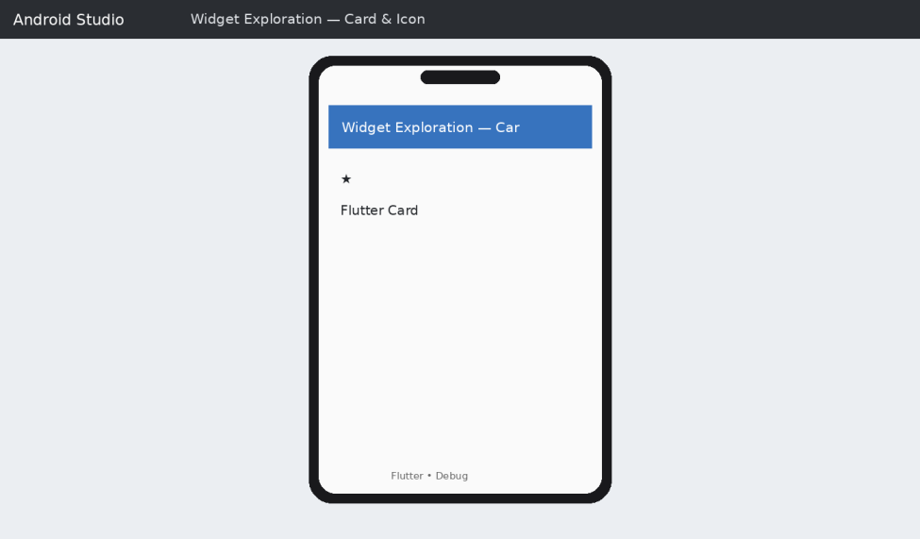

Expected output: ★ | Flutter Card

PROGRAM 10: WIDGET EXPLORATION — COMBINED UI

Aim: To explore the Combined widget UI in a Flutter application.

Procedure: Replace lib/main.dart with the program, save, run the application on the emulator, and observe the rendered widget.

import 'package:flutter/material.dart'; void main() {
runApp(MaterialApp( home: Scaffold(
appBar: AppBar(title: const Text("Widget Exploration")), body: Center(
child: Card( child: Padding(
padding: const EdgeInsets.all(20), child: Column(
mainAxisSize: MainAxisSize.min, children: const [ Icon(Icons.flutter_dash, size: 60), Text("Flutter Widgets",
style: TextStyle(fontSize: 24, fontWeight: FontWeight.bold)),
SizedBox(height: 12),
Text("Text • Container • Row • Column"),
],
),
),
),
),
),
));
}

Code screenshot:

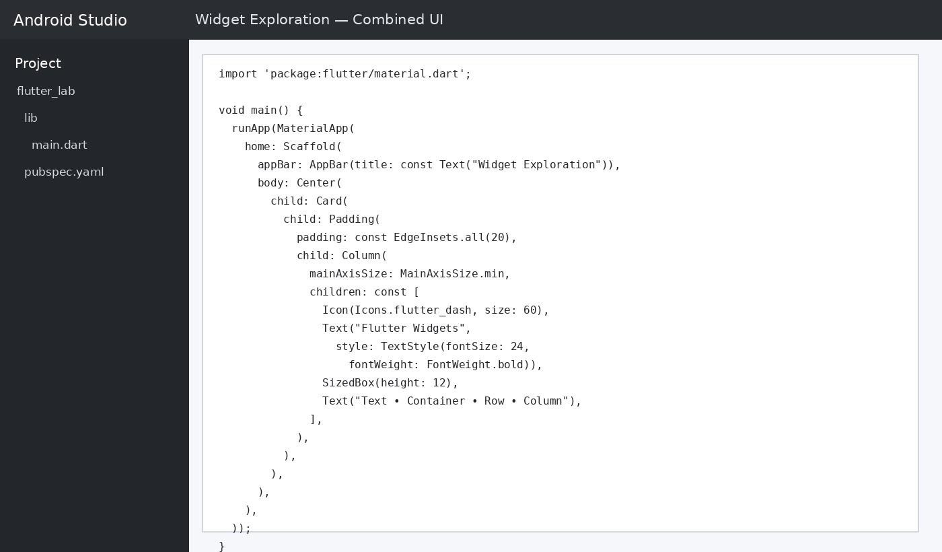

OUTPUT:
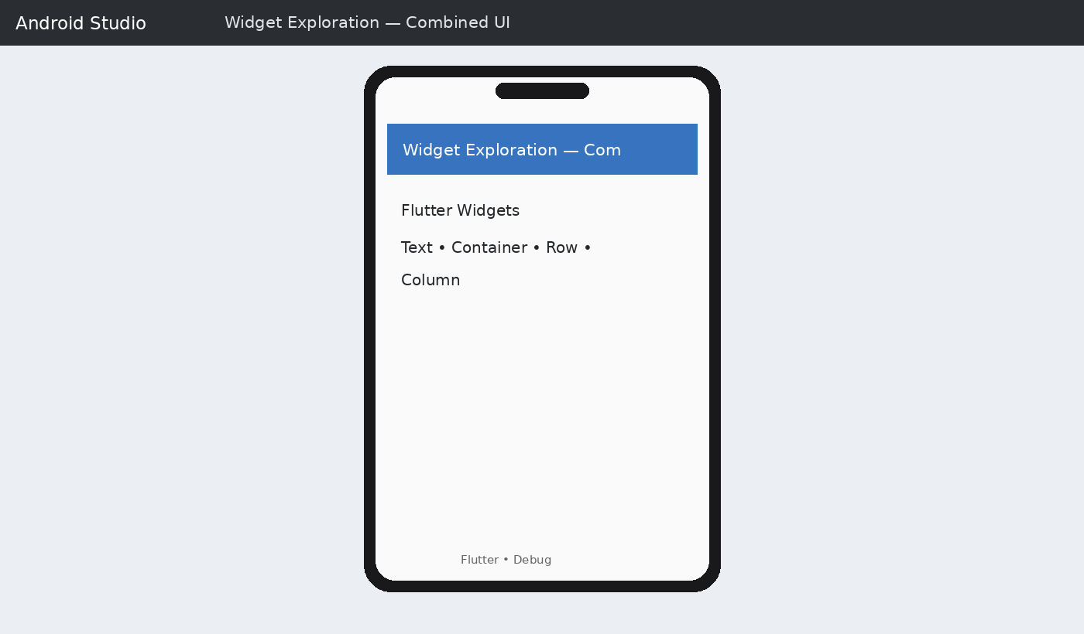

Expected output: Flutter Widgets | Text • Container • Row • Column

RESULT:

The Dart function programs and Flutter widget exploration programs were implemented in a Flutter project was executed and completed successfully.

EX.NO:4.a DESIGN OF PROFILE PAGE USING TEXT, IMAGE AND ICON DATE: WIDGETS

AIM:

To design and develop a Profile Page in Flutter using Text, Image, and Icon widgets to display user information, profile picture, and relevant icons with an attractive and user-friendly interface.

THEORY:

Flutter is an open-source UI framework developed by Google for building cross-platform applications. A Profile Page in Flutter is designed using the following widgets:
- Text Widget: Displays user details such as name, email, phone number, and other profile information.

- Image Widget: Displays the user's profile picture or avatar.

- Icon Widget: Displays icons for email, phone, location, settings, and other profile options.

- Container Widget: Used to arrange and style the profile elements with padding, margins, and colors.

- Column and Row Widgets: Used to arrange widgets vertically and horizontally.

By combining these widgets, an attractive, organized, and user-friendly profile page can be created in Flutter.

PROCEDURE:

- Create a new Flutter project Run the following commands in the terminal: flutter create profile_page
cd profile_page

- Open the project in VS Code Use the code . command to open the project in VS Code, then open the lib/main.dart file.

- Write the main() function Define the entry point of the app:

dart

void main() { runApp(const MyApp());
}

- Create the root widget (MyApp) Extend StatelessWidget and return a MaterialApp widget. Set the title, theme, and home properties (home: ProfilePage()).

- Create the ProfilePage widget Create another StatelessWidget class — this is the main UI screen.

  - Use a Scaffold widget with an appBar (title: "My Profile").

  - In the body, use SingleChildScrollView → Column to arrange the content.

- Add the profile picture and name

  - Use a CircleAvatar or Icon widget to display the profile picture.

  - Use two Text widgets — one for the name (bold, larger font) and one for the subtitle/role (grey, smaller font).

- Add the "Personal Information" section Use a Container with a Column to design a card-like section. For each row, use an Icon and Text combination inside a Row widget to display email, phone number, and location.

- Add the "Skills" section Create another Container card, and use Icon + Text rows to list skills (Java, Flutter, Python).

- Run the application flutter run
Select the emulator/device and run the app to check the output.

- Verify the output Confirm that the app bar title, profile picture, name, personal information card, and skills card are displayed correctly.

PROGRAM:

import 'package:flutter/material.dart'; void main() {
runApp(const MyApp());

}

class MyApp extends StatelessWidget { const MyApp({super.key});
@override

Widget build(BuildContext context) { return MaterialApp( debugShowCheckedModeBanner: false, title: 'Profile Page',
home: const ProfilePage(),

);

}

}

class ProfilePage extends StatelessWidget { const ProfilePage({super.key});
@override

Widget build(BuildContext context) { return Scaffold(
appBar: AppBar(

title: const Text('My Profile'),

centerTitle: true,

),

body: Center( child: Column(
mainAxisAlignment: MainAxisAlignment.center, children: [
// Profile Image const CircleAvatar( radius: 70,
child: Icon( Icons.person, size: 80,
),

),

const SizedBox(height: 20),

// Name const Text(
'Dharshini Priya', style: TextStyle( fontSize: 26,
fontWeight: FontWeight.bold,

),

),

const SizedBox(height: 10),

// Course const Text(
'Computer Science Student', style: TextStyle(
fontSize: 18,

),

),

const SizedBox(height: 25),

// Email Row(
mainAxisAlignment: MainAxisAlignment.center, children: const [
Icon( Icons.email, size: 25,
),

SizedBox(width: 10), Text( 'dharshini@example.com', style: TextStyle(

fontSize: 16,

),

),

],

),

const SizedBox(height: 15),

// Phone Row(
mainAxisAlignment: MainAxisAlignment.center, children: const [
Icon( Icons.phone, size: 25,
),

SizedBox(width: 10), Text(
'+91 98765 43210',

style: TextStyle( fontSize: 16,
),

),

],

),

const SizedBox(height: 25),

// Location Row(
mainAxisAlignment: MainAxisAlignment.center, children: const [
Icon( Icons.location_on, size: 25,
),

SizedBox(width: 10), Text(
'Tamil Nadu, India', style: TextStyle(
fontSize: 16, ), ), ], ), ], ), ), ); } }

OUTPUT:
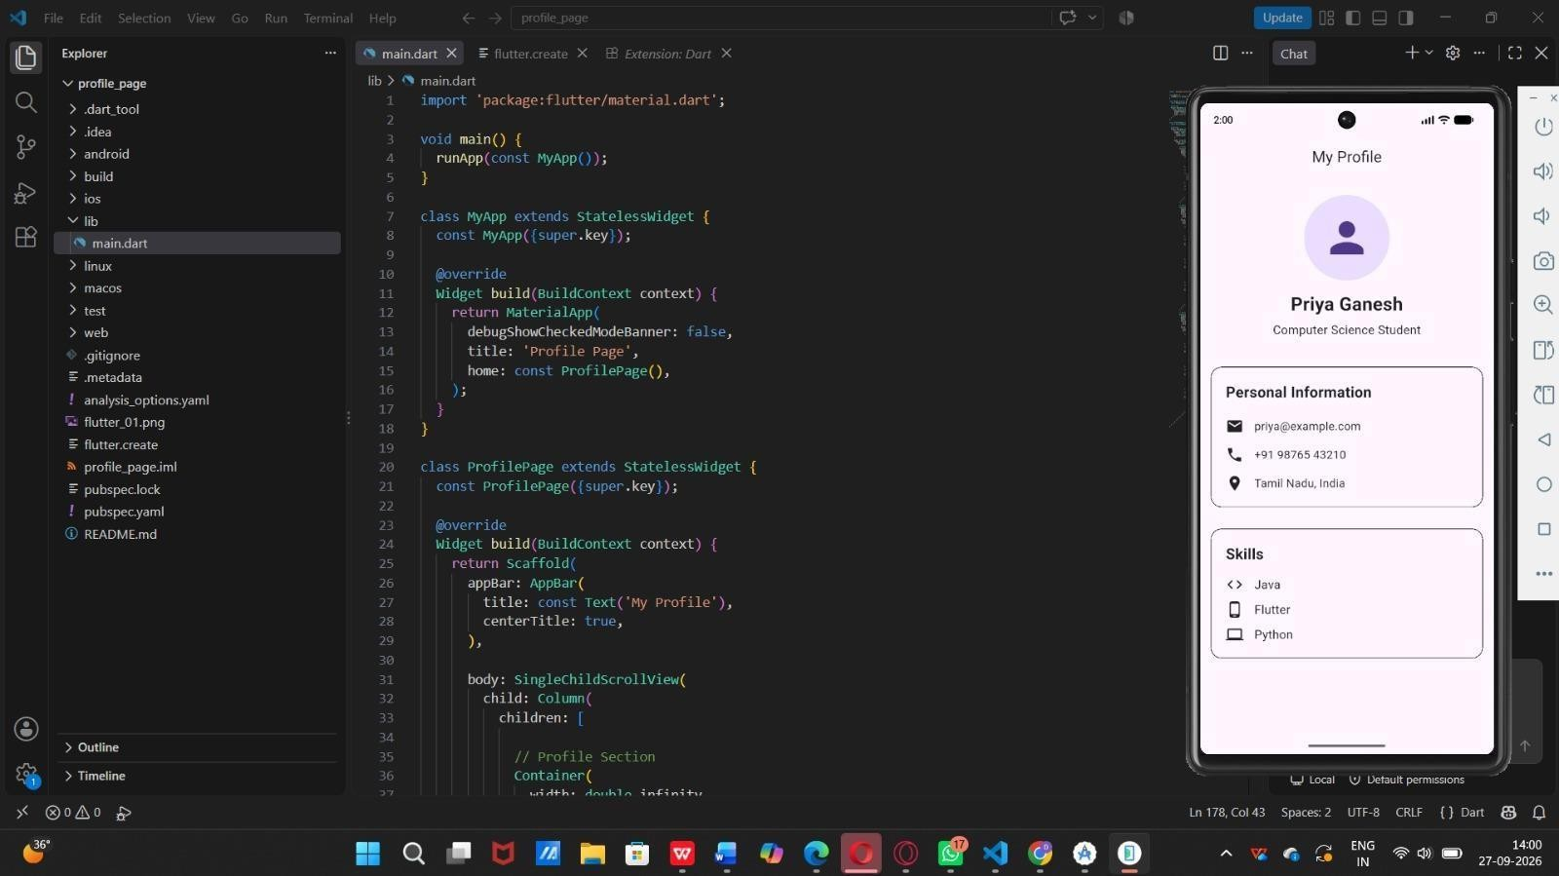

RESULT:

The Flutter application was successfully created and executed. Using StatelessWidget, along with Column, Row, Container, Icon, and Text widgets, a complete Profile Page UI was designed, displaying the profile picture, name, role, personal information (email, phone, location), and skills (Java, Flutter, Python) sections correctly.

EX.NO:4.b DESIGN OF PROFILE PAGE USING ROW, COLUMN AND DATE: CONTAINER

AIM:

To design and develop a mobile application "profile page" using flutter framework that displays user personal information (name, designation, email, phone number, address) and skills using widgets such as scaffold, appbar, container, column, and singlechildscrollview.

THEORY:

Flutter is an open-source UI software development toolkit created by Google, used to build natively compiled applications for mobile, web, and desktop from a single codebase, using the Dart programming language.

Key concepts used in this program:

StatelessWidget: A widget that describes part of the user interface which does not depend on any mutable state — once built, it does not change. Both MyApp and ProfilePage are implemented as StatelessWidget.

MaterialApp: The root widget that implements Material Design and provides navigation, theming, and other app-level configuration.

Scaffold: Provides the basic visual structure of the screen — app bar, body, background color, etc.

AppBar: Displays a title bar at the top of the screen (here showing "My Profile"). SingleChildScrollView: Allows the body content to be scrollable when it exceeds the screen height. Column: Arranges child widgets vertically.
Container: A convenience widget used for styling, padding, margin, and decoration (used here to build the "Personal Information" and "Skills" card sections).

CircleAvatar / Icon widgets: Used to display the profile picture placeholder and icons next to contact details (email, phone, location) and skills (Java, Flutter, Python).

This app demonstrates the basic building blocks of Flutter UI design — widget composition, nesting, and Material Design styling — to create a static profile display screen.

PROCEDURE:

- Install Flutter SDK and set up the development environment (VS Code with Flutter and Dart extensions).

- Create a new Flutter project using the command:

flutter create profile_page

- Open the project in VS Code and navigate to lib/main.dart.

- Import the Material package:

dart

import 'package:flutter/material.dart';

- Define the main() function to run the app using runApp(const MyApp()).

- Create the MyApp class extending StatelessWidget, and inside its build() method, return a MaterialApp widget with title, debugShowCheckedModeBanner: false, and home: const ProfilePage().

- Create the ProfilePage class extending StatelessWidget.

- Inside its build() method, return a Scaffold widget containing:

  - An AppBar with the title "My Profile".

  - A SingleChildScrollView as the body, wrapping a Column of widgets.

- Inside the Column, add:

  - A profile picture section (circular avatar icon), name ("Priya Ganesh"), and designation ("Computer Science Student").

  - A "Personal Information" card Container listing email, phone number, and location with corresponding icons.

  - A "Skills" card Container listing skills (Java, Flutter, Python) with corresponding icons.

- Save the file and run the application using:

flutter run or use the built-in emulator/device preview in VS Code.

- Observe the output on the simulator/emulator screen.

PROGRAM:

import 'package:flutter/material.dart'; void main() {
runApp(const MyApp());

}

class MyApp extends StatelessWidget { const MyApp({super.key});
@override

Widget build(BuildContext context) { return MaterialApp( debugShowCheckedModeBanner: false, title: 'Profile Page',
home: const ProfilePage(),

);

}

}

class ProfilePage extends StatelessWidget { const ProfilePage({super.key});
@override

Widget build(BuildContext context) { return Scaffold(
appBar: AppBar(

title: const Text('My Profile'), centerTitle: true,
),

body: SingleChildScrollView( child: Column(
children: [

// Profile Section Container(
width: double.infinity,

padding: const EdgeInsets.all(25), child: Column(
children: [

const CircleAvatar( radius: 60,
child: Icon(

Icons.person, size: 70,
),

),

const SizedBox(height: 15), const Text(
'Priya Ganesh', style: TextStyle( fontSize: 26,
fontWeight: FontWeight.bold,

),

),

const SizedBox(height: 5), const Text(
'Computer Science Student', style: TextStyle(
fontSize: 17,

),

),

],

),

),

// Personal Information Container(
margin: const EdgeInsets.all(15), padding: const EdgeInsets.all(20), width: double.infinity, decoration: BoxDecoration( border: Border.all(),
borderRadius: BorderRadius.circular(15),

),

child: Column(

crossAxisAlignment: CrossAxisAlignment.start, children: [
const Text(

'Personal Information', style: TextStyle( fontSize: 21,
fontWeight: FontWeight.bold,

),

),

const SizedBox(height: 20),

// Email Row Row(

children: const [ Icon(Icons.email, size: 25),
SizedBox(width: 15), Text( 'priya@example.com',
style: TextStyle(fontSize: 16),

),

],

),

const SizedBox(height: 15),

// Phone Row Row(
children: const [ Icon(Icons.phone, size: 25),
SizedBox(width: 15), Text(
'+91 98765 43210',

style: TextStyle(fontSize: 16),

),

],

),

const SizedBox(height: 15),

// Location Row Row(
children: const [ Icon(Icons.location_on, size: 25),
SizedBox(width: 15), Text(
'Tamil Nadu, India',

style: TextStyle(fontSize: 16),

),

],

),

],

),

),

// Skills Section Container(
margin: const EdgeInsets.all(15), padding: const EdgeInsets.all(20), width: double.infinity, decoration: BoxDecoration( border: Border.all(),
borderRadius: BorderRadius.circular(15),

),

child: Column(

crossAxisAlignment: CrossAxisAlignment.start, children: [
const Text( 'Skills',
style: TextStyle( fontSize: 21,
fontWeight: FontWeight.bold,

),

),

const SizedBox(height: 15),

// Java Row Row(
children: const [ Icon(Icons.code, size: 25),
SizedBox(width: 15), Text(
'Java',

style: TextStyle(fontSize: 17),

),

],

),

const SizedBox(height: 10),

// Flutter Row Row(
children: const [ Icon(Icons.phone_android, size: 25),
SizedBox(width: 15), Text(
'Flutter',

style: TextStyle(fontSize: 17),

),

],

),

const SizedBox(height: 10),

// Python Row Row(
children: const [ Icon(Icons.computer, size: 25),
SizedBox(width: 15), Text(
'Python',

style: TextStyle(fontSize: 17),

), ], ), ], ), ), ], ), ), ); } }

const SizedBox(height: 20),

// Name const Text(
'Dharshini Priya', style: TextStyle( fontSize: 26,
fontWeight: FontWeight.bold,

),

),

const SizedBox(height: 10),

// Course const Text(
'Computer Science Student', style: TextStyle(
fontSize: 18,

),

),

const SizedBox(height: 25),

// Email Row(
mainAxisAlignment: MainAxisAlignment.center,

children: const [ Icon( Icons.email, size: 25,
),

SizedBox(width: 10), Text( 'dharshini@example.com', style: TextStyle( fontSize: 16,
),

),

],

),

const SizedBox(height: 15),

// Phone Row(
mainAxisAlignment: MainAxisAlignment.center, children: const [
Icon( Icons.phone, size: 25,

),

SizedBox(width: 10), Text(
'+91 98765 43210',

style: TextStyle( fontSize: 16,
),

),

],

),

const SizedBox(height: 25),

// Location Row(
mainAxisAlignment: MainAxisAlignment.center, children: const [
Icon( Icons.location_on, size: 25,
),

SizedBox(width: 10), Text(
'Tamil Nadu, India',

style: TextStyle( fontSize: 16,
), ),], ),], ), ), ); } }

RESULT:

The Flutter application was successfully designed and executed. The "My Profile" screen was displayed on the emulator showing the user's name, designation, profile picture placeholder, personal information (email, phone, address), and skill set (Java, Flutter, Python), confirming that the widget tree was built and rendered correctly without errors.

EX.NO:5.a INTERACTIVE UI DEVELOPMENT – LOGIN SCREEN DATE:

AIM:

To design and implement a Flutter application that creates an interactive Student Registration form, demonstrating the use of TextFormField, DropdownButton, form validation, and event handling using onPressed callbacks, setState(), and SnackBar notifications

THEORY:

A login screen is one of the most common UI patterns in mobile applications, requiring text input, basic validation, and user feedback. This program demonstrates several important Flutter concepts:

TextField vs TextFormField: Unlike TextFormField (which is used with a Form widget and validators), this program uses plain TextField widgets with manual, logic-based validation performed inside the login() method rather than a Form.

TextEditingController: Used to read and manage the current text of the Email and Password fields (emailController, passwordController).

Password Visibility Toggle: The boolean state variable hidePassword controls the obscureText property of the password field. An IconButton in the suffixIcon toggles this boolean using setState(), switching the icon between Icons.visibility and Icons.visibility_off and revealing/hiding the password text.

Manual Validation Logic: Instead of validators, the login() method directly checks if (emailController.text.isEmpty || passwordController.text.isEmpty). If either field is empty,

an error SnackBar is shown; otherwise, a success SnackBar ("Login Successful!") is displayed.

SnackBar for Feedback: ScaffoldMessenger.of(context).showSnackBar() is used three times in this app
— for empty-field warning, for the "Forgot Password" tap, and for successful login — showing how SnackBars provide lightweight, non-blocking user feedback.

UI Styling: A Card widget with elevation and rounded corners holds all the form elements, placed over a gradient-colored background Container, giving the login screen a polished, modern look.

PROCEDURE:

- Create a new Flutter project and open the main Dart file.

- Import the Material package: import 'package:flutter/material.dart';

- Define main() to run MyApp.

- Create a StatelessWidget (MyApp) that sets up MaterialApp with home: LoginPage().

- Create a StatefulWidget (LoginPage) along with its _LoginPageState.

- Declare TextEditingControllers for the Email and Password fields.

- Declare a boolean state variable hidePassword = true to control password obscuring.

- Write the login() method:

  - Check if emailController.text or passwordController.text is empty.

  - If empty, show a SnackBar prompting the user to enter both fields.

  - Otherwise, show a SnackBar confirming "Login Successful!".

- In build(), design the UI with a Scaffold and a gradient-colored background Container.

- Place a Card widget at the center containing all form elements, using SingleChildScrollView to handle overflow on smaller screens.

- Add a circular icon container with a lock icon at the top.

- Add title text ("Welcome Back!") and subtitle text ("Login to your account").

- Add a TextField for Email with an email icon prefix.

- Add a TextField for Password with a lock icon prefix and a visibility-toggle IconButton as suffix, linked to hidePassword and setState().

- Add a "Forgot Password?" TextButton aligned to the right, showing a SnackBar when tapped.

- Add a LOGIN button (ElevatedButton) that calls the login() method.

- Add a footer text ("Welcome to our application").

- Run the app using flutter run, enter email and password, and tap the LOGIN button.

- Observe the SnackBar feedback and test the password visibility toggle.

PROGRAM:

import 'package:flutter/material.dart'; void main() { runApp(const MyApp()); }
class MyApp extends StatelessWidget { const MyApp({super.key}); @override Widget build(BuildContext context) {
return MaterialApp( debugShowCheckedModeBanner: false, title: 'Login Screen', home: const LoginPage(), ); } }

class LoginPage extends StatefulWidget { const LoginPage({super.key}); @override State<LoginPage> createState() => _LoginPageState(); }
class _LoginPageState extends State<LoginPage> { final TextEditingController emailController = TextEditingController(); final TextEditingController passwordController = TextEditingController();

bool hidePassword = true;

void login() { if (emailController.text.isEmpty || passwordController.text.isEmpty) { ScaffoldMessenger.of(context).showSnackBar( const SnackBar( content: Text('Please enter email and password'), ), ); } else { ScaffoldMessenger.of(context).showSnackBar( const SnackBar( content: Text('Login Successful!'),

), ); } }

@override Widget build(BuildContext context) { return Scaffold( body: Container( width: double.infinity, height: double.infinity,

decoration: const BoxDecoration( gradient: LinearGradient(
begin: Alignment.topLeft, end: Alignment.bottomRight, colors: [ Color(0xFF6A11CB), Color(0xFF2575FC),
],

),

),

child: Center(

child: SingleChildScrollView( padding: const EdgeInsets.all(25), child: Card(
elevation: 12,

shape: RoundedRectangleBorder( borderRadius: BorderRadius.circular(25),
),

child: Padding(

padding: const EdgeInsets.all(30), child: Column(
children: [

// Login Icon Container(
padding: const EdgeInsets.all(18), decoration: BoxDecoration( color: const Color(0xFFEDE7F6), shape: BoxShape.circle,
),

child: const Icon( Icons.lock_person, size: 65,
color: Color(0xFF6A11CB),

),

),

const SizedBox(height: 20),

// Title const Text(
'Welcome Back!', style: TextStyle( fontSize: 30,
fontWeight: FontWeight.bold, color: Color(0xFF333333),
),

),

const SizedBox(height: 8), const Text(
'Login to your account', style: TextStyle( fontSize: 16,
color: Colors.grey,

),

),

const SizedBox(height: 30),

// Email TextField(
controller: emailController,

keyboardType: TextInputType.emailAddress, decoration: InputDecoration(
labelText: 'Email', hintText: 'Enter your email', prefixIcon: const Icon( Icons.email,
color: Color(0xFF6A11CB),

),

filled: true,

fillColor: const Color(0xFFF5F3FF), border: OutlineInputBorder( borderRadius: BorderRadius.circular(15), borderSide: BorderSide.none,
),

),

),

const SizedBox(height: 20),

// Password TextField(
controller: passwordController, obscureText: hidePassword, decoration: InputDecoration( labelText: 'Password', hintText: 'Enter your password', prefixIcon: const Icon( Icons.lock,
color: Color(0xFF6A11CB),

),

suffixIcon: IconButton( icon: Icon( hidePassword

? Icons.visibility

: Icons.visibility_off,

color: const Color(0xFF6A11CB),

),

onPressed: () {

setState(() {

hidePassword = !hidePassword;

});

},

),

filled: true,

fillColor: const Color(0xFFF5F3FF), border: OutlineInputBorder( borderRadius: BorderRadius.circular(15), borderSide: BorderSide.none,
),

),

),

const SizedBox(height: 15),

// Forgot Password Align(
alignment: Alignment.centerRight,

child: TextButton( onPressed: () {
ScaffoldMessenger.of(context).showSnackBar( const SnackBar(
content: Text(

'Forgot Password selected',

),

),

);

},

child: const Text( 'Forgot Password?', style: TextStyle(
color: Color(0xFF6A11CB),

),

),

),

),

const SizedBox(height: 15),

// Login Button SizedBox(
width: double.infinity,

height: 55,

child: ElevatedButton( onPressed: login,
style: ElevatedButton.styleFrom( backgroundColor: const Color(0xFF6A11CB), foregroundColor: Colors.white,
shape: RoundedRectangleBorder( borderRadius: BorderRadius.circular(15),
),

elevation: 5,

),

child: const Text( 'LOGIN',
style: TextStyle( fontSize: 18,
fontWeight: FontWeight.bold,

),

),

),

),

const SizedBox(height: 20), const Text(

'Welcome to our application', style: TextStyle(
color: Colors.grey, fontSize: 14,
), ), ], ), ), ), ), ), ),); } }

OUTPUT:
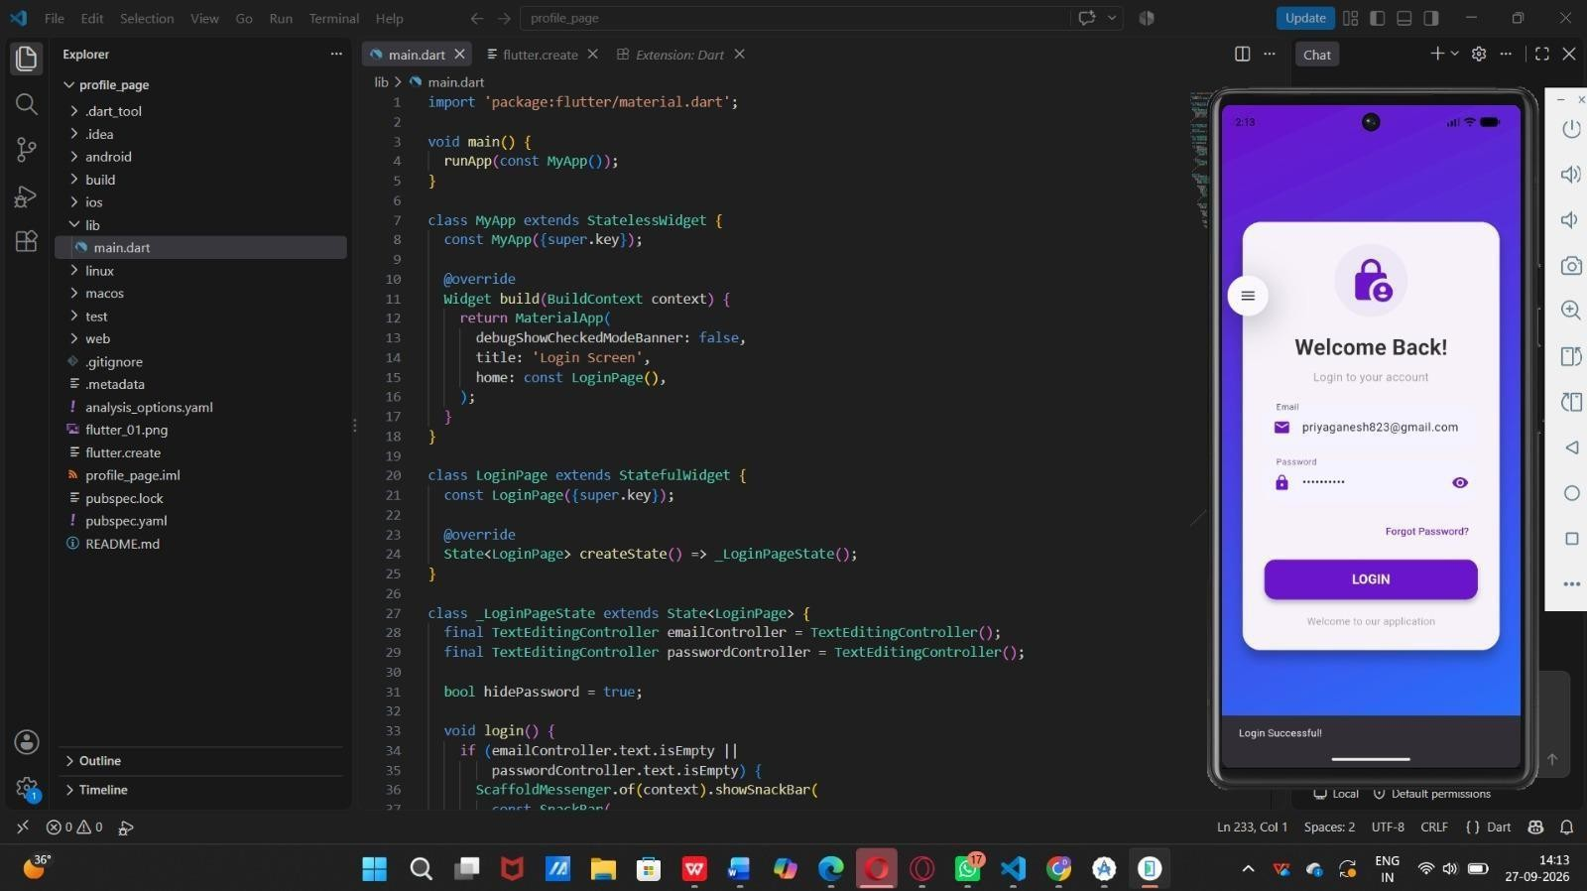

RESULT:

The Flutter Login Screen application was successfully executed. On entering a valid email ("priyaganesh823@gmail.com") and a password, tapping the LOGIN button triggered the login() method, which verified that both fields were non-empty and displayed a SnackBar with the message "Login Successful!" at the bottom of the screen, as seen in the output. The password visibility toggle (eye icon) also worked correctly, allowing the user to show or hide the entered password. This confirms that input handling, conditional validation, and state-based UI updates in Flutter were implemented and successfully verified.

EX.NO:5.b INTERACTIVE UI DEVELOPMENT - REGISTRATION FORM DATE:

AIM:

To design and implement a Flutter application that creates an interactive Student Registration form, demonstrating the use of TextFormField, DropdownButton, form validation, and event handling using onPressed callbacks, setState(), and SnackBar notifications.

THEORY:

Flutter's Form widget provides a convenient way to group multiple form fields and validate them together. It works with a GlobalKey<FormState> which is used to access the form's current state, trigger validation, and retrieve field values.

Key concepts used in this program:

Form & GlobalKey: The Form widget wraps all input fields, and _formKey allows access to methods like validate() to check whether all fields meet their validation criteria.

TextFormField: Used for taking text input (Name, Email). Each field has a controller (to read/manage its value) and a validator function that returns an error message if the input is invalid, or null if valid.

TextEditingController: Manages and retrieves the text entered by the user in a TextFormField. It can also be used to clear the field, as done in the Reset button.

DropdownButton: Displays a list of selectable options (Flutter, Java, Python) for choosing a course. Its onChanged callback updates the selected value using setState().

Event Handling: The SUBMIT button's onPressed calls submitForm(), which first validates the form. If valid, it updates the message variable inside setState() to rebuild the UI with a personalized welcome message, and simultaneously shows a SnackBar confirming successful submission.

State Management with setState(): Any time a variable used in the widget tree changes (message, course), setState() is called to notify Flutter to rebuild the widget with updated values.

SnackBar: A temporary message displayed at the bottom of the screen using ScaffoldMessenger.of(context).showSnackBar(), useful for giving user feedback without disrupting the UI flow.

PROCEDURE:

- Create a new Flutter project and open the main Dart file.

- Import the Material package: import 'package:flutter/material.dart';

- Define main() to run MyApp.

- Create a StatelessWidget (MyApp) that sets up MaterialApp with home: InteractivePage().

- Create a StatefulWidget (InteractivePage) along with its _InteractivePageState.

- Declare a GlobalKey<FormState> (_formKey) to manage form validation.

- Declare TextEditingControllers for the Name and Email fields.

- Declare state variables: course (default 'Flutter') and message (default prompt text).

- Write the submitForm() method:

  - Call _formKey.currentState!.validate() to check all validators.

  - If valid, update message inside setState() using the entered name and selected course.

  - Show a green SnackBar confirming successful submission.

- In build(), design the UI with a Scaffold, AppBar, and gradient-decorated background Container.

- Wrap the form fields in a Form widget using _formKey.

- Add a TextFormField for Student Name with a validator checking for empty input.

- Add a TextFormField for Email with a validator checking for empty input.

- Add a DropdownButton<String> for course selection with three options (Flutter, Java, Python), updating course on change.

- Add a SUBMIT button (ElevatedButton) that calls submitForm().

- Add a RESET button (OutlinedButton) that clears both controllers and resets course and message to their default values.

- Display the message in a styled purple result Container below the form.

- Run the app using flutter run, enter a name and email, select a course, and tap Submit.

- Observe the Welcome message update and the SnackBar appear at the bottom.

PROGRAM:

import 'package:flutter/material.dart'; void main() {
runApp(const MyApp());

}

class MyApp extends StatelessWidget { const MyApp({super.key});
@override

Widget build(BuildContext context) { return MaterialApp( debugShowCheckedModeBanner: false, title: 'Buttons and Event Handling', home: const ButtonPage(),
);

}

}

class ButtonPage extends StatefulWidget { const ButtonPage({super.key});

@override

State<ButtonPage> createState() => _ButtonPageState();

}

class _ButtonPageState extends State<ButtonPage> { String message = 'Press a button';
void showMessage(String text) { setState(() {
message = text;

});

}

@override

Widget build(BuildContext context) { return Scaffold(
appBar: AppBar(

title: const Text('Buttons & Event Handling'), centerTitle: true,
backgroundColor: Colors.deepPurple, foregroundColor: Colors.white,
),

body: Container( width: double.infinity,
decoration: const BoxDecoration(

gradient: LinearGradient( colors: [ Color(0xFFEDE7F6), Color(0xFFE3F2FD),
],

begin: Alignment.topCenter, end: Alignment.bottomCenter,
),

),

child: Center( child: Padding(
padding: const EdgeInsets.all(25), child: Column(
mainAxisAlignment: MainAxisAlignment.center, children: [
const Icon( Icons.touch_app, size: 80,
color: Colors.deepPurple,

),

const SizedBox(height: 20), const Text(

'Button Event Handling', style: TextStyle( fontSize: 25,
fontWeight: FontWeight.bold, color: Colors.deepPurple,
),

),

const SizedBox(height: 20), Container(
padding: const EdgeInsets.all(20), width: double.infinity, decoration: BoxDecoration( color: Colors.white,
borderRadius: BorderRadius.circular(20), boxShadow: const [
BoxShadow( blurRadius: 10,
color: Colors.black26,

),

],

),

child: Text(

message,

textAlign: TextAlign.center, style: const TextStyle( fontSize: 20,
fontWeight: FontWeight.bold,

),

),

),

const SizedBox(height: 30),

// Elevated Button SizedBox(
width: double.infinity, height: 50,
child: ElevatedButton( onPressed: () {
showMessage('Elevated Button Pressed!');

},

style: ElevatedButton.styleFrom( backgroundColor: Colors.deepPurple, foregroundColor: Colors.white,
),

child: const Text(

'Elevated Button',

style: TextStyle(fontSize: 17),

),

),

),

const SizedBox(height: 15),

// Text Button TextButton( onPressed: () {
showMessage('Text Button Pressed!');

},

child: const Text( 'Text Button',
style: TextStyle(fontSize: 17),

),

),

const SizedBox(height: 10),

// Icon Button IconButton( onPressed: () {
showMessage('Icon Button Pressed!');

},

icon: const Icon( Icons.favorite, color: Colors.red, size: 40,
),

),

const SizedBox(height: 10),

// Outlined Button OutlinedButton( onPressed: () {
showMessage('Outlined Button Pressed!');

},

child: const Text( 'Outlined Button',
style: TextStyle(fontSize: 17),

),

),

const SizedBox(height: 15),

// Reset Button ElevatedButton( onPressed: () {
showMessage('Press a button'); }, style: ElevatedButton.styleFrom(

backgroundColor: Colors.orange, foregroundColor: Colors.white,
), child: const Text('RESET'),

), ], ), ), ), ), ); } }

OUTPUT:
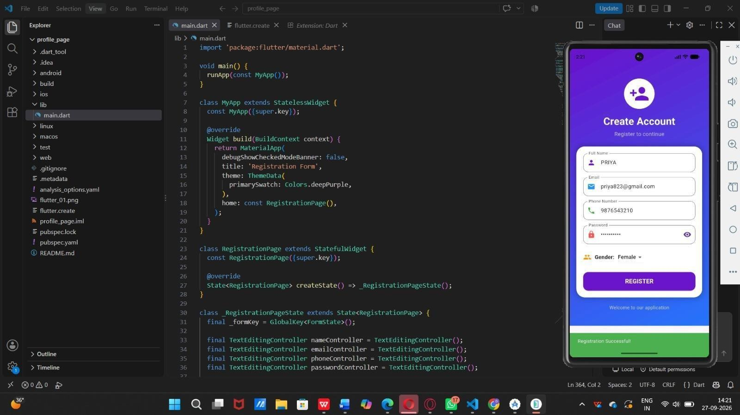

RESULT:

The Flutter application was successfully executed. On entering valid Student Name ("priya") and Email ("priya823@gmail.com") and selecting the Course ("Flutter"), tapping the SUBMIT button triggered form validation, updated the result container to display "Welcome priya! Course: Flutter", and showed a green SnackBar stating "Form submitted successfully!" at the bottom of the screen. This confirms that form validation, state management, and event handling in Flutter were implemented and working correctly.

EX.NO: 6.a IMPLEMENT BUTTONS AND EVENT HANDLING DATE:

AIM:

To design and implement a Flutter application that demonstrates different types of buttons (Elevated Button, Text Button, Icon Button, Outlined Button) and handle button press events using the onPressed callback and setState() to dynamically update the UI.

THEORY:

Flutter provides several pre-built button widgets, each suited to different UI emphasis levels: ElevatedButton – A raised button with a filled background, used for primary/main actions. TextButton – A flat button with no elevation, typically used for less prominent actions.
IconButton – A button that displays only an icon, commonly used for compact actions like favorite, delete, share.

OutlinedButton – A button with a border and transparent background, used for secondary actions.

Event Handling in Flutter: Every button widget has an onPressed property that accepts a callback function. This function executes when the user taps the button. Since Flutter follows a reactive/declarative UI model, any change in the UI must be triggered through setState(), which tells the framework that the widget's state has changed and the build() method needs to be called again to reflect the update.

In this app, a StatefulWidget (ButtonPage) maintains a String message variable. Each button's onPressed callback calls a helper method showMessage(text), which updates message

inside setState(). This causes the UI to rebuild and display the updated message in a styled container.

PROCEDURE:

- Create a new Flutter project (or open an existing one).

- Import the Material package: import 'package:flutter/material.dart';

- Define the main() function to run MyApp.

- Create a StatelessWidget called MyApp that returns a MaterialApp, setting the home to ButtonPage.

- Create a StatefulWidget called ButtonPage with its corresponding _ButtonPageState.

- Declare a state variable String message = 'Press a button'; to hold the current status text.

- Write a method showMessage(String text) that updates message inside setState().

- In the build() method, design the UI using a Scaffold with an AppBar.

- Add a gradient-decorated Container as the body background.

- Place an Icon, a Text heading, and a message display Container inside a Column.

- Add four button widgets — ElevatedButton, TextButton, IconButton, and OutlinedButton — each with an onPressed callback calling showMessage() with a relevant string.

- Add a fifth ElevatedButton (styled differently) to act as a Reset button, restoring the message to its default value.

- Run the application on an emulator/device using flutter run.

- Tap each button one by one and observe the message container updating accordingly.

PROGRAM

import 'package:flutter/material.dart'; void main() {
runApp(const MyApp());

}

class MyApp extends StatelessWidget { const MyApp({super.key});
@override

Widget build(BuildContext context) { return MaterialApp(

debugShowCheckedModeBanner: false, title: 'Buttons and Event Handling', home: const ButtonPage(),
);

}

}

class ButtonPage extends StatefulWidget { const ButtonPage({super.key}); @override
State<ButtonPage> createState() => _ButtonPageState();

}

class _ButtonPageState extends State<ButtonPage> { String message = 'Press a button';
void showMessage(String text) { setState(() {
message = text;

});

}

@override

Widget build(BuildContext context) { return Scaffold(
appBar: AppBar(

title: const Text('Buttons & Event Handling'), centerTitle: true,
backgroundColor: Colors.deepPurple, foregroundColor: Colors.white,
),

body: Container( width: double.infinity,
decoration: const BoxDecoration( gradient: LinearGradient(
colors: [ Color(0xFFEDE7F6), Color(0xFFE3F2FD),
],

begin: Alignment.topCenter, end: Alignment.bottomCenter,
),

),

child: Center( child: Padding(
padding: const EdgeInsets.all(25), child: Column(
mainAxisAlignment: MainAxisAlignment.center,

children: [ const Icon(
Icons.touch_app, size: 80,
color: Colors.deepPurple,

),

const SizedBox(height: 20), const Text(
'Button Event Handling', style: TextStyle( fontSize: 25,
fontWeight: FontWeight.bold, color: Colors.deepPurple,
),

),

const SizedBox(height: 20), Container(
padding: const EdgeInsets.all(20), width: double.infinity, decoration: BoxDecoration( color: Colors.white,
borderRadius: BorderRadius.circular(20),

boxShadow: const [ BoxShadow( blurRadius: 10,
color: Colors.black26,

),

],

),

child: Text( message,
textAlign: TextAlign.center, style: const TextStyle( fontSize: 20,
fontWeight: FontWeight.bold,

),

),

),

const SizedBox(height: 30),

// Elevated Button SizedBox(
width: double.infinity, height: 50,
child: ElevatedButton(

onPressed: () {

showMessage('Elevated Button Pressed!');

},

style: ElevatedButton.styleFrom( backgroundColor: Colors.deepPurple, foregroundColor: Colors.white,
),

child: const Text( 'Elevated Button',
style: TextStyle(fontSize: 17),

),

),

),

const SizedBox(height: 15),

// Text Button TextButton( onPressed: () {
showMessage('Text Button Pressed!');

},

child: const Text( 'Text Button',
style: TextStyle(fontSize: 17),

),

),

const SizedBox(height: 10),

// Icon Button IconButton( onPressed: () {
showMessage('Icon Button Pressed!');

},

icon: const Icon( Icons.favorite, color: Colors.red, size: 40,
),

),

const SizedBox(height: 10),

// Outlined Button OutlinedButton( onPressed: () {
showMessage('Outlined Button Pressed!');

},

child: const Text( 'Outlined Button',

style: TextStyle(fontSize: 17),

),

),

const SizedBox(height: 15),

// Reset Button ElevatedButton( onPressed: () {
showMessage('Press a button');

},

style: ElevatedButton.styleFrom( backgroundColor: Colors.orange, foregroundColor: Colors.white,
),

child: const Text('RESET'),

), ], ), ), ), ), ); } }

OUTPUT:
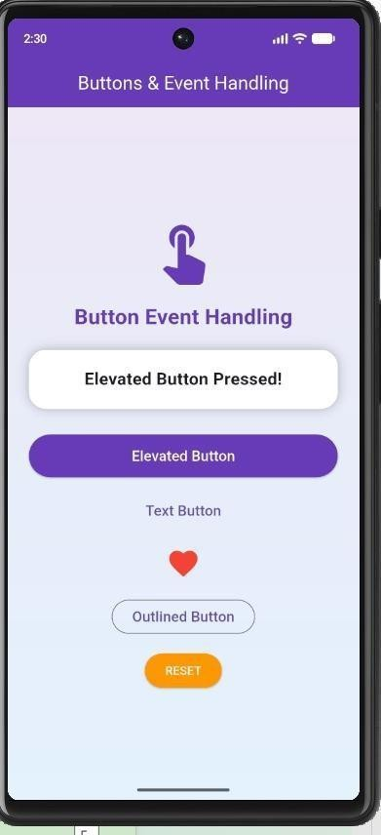

RESULT:

The Flutter application was successfully executed. On tapping each button (Elevated, Text, Icon, Outlined), the corresponding message was displayed dynamically in the message container using setState(), confirming that button event handling works correctly. The Reset button successfully restored the default message ("Press a button"), verifying that state management and UI re-rendering function as expected.

EX.NO:6.b DEVELOP AN INTERACTIVE UI INTEGRATING WIDGETS, DATE: LAYOUTS, FORMS AND EVENT HANDLING

AIM:

To design and develop an interactive mobile user interface in Flutter that accepts student details (name, email, course) through a validated form and displays the submitted result on screen using event handling and state management.

THEORY:

Flutter is Google's open-source UI toolkit that uses the Dart language to build natively compiled applications for mobile, web and desktop from a single codebase. Everything in Flutter is a widget.

Key concepts used in this program:

- StatelessWidget and StatefulWidget

  - MyApp is a StatelessWidget because it never changes.

  - InteractivePage is a StatefulWidget because its data (course, message) changes at runtime. The setState() method tells Flutter to rebuild the UI when data changes.

- MaterialApp and Scaffold

  - MaterialApp is the root widget that provides Material Design styling.

  - Scaffold gives the basic page structure (AppBar, body).

- Layout widgets

  - Column and Row arrange widgets vertically and horizontally.

  - Container provides padding, colour, border radius and shadow.

  - SizedBox adds spacing.

  - SingleChildScrollView makes the page scrollable so that the keyboard does not cause overflow.

- Form and TextFormField

  - Form with a GlobalKey<FormState> groups the input fields and allows validation.

  - TextFormField takes user input, and the validator property checks that fields are not empty.

  - TextEditingController reads and clears the text in the fields.

- DropdownButton: lets the user choose one course from a list (Flutter, Java, Python).

- Buttons: ElevatedButton (Submit) and OutlinedButton (Reset) trigger events through onPressed.

- Event handling and feedback: on a successful submit, the message text is updated with setState(), and a SnackBar shows a confirmation through ScaffoldMessenger.

- Styling: a LinearGradient background, BoxShadow, rounded corners and icons make the UI attractive.

PROCEDURE:

- Install Flutter SDK and Android Studio (or VS Code) and set up an emulator or physical device.

- Create a new project using the command:

flutter create interactive_ui

- Open the project and replace the content of lib/main.dart with the program code.

- In main(), call runApp(const MyApp()) to start the app.

- Create MyApp (StatelessWidget) returning a MaterialApp with InteractivePage as home.

- Create InteractivePage (StatefulWidget) and declare the form key, the controllers for name and email, and the variables course and message.

- Build the UI in the build() method:

  - AppBar titled "Interactive UI".

  - Gradient background container with a scroll view.

  - School icon and "Student Registration" heading.

  - A white card containing the Name field, Email field, Course dropdown, SUBMIT button and RESET button.

  - A purple container at the bottom to show the result message.

- Write submitForm() to validate the form; if valid, update message with setState() and show a green SnackBar.

- Write the Reset button's onPressed to clear the controllers and restore the default course and message.

- Run the app using:

flutter run

- Enter the name and email, select a course, and press SUBMIT to test. Then press RESET to test clearing.

PROGRAM :

import 'package:flutter/material.dart'; void main() {
runApp(const MyApp());

}

class MyApp extends StatelessWidget { const MyApp({super.key});
@override

Widget build(BuildContext context) { return MaterialApp( debugShowCheckedModeBanner: false,

title: 'Interactive UI',

home: const InteractivePage(),

);

}

}

class InteractivePage extends StatefulWidget { const InteractivePage({super.key}); @override
State<InteractivePage> createState() => _InteractivePageState();

}

class _InteractivePageState extends State<InteractivePage> { final _formKey = GlobalKey<FormState>();
final nameController = TextEditingController(); final emailController = TextEditingController(); String course = 'Flutter';
String message = 'Fill the form and press Submit'; void submitForm() {
if (_formKey.currentState!.validate()) { setState(() {
message = 'Welcome ${nameController.text}!\n' 'Course: $course';
});

ScaffoldMessenger.of(context).showSnackBar( const SnackBar(
content: Text('Form submitted successfully!'), backgroundColor: Colors.green,
),

);

}

}

@override

Widget build(BuildContext context) { return Scaffold(
appBar: AppBar(

title: const Text('Interactive UI'), centerTitle: true,
backgroundColor: Colors.deepPurple, foregroundColor: Colors.white,
),

body: Container(

decoration: const BoxDecoration( gradient: LinearGradient(
colors: [ Color(0xFFEDE7F6),

Color(0xFFE3F2FD),

],

begin: Alignment.topCenter, end: Alignment.bottomCenter,
),

),

child: SingleChildScrollView( padding: const EdgeInsets.all(20), child: Form(
key: _formKey, child: Column( children: [
// Widget const Icon( Icons.school, size: 80,
color: Colors.deepPurple,

),

const SizedBox(height: 10), const Text(
'Student Registration', style: TextStyle(

fontSize: 28,

fontWeight: FontWeight.bold, color: Colors.deepPurple,
),

),

const SizedBox(height: 20),

// Container - Layout Container(
padding: const EdgeInsets.all(20), decoration: BoxDecoration( color: Colors.white,
borderRadius: BorderRadius.circular(20), boxShadow: const [
BoxShadow( blurRadius: 10,
color: Colors.black26,

),

],

),

child: Column( children: [
// Name

TextFormField(

controller: nameController, decoration: InputDecoration( labelText: 'Student Name', prefixIcon: const Icon(Icons.person), border: OutlineInputBorder(
borderRadius: BorderRadius.circular(15),

),

),

validator: (value) {

if (value == null || value.isEmpty) { return 'Please enter your name';
}

return null;

},

),

const SizedBox(height: 15),

// Email TextFormField(
controller: emailController,

keyboardType: TextInputType.emailAddress, decoration: InputDecoration(

labelText: 'Email',

prefixIcon: const Icon(Icons.email), border: OutlineInputBorder( borderRadius: BorderRadius.circular(15),
),

),

validator: (value) {

if (value == null || value.isEmpty) { return 'Please enter your email';
}

return null;

},

),

const SizedBox(height: 15),

// Dropdown Row( children: [ const Icon( Icons.book,
color: Colors.deepPurple,

),

const SizedBox(width: 10),

const Text( 'Course:',
style: TextStyle( fontSize: 16,
fontWeight: FontWeight.bold,

),

),

const SizedBox(width: 10), DropdownButton<String>( value: course,
items: const [ DropdownMenuItem( value: 'Flutter',
child: Text('Flutter'),

),

DropdownMenuItem( value: 'Java',
child: Text('Java'),

),

DropdownMenuItem( value: 'Python', child: Text('Python'),

),

],

onChanged: (value) { setState(() {
course = value!;

});

},

),

],

),

const SizedBox(height: 20),

// Submit Button SizedBox(
width: double.infinity, height: 50,
child: ElevatedButton( onPressed: submitForm,
style: ElevatedButton.styleFrom( backgroundColor: Colors.deepPurple, foregroundColor: Colors.white, shape: RoundedRectangleBorder(
borderRadius: BorderRadius.circular(15),

),

),

child: const Text( 'SUBMIT',
style: TextStyle( fontSize: 18,
fontWeight: FontWeight.bold,

),

),

),

),

const SizedBox(height: 15),

// Reset Button OutlinedButton( onPressed: () {
setState(() { nameController.clear(); emailController.clear(); course = 'Flutter';
message = 'Fill the form and press Submit';

});

},

child: const Text('RESET'),

),

],

),

),

const SizedBox(height: 20),

// Event result Container(
width: double.infinity,

padding: const EdgeInsets.all(20), decoration: BoxDecoration( color: Colors.deepPurple,
borderRadius: BorderRadius.circular(20),

),

child: Text( message,
textAlign: TextAlign.center, style: const TextStyle( color: Colors.white, fontSize: 18,
fontWeight: FontWeight.bold,

), ), ), ], ), ), ), ), ); } } ),), ), ), ); } }

OUTPUT:
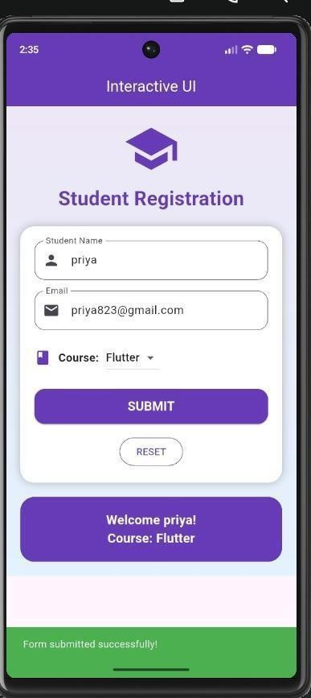

RESULT:

The application ran successfully on the Android emulator. The screen displays the "Student Registration" form. When the name "priya", the email "priya823@gmail.com" and the course "Flutter" were entered and SUBMIT was pressed: The result box showed "Welcome priya! Course: Flutter" and “A green SnackBar displayed "Form submitted successfully!".

EX.NO: 7.a MULTI-SCREEN APPLICATION DEVELOPMENT DATE:

AIM:

To develop a Flutter application with multiple screens and implement navigation between the screens.

SOFTWARE REQUIRED:

- Flutter SDK
- Android Studio / VS Code

PROCEDURE:

STEP 1: Create a new Flutter project and create multiple screens such as Home Screen and Second Screen.
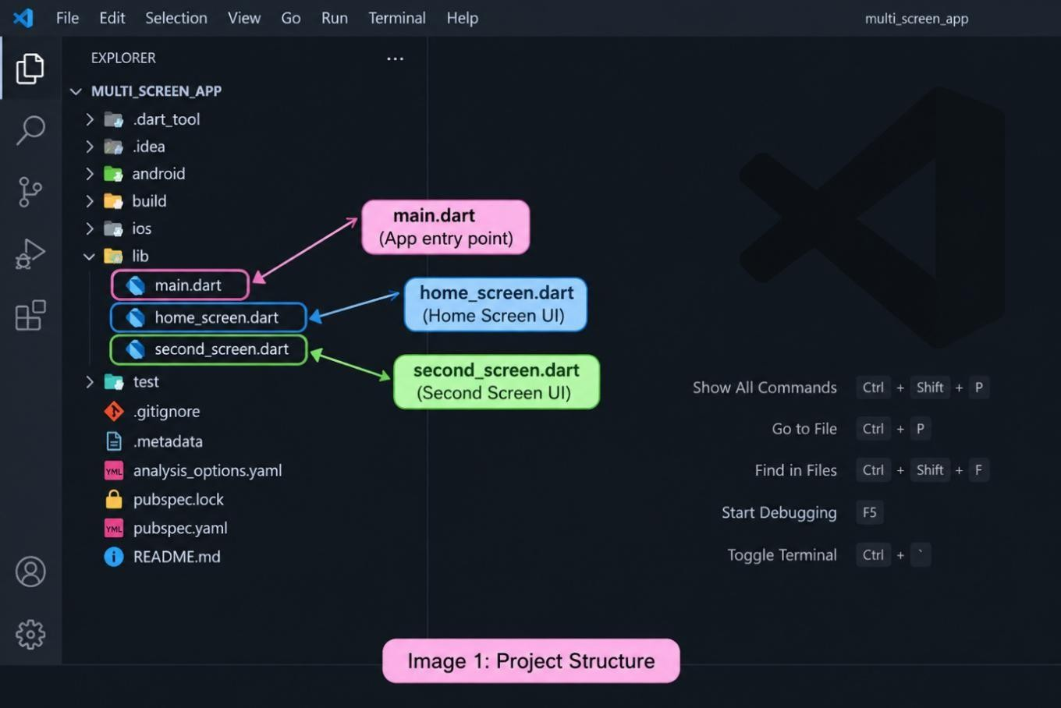

STEP 2: Design the Home Screen with a title and a button to navigate to the next screen.

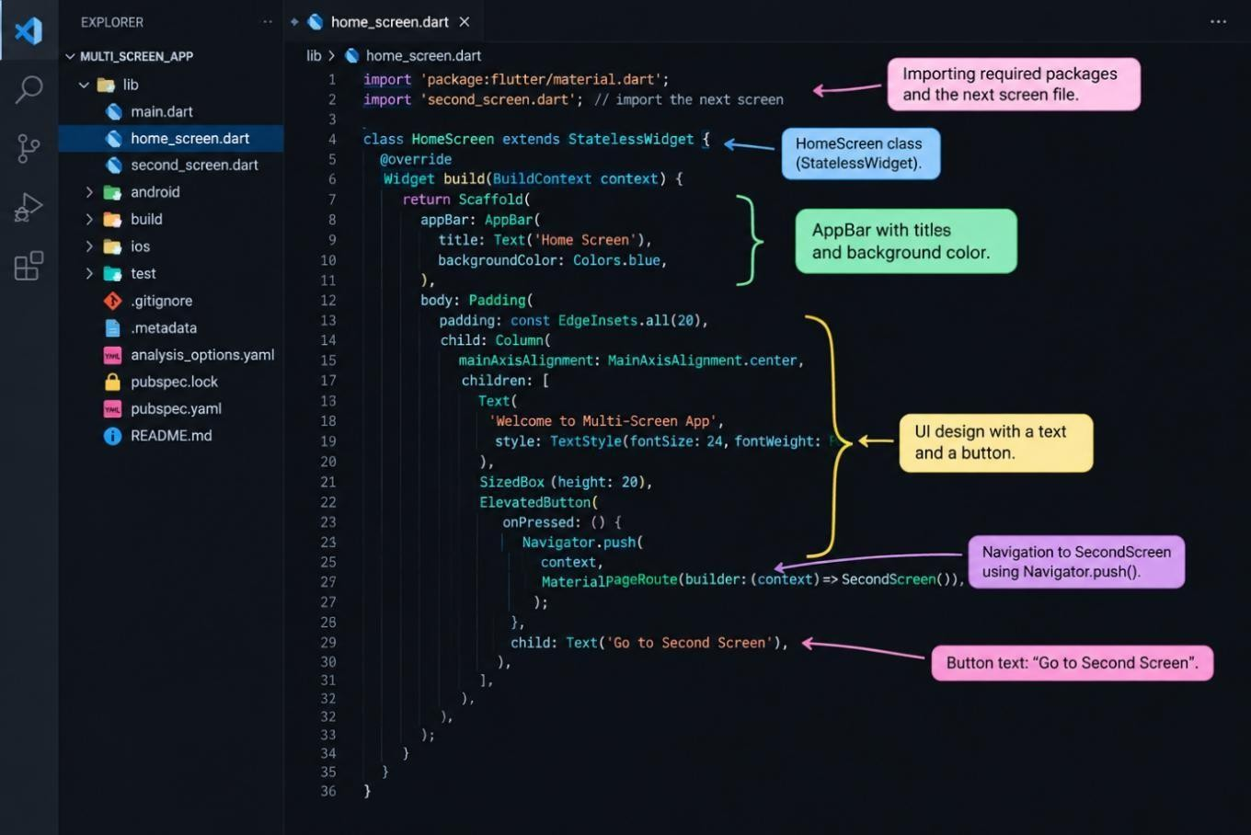

STEP 3: Implement navigation from the Home Screen to the Second Screen using Navigator.push().
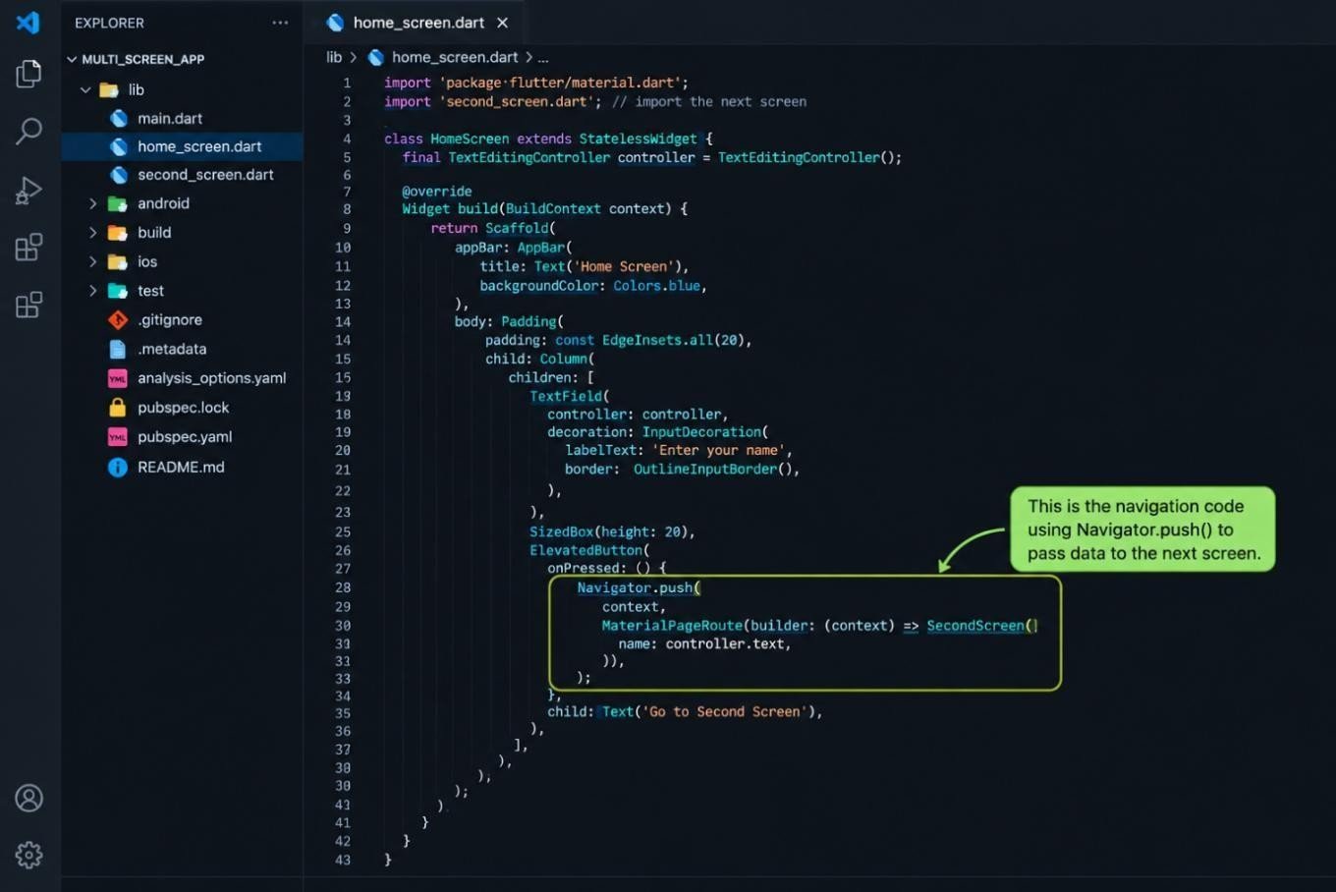

STEP 4: Run the application and verify that the user can move from the Home Screen to the Second Screen.

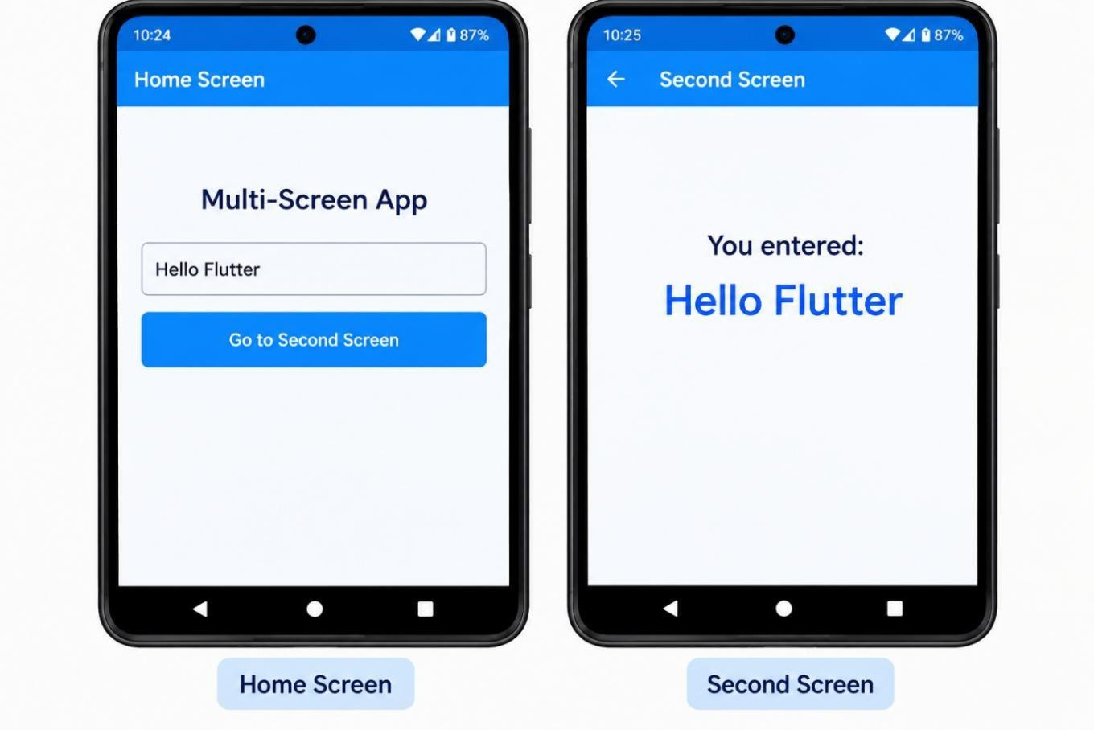

PROGRAM:

import 'package:flutter/material.dart' void main() {
runApp(MyApp());

}

class MyApp extends StatelessWidget { @override
Widget build(BuildContext context) { return MaterialApp( debugShowCheckedModeBanner: false,

home: HomeScreen(),

);

}

}

class HomeScreen extends StatelessWidget { @override
Widget build(BuildContext context) { return Scaffold(
appBar: AppBar(

title: Text('Home Screen'),

),

body: Center(

child: ElevatedButton( onPressed: () { Navigator.push(
context, MaterialPageRoute(
builder: (context) => SecondScreen(),

),

);

},

child: Text('Go to Second Screen'),

),

),

);

}

}

class SecondScreen extends StatelessWidget { @override
Widget build(BuildContext context) { return Scaffold(
appBar: AppBar(

title: Text('Second Screen'),

),

body: Center( child: Text(
'Welcome to Second Screen', style: TextStyle(fontSize: 22),
),),);}}

OUTPUT:

RESULT:

Thus, a Flutter application with multiple screens was successfully developed and navigation between the screens was implemented.

EX.NO:7.b IMPLEMENT NAVIGATION USING ROUTES AND NAMED ROUTES DATE:

AIM:

To develop a Flutter application that implements navigation between multiple screens using Routes and Named Routes.

SOFTWARE REQUIRED:

- Flutter SDK
- Android Studio / VS Code

PROCEDURE:

STEP 1: Create a new Flutter project and create two screens, such as Home Screen and Second Screen.
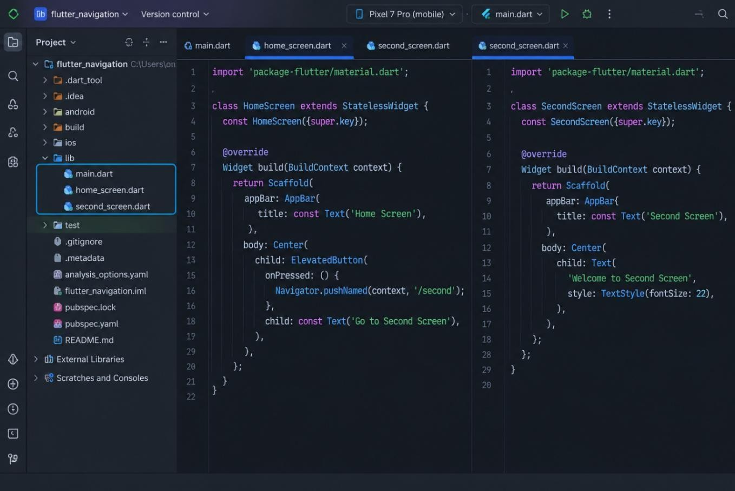

STEP 2: Create routes for the screens using MaterialApp and define the routes property.
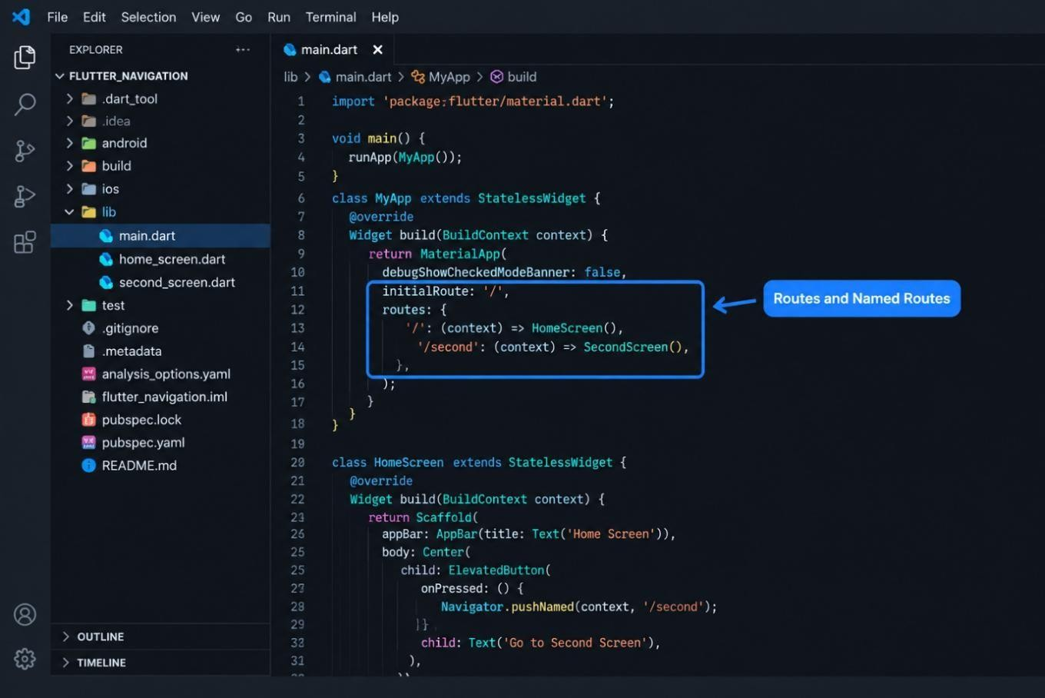

STEP 3: Add a button in the Home Screen and navigate to the Second Screen using Navigator.pushNamed().
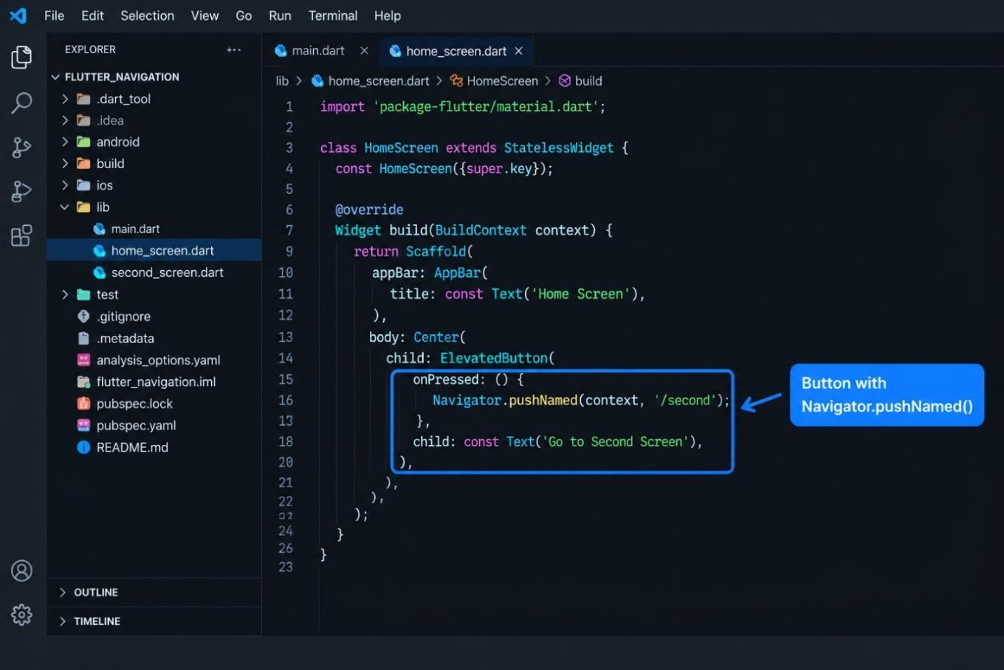

STEP 4: Run the application and click the button to verify that the navigation works.
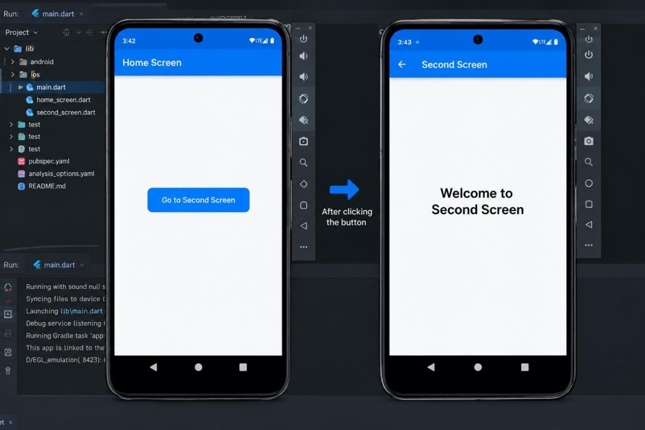

PROGRAM:

import 'package:flutter/material.dart'; void main() {
runApp(MyApp());

}

class MyApp extends StatelessWidget { @override
Widget build(BuildContext context) { return MaterialApp( debugShowCheckedModeBanner: false, initialRoute: '/',

routes: {

'/': (context) => HomeScreen(), '/second': (context) => SecondScreen(),
},

);

}

}

class HomeScreen extends StatelessWidget { @override
Widget build(BuildContext context) { return Scaffold(
appBar: AppBar(title: Text('Home Screen')), body: Center(
child: ElevatedButton( onPressed: () {
Navigator.pushNamed(context, '/second');

},

child: Text('Go to Second Screen'),

),

),

);

}

}

class SecondScreen extends StatelessWidget { @override
Widget build(BuildContext context) { return Scaffold(
appBar: AppBar(title: Text('Second Screen')), body: Center(
child: Text(

'Welcome to Second Screen', style: TextStyle(fontSize: 22),
),),);}}

OUTPUT:

RESULT:

Thus, the Flutter application was successfully developed and navigation between screens using Routes and Named Routes was implemented successfully.

EX.NO:8.a DATA PASSING EXERCISES BETWEEN SCREENS DATE:

AIM:

To develop a Flutter application that passes data from one screen to another using navigation.

SOFTWARE REQUIRED:

- Flutter SDK
- Android Studio / VS Code

PROCEDURE:

STEP 1: Create a new Flutter project and create two screens, Home Screen and Second Screen.
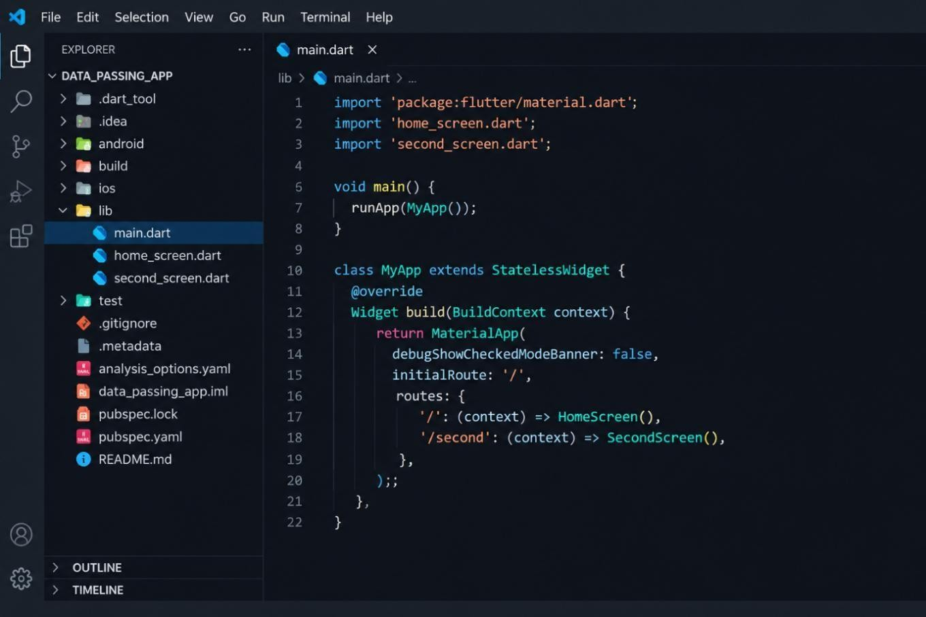

STEP 2: In the Home Screen, create a text field and button to enter and send data to the next screen.
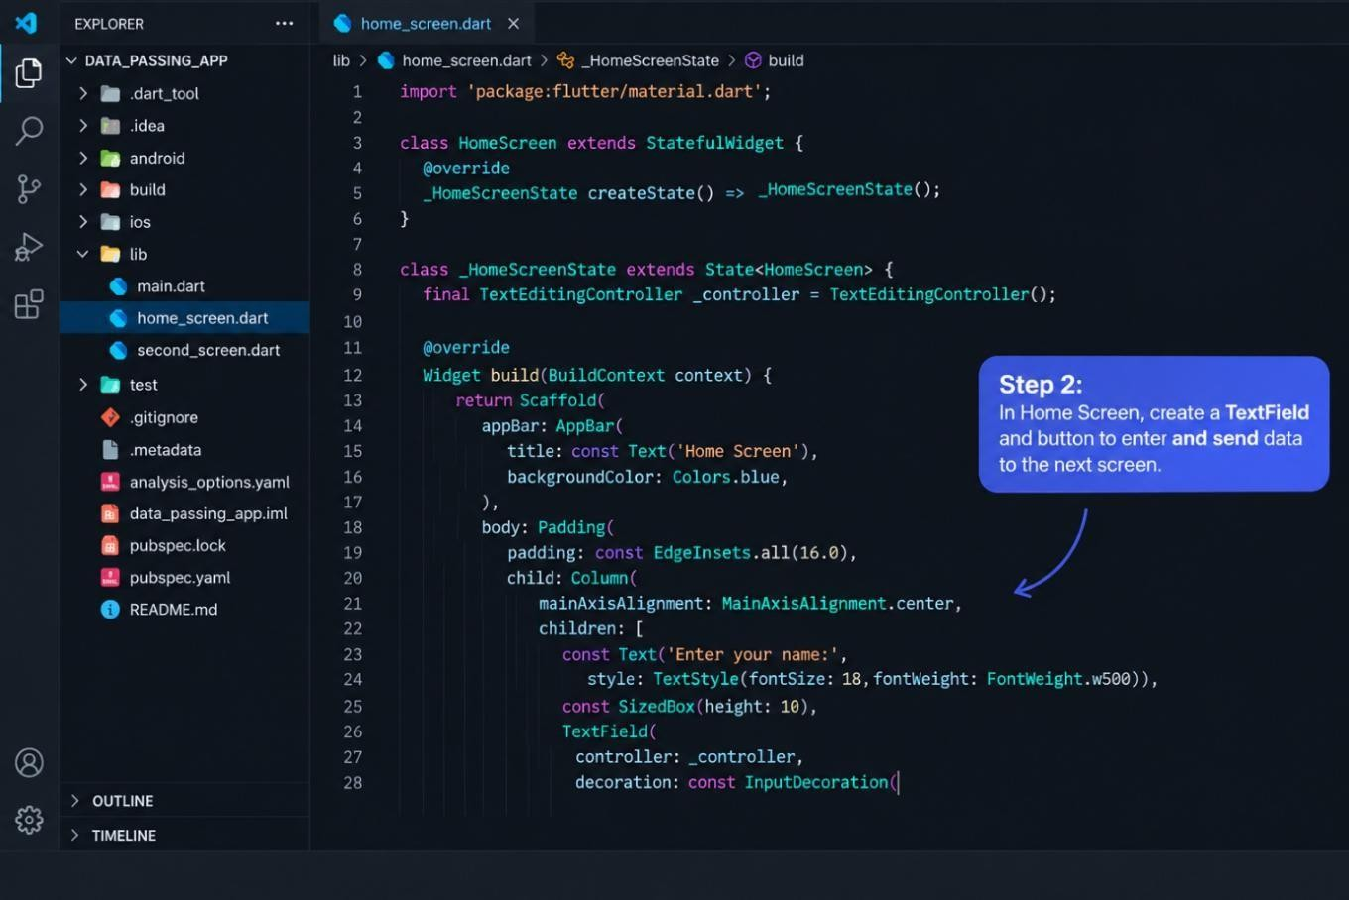

STEP 3: Pass the entered data to the Second Screen using the constructor while navigating with Navigator.push().
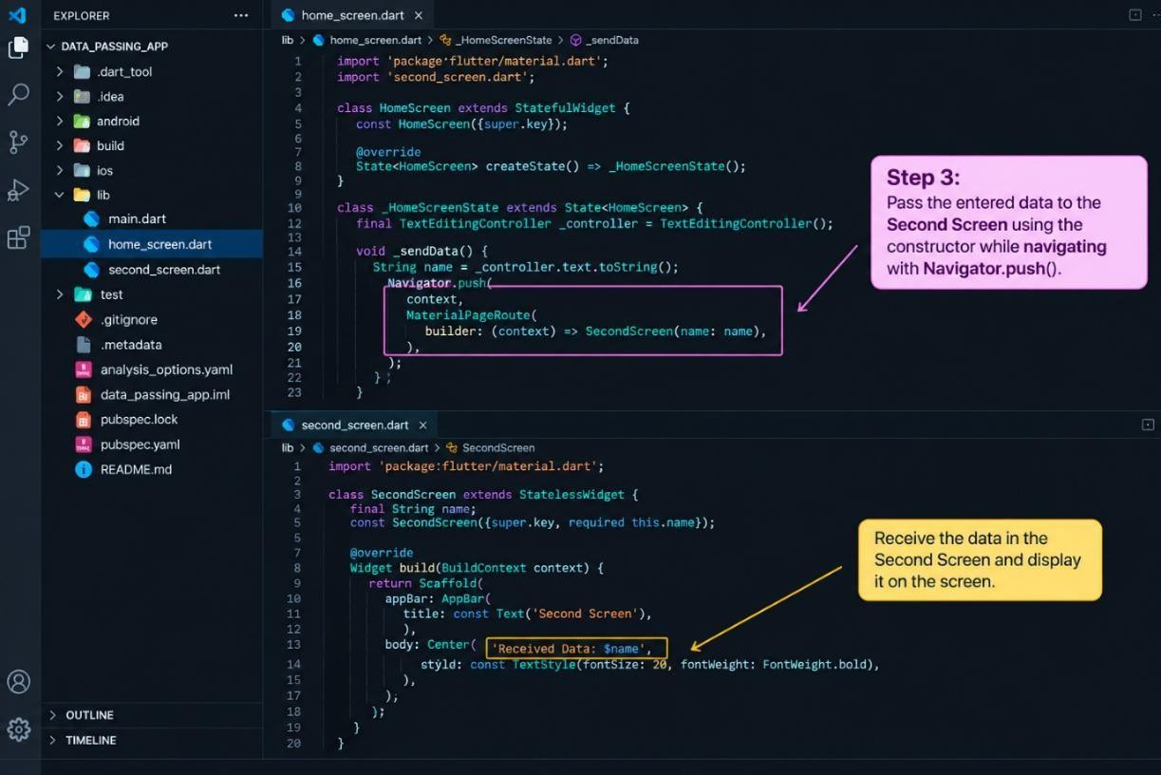

STEP 4: Receive the data in the Second Screen and display it on the screen.

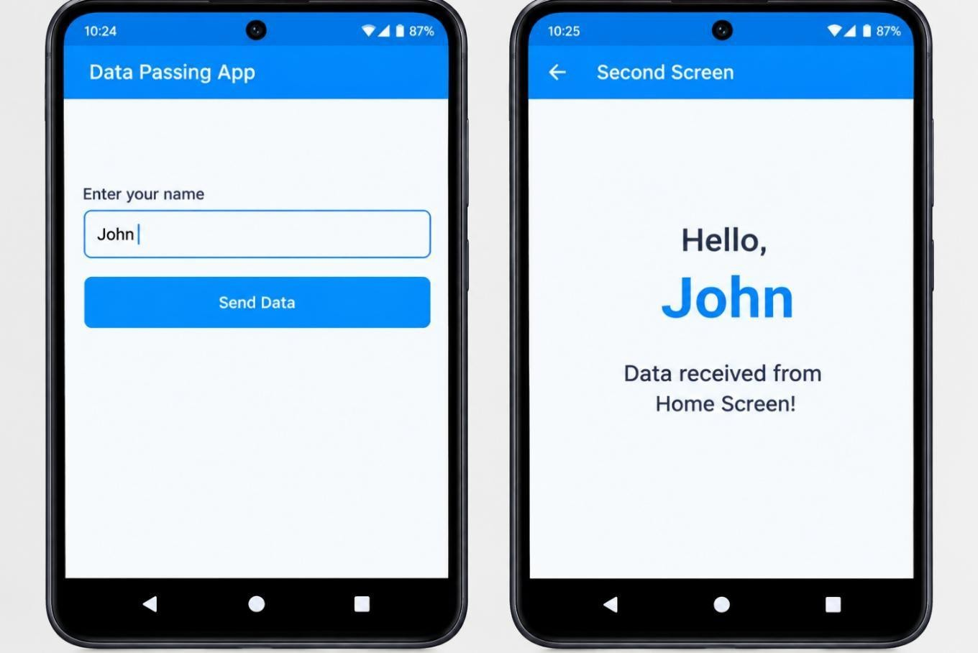

PROGRAM:

import 'package:flutter/material.dart'; void main() {
runApp(MyApp());

}

class MyApp extends StatelessWidget { @override
Widget build(BuildContext context) { return MaterialApp( debugShowCheckedModeBanner: false, home: HomeScreen(),
);

}

}

class HomeScreen extends StatelessWidget {

final TextEditingController controller = TextEditingController(); @override
Widget build(BuildContext context) { return Scaffold(
appBar: AppBar(title: Text('Home Screen')), body: Padding(
padding: EdgeInsets.all(20), child: Column(
children: [ TextField(
controller: controller, decoration: InputDecoration( labelText: 'Enter Data', border: OutlineInputBorder(),
),

),

SizedBox(height: 20), ElevatedButton( onPressed: () {

Navigator.push( context, MaterialPageRoute( builder: (context) =>
SecondScreen(data: controller.text),

),

);

},

child: Text('Send Data'),),],),),);}} class SecondScreen extends StatelessWidget { final String data;
secondScreen({required this.data}); @override
Widget build(BuildContext context) { return Scaffold(
appBar: AppBar(title: Text('Second Screen')), body: Center(
child: Text(

'Received Data: $data',

style: TextStyle(fontSize: 22),

),),);}}

OUTPUT:

RESULT:

Thus, the Flutter application was successfully developed to pass data between two screens using navigation.

EX.NO:8.b JSON DATA HANDLING EXERCISES DATE:

AIM:

To develop a Flutter application that demonstrates JSON data handling by converting JSON data into a Dart object and displaying the data on the screen.

THEORY:

To develop a Flutter application that demonstrates JSON data handling by converting JSON data into a Dart object and displaying the data on the screen.

PROCEDURE:

STEP 1: Create a new Flutter project.
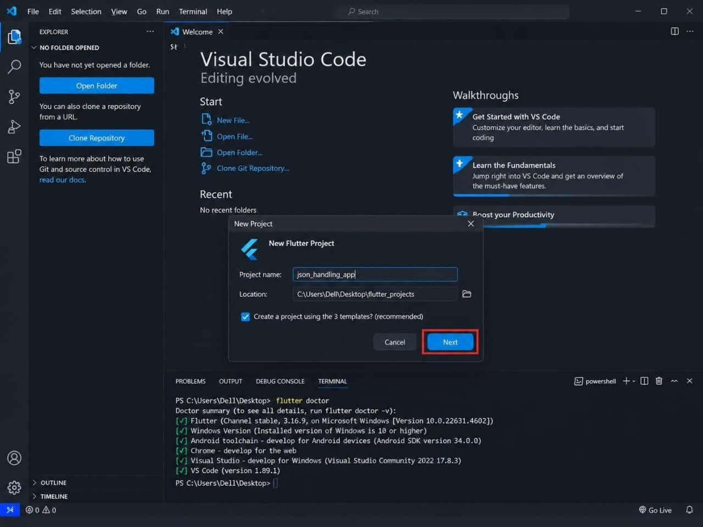

STEP 2: Import the dart:convert library.
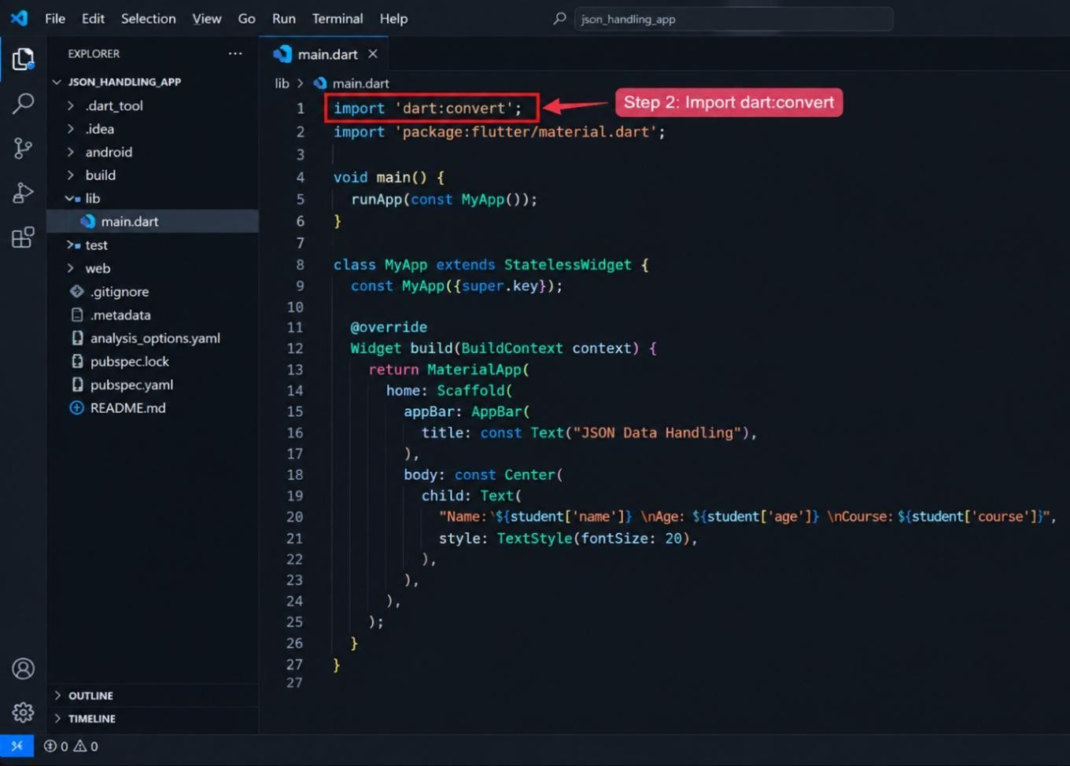

STEP 3: Create a JSON string containing student details.
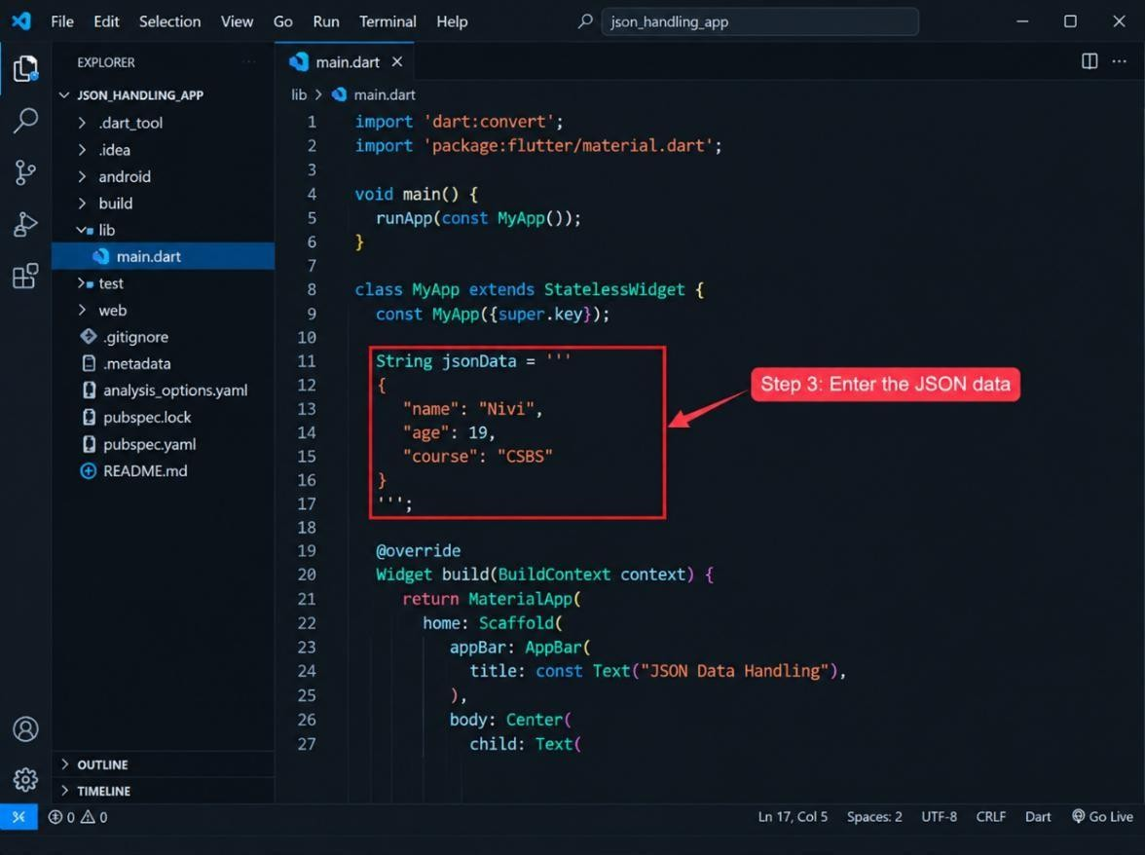

STEP 4: Use jsonDecode() to convert the JSON string into a Dart Map.
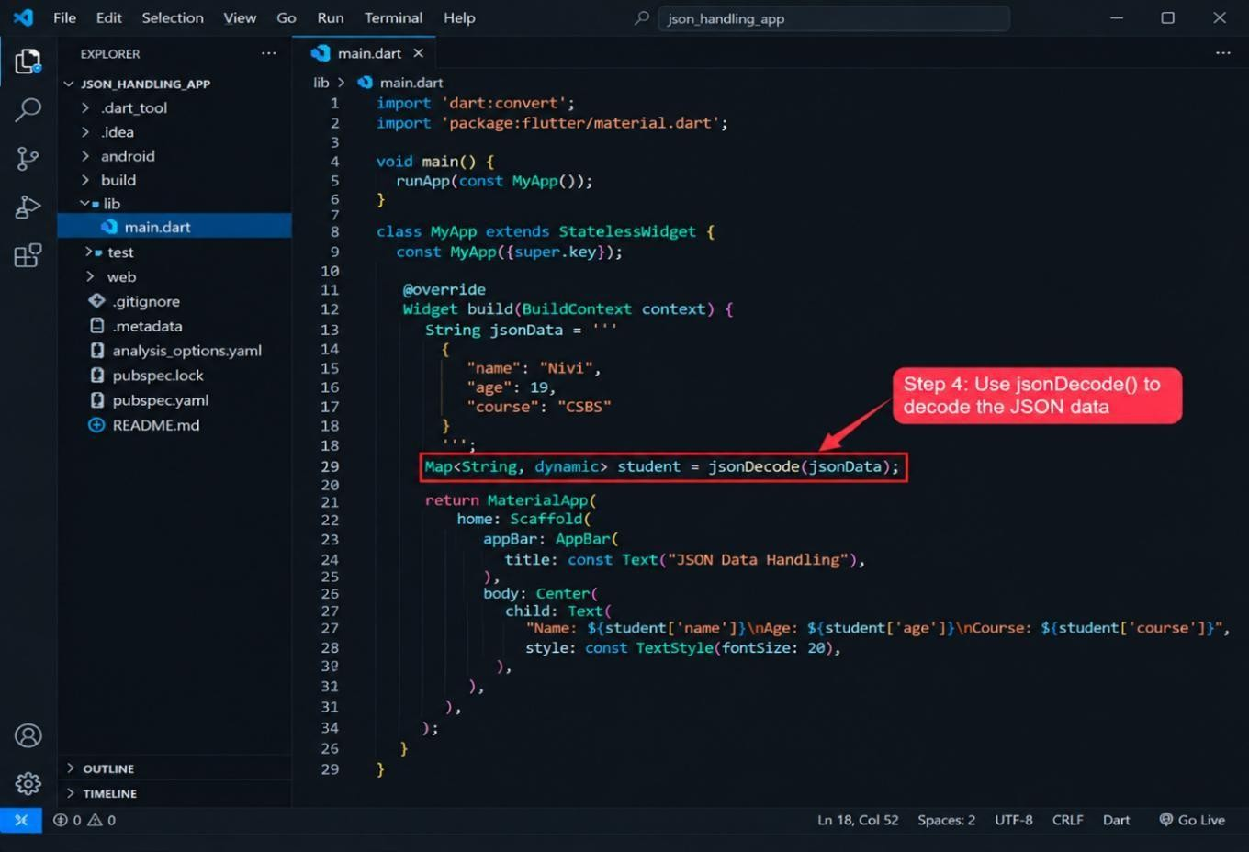

STEP 5: Display the decoded data in the Flutter UI.
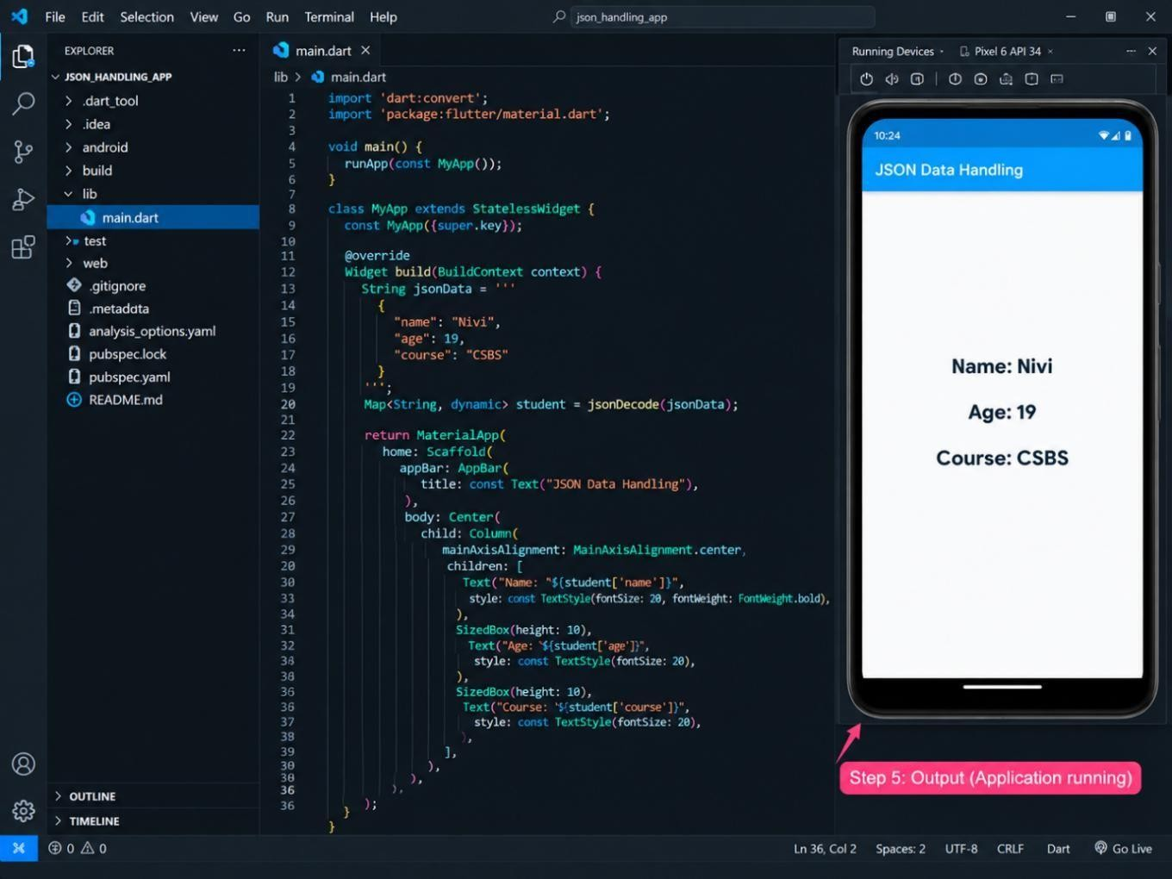

PROGRAM:

import 'dart:convert';

import 'package:flutter/material.dart'; void main() {
runApp(const MyApp());

}

class MyApp extends StatelessWidget { const MyApp({super.key});

@override

Widget build(BuildContext context) { String jsonData = '''
{

"name": "Nivi", "age": 19,
"course": "CSBS"

}

Map<String, dynamic> student = jsonDecode(jsonData); return MaterialApp(
home: Scaffold( appBar: AppBar(
title: const Text("JSON Data Handling"),

),

body: Center( child: Text(
"Name: ${student['name']}\n"

"Age: ${student['age']}\n"

"Course: ${student['course']}", style: const TextStyle(fontSize: 20):
),

),

),

);

}

}

OUTPUT:
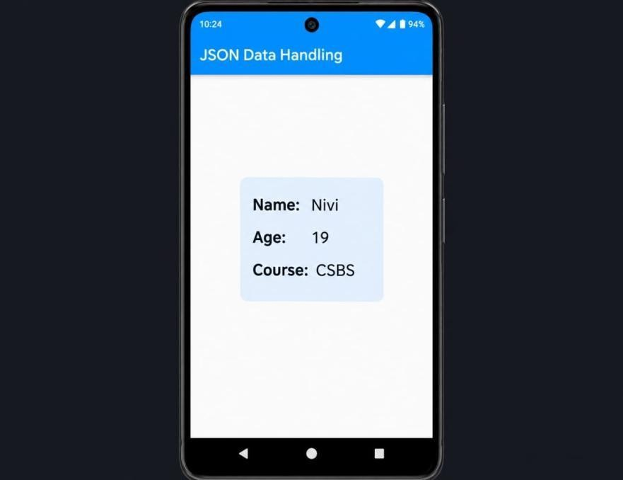

RESULT:

Thus, the Flutter application was successfully developed to decode JSON data and display the data on the screen.

EX.NO:9.a API INTEGRATION USING HTTP REQUESTS DATE:

AIM:
To develop a Flutter application that fetches data from a web API using HTTP requests and displays the received data.

THEORY:

An API (Application Programming Interface) allows a Flutter application to communicate with a server and exchange data.

PROCEDURE:

Step 1: Create a new Flutter project.
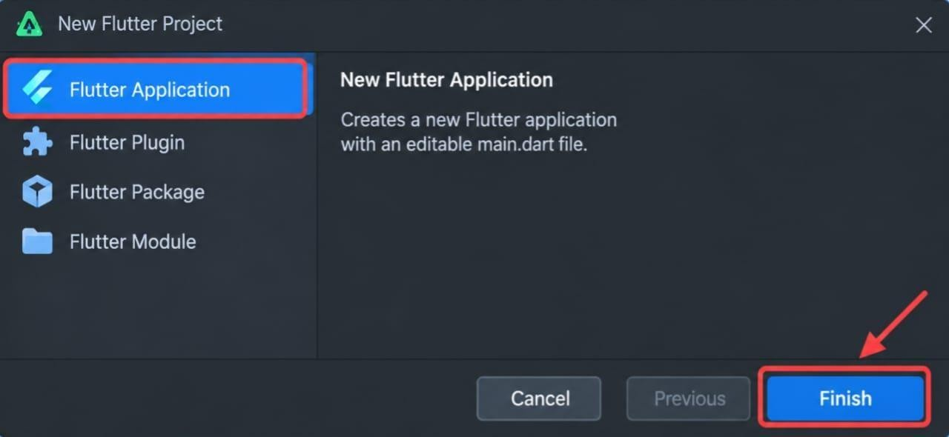

Step 2: Add the http package in pubspec.yaml.
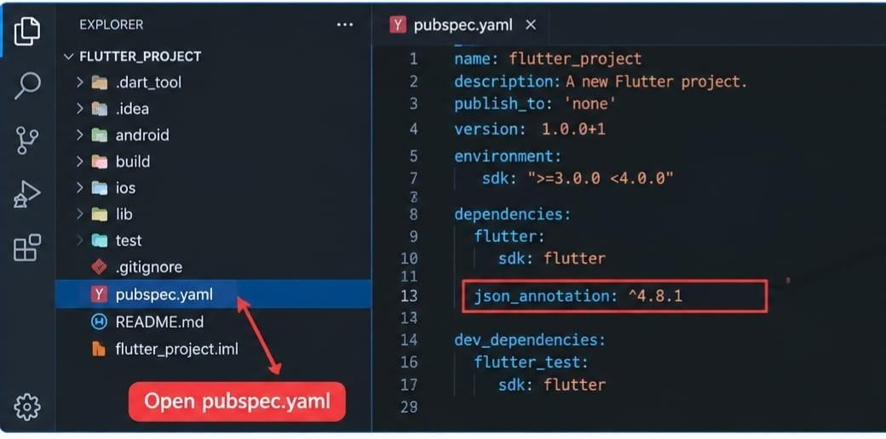

Step 3: Import http and dart:convert in main.dart.
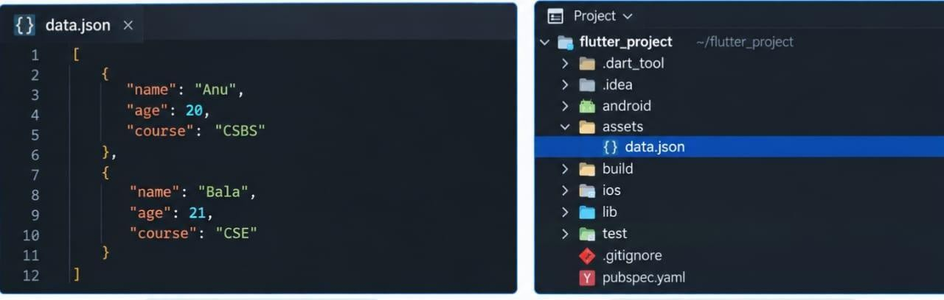

Step 4: Send a GET request to the API using http.get().
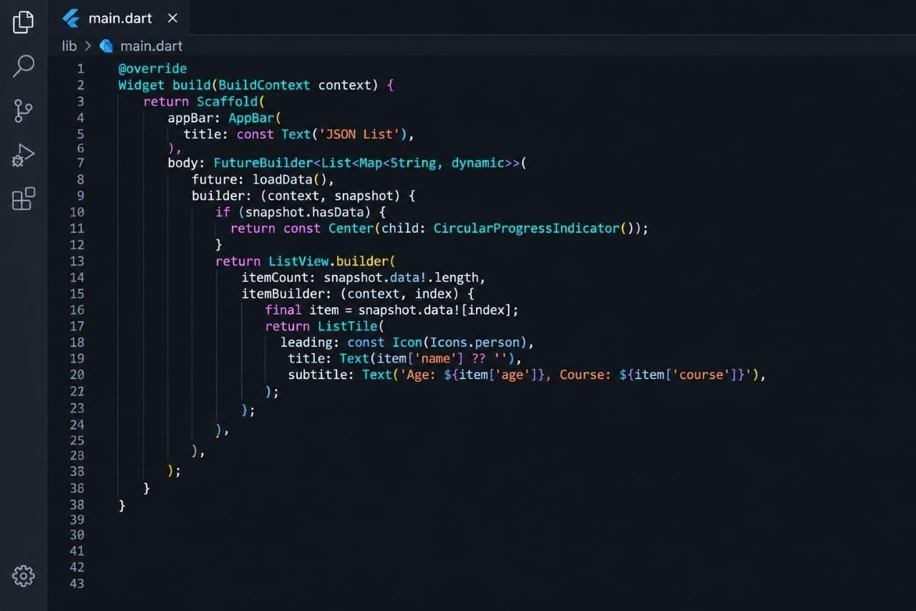

PROGRAM:

import 'dart:convert';

import 'package:flutter/material.dart'; import 'package:flutter/services.dart';
void main() => runApp(const MaterialApp(home: JsonListScreen())); class JsonListScreen extends StatelessWidget {
const JsonListScreen({super.key}); Future<List<dynamic>> loadData() async {
final String response = await rootBundle.loadString('assets/data.json'); return json.decode(response);
}

@override

Widget build(BuildContext context) { return Scaffold(
appBar: AppBar(title: const Text('JSON List')), body: FutureBuilder<List<dynamic>>(
future: loadData(),

builder: (context, snapshot) { if (!snapshot.hasData) {
return const Center(child: CircularProgressIndicator());

}

return ListView.builder(

itemCount: snapshot.data!.length, itemBuilder: (context, index) { final item = snapshot.data![index]; return ListTile(
leading: const CircleAvatar(child: Icon(Icons.person)), title: Text(item['name'] ?? ''),
subtitle: Text('Age: ${item['age']}\nCourse: ${item['course']}'),

);

},

);

[

{"name": "Anu", "age": 20, "course": "CSBS"},

{"name": "Bala", "age": 21, "course": "CSE"},

{"name": "Charan", "age": 22, "course": "IT"}

]},),);}}

OUTPUT:

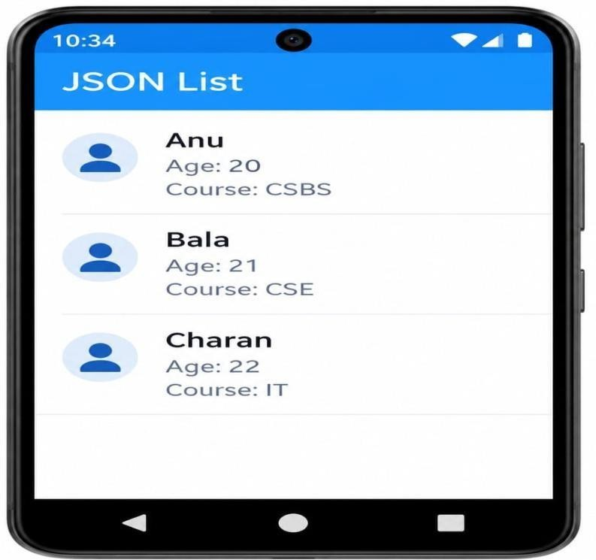

RESULT:

Thus, the Flutter application was successfully developed to fetch data from an API using an HTTP GET request and display the JSON data.

EX.NO:9.b LOCAL STORAGE IMPLEMENTATION USING SHARED DATE: PREFERENCES

AIM:

To develop a Flutter application that stores and retrieves data locally using SharedPreferences.

SOFTWARE REQUIRED:

- Flutter SDK
- Android Studio / VS Code

PROCEDURE:

STEP 1: Create a new Flutter project and add the shared_preferences package to the project.
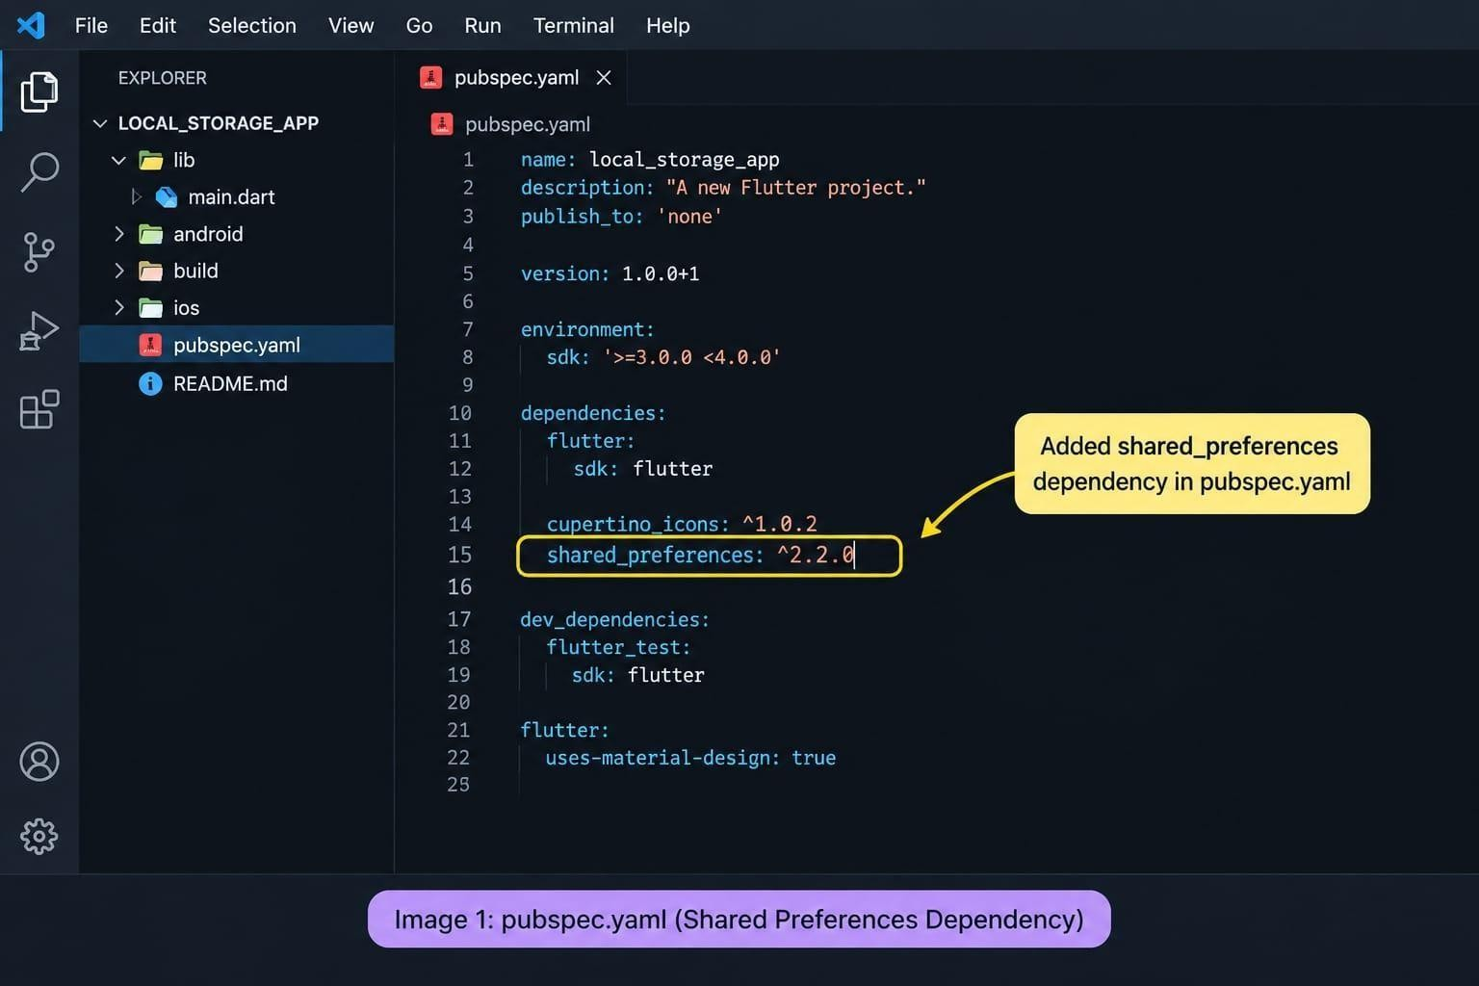

STEP 2: Create a text field and button to enter data that needs to be stored locally.
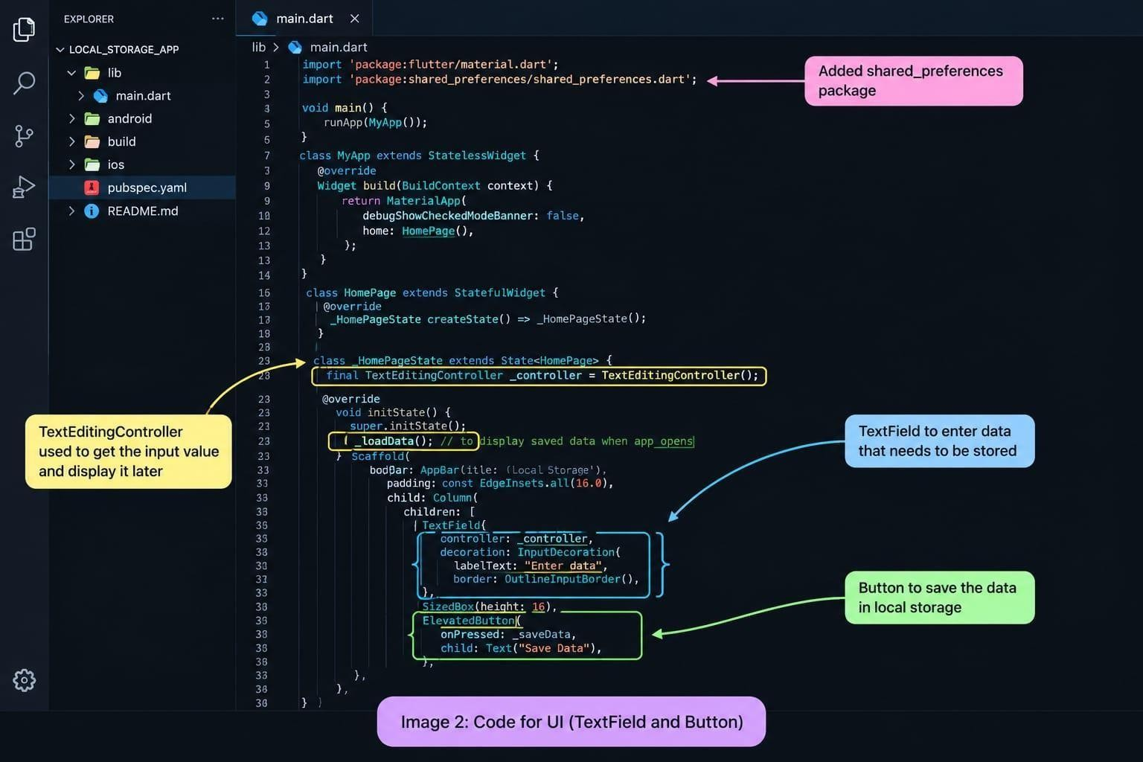

STEP 3: Use SharedPreferences to save the entered data in local storage.
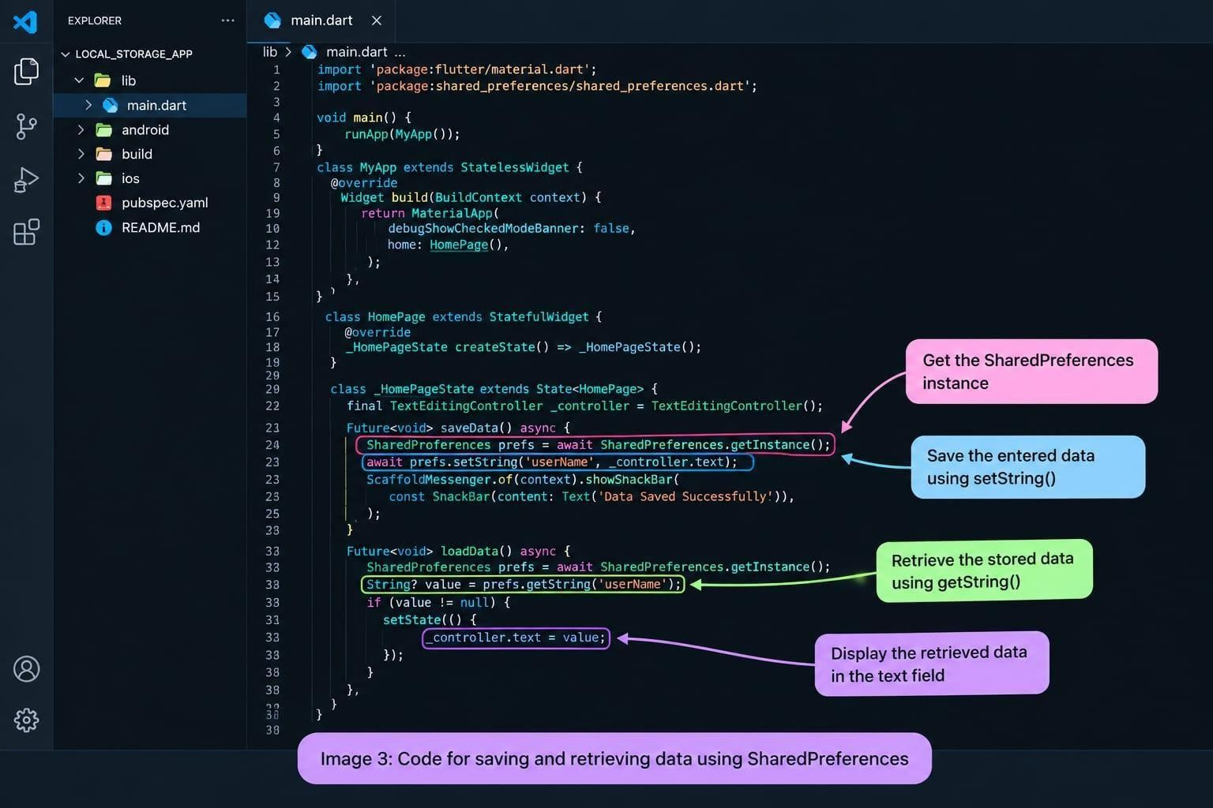

STEP 4: Retrieve the stored data using getString() and display it when the application is reopened.
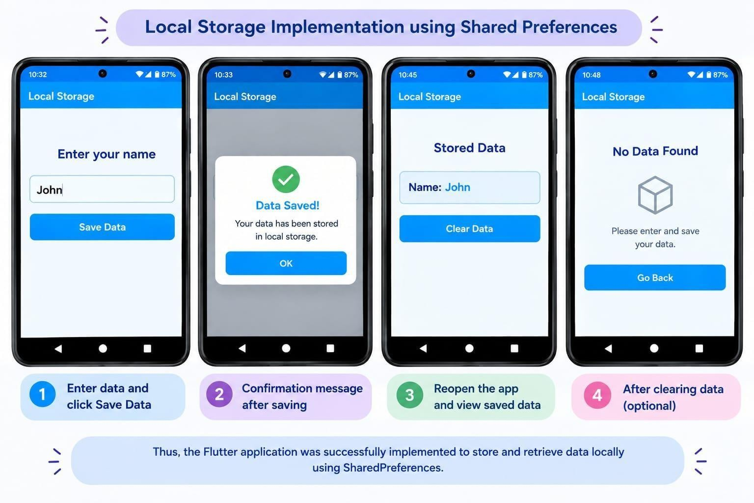

PROGRAM:

import 'package:flutter/material.dart';

import 'package:shared_preferences/shared_preferences.dart'; void main() {
runApp(MyApp());

}

class MyApp extends StatelessWidget { @override
Widget build(BuildContext context) { return MaterialApp( debugShowCheckedModeBanner: false,

home: LocalStorageScreen(),

);

}

}

class LocalStorageScreen extends StatefulWidget { @override
State<LocalStorageScreen> createState() => _LocalStorageScreenState();

}

class _LocalStorageScreenState extends State<LocalStorageScreen> { final TextEditingController controller = TextEditingController(); String savedData = '';
Future<void> saveData() async {

SharedPreferences prefs = await SharedPreferences.getInstance(); await prefs.setString('name', controller.text);
setState(() {

savedData = controller.text;

});

ScaffoldMessenger.of(context).showSnackBar( SnackBar(content: Text('Data Saved Successfully')),
);

}

Future<void> loadData() async {

SharedPreferences prefs = await SharedPreferences.getInstance(); String? data = prefs.getString('name');

setState(() {

savedData = data ?? 'No Data Found';

});

}

@override

void initState() { super.initState(); loadData();
}

@override

Widget build(BuildContext context) { return Scaffold(
appBar: AppBar(

title: Text('Local Storage'),

),

body: Padding(

padding: EdgeInsets.all(20), child: Column(

children: [ TextField(
controller: controller, decoration: InputDecoration( labelText: 'Enter your name', border: OutlineInputBorder(),
),

),

SizedBox(height: 20), ElevatedButton( onPressed: saveData, child: Text('Save Data'),
),

SizedBox(height: 30), Text(
'Stored Data: $savedData', style: TextStyle(fontSize: 20),
),

],),),);}}

OUTPUT:

RESULT:

Thus, the Flutter application was successfully implemented to store and retrieve data locally using SharedPreferences.

EX.NO:10.a DEVELOP APPLICATIONS USING LISTS AND GRID VIEWS DATE:

AIM:

To design and develop a mobile application interface using ListView and GridView widgets in Flutter to display dynamic collections of data in linear and grid formats.

THEORY:

Lists and Grid Views are foundational layout structures used in mobile applications to present repeating elements or scrollable collections of components efficiently.

ListView

Displays items linearly in a vertical or horizontal scrollable list. It is commonly used for menus, task lists, feeds, and structured settings screens.

  - ListView.builder: A performance-optimized constructor that lazily creates items only as they become visible on screen, essential for long or dynamic lists.
  - ListTile: A specialized single-line or multi-line row container containing leading icons/avatars, titles, subtitles, and trailing elements.

GridView

Arranges elements in a two-dimensional grid format (rows and columns). It is useful for photo galleries, product catalogs, and dashboard icon layouts.

  - GridView.builder: Generates grid items dynamically on demand as the screen scrolls.
  - SliverGridDelegateWithFixedCrossAxisCount: Defines grid parameters such as the number of columns (crossAxisCount) and item spacing.

PROCEDURE:

STEP 1: Open Android Studio.

STEP 2: Create a new Flutter project:

- Click on New Flutter Project on the Welcome screen (or go to File > New > New Flutter Project...).
- Select Flutter on the left menu, ensure the Flutter SDK path is selected, and click Next.
- Set the Project name as list_grid_demo.
- Choose your project location and ensure Java/Kotlin and Swift/Objective-C are selected if prompted.
- Click Create.
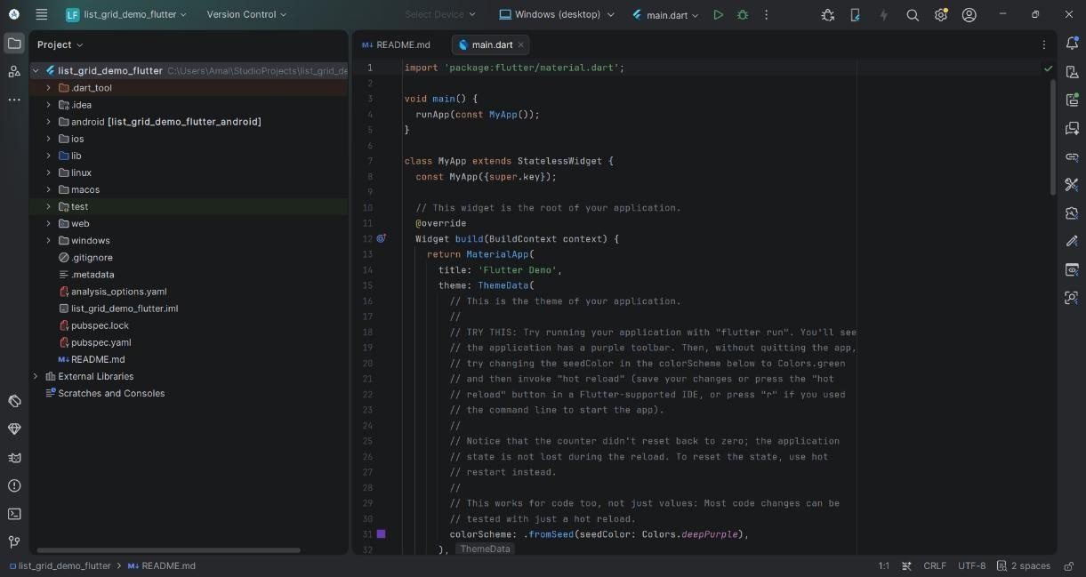

STEP 3: Start the Android Emulator:

- Open the Device Manager from the right side panel (or go to Tools > Device Manager).
- Select an available virtual device and click the Play (▶) button to launch the emulator.
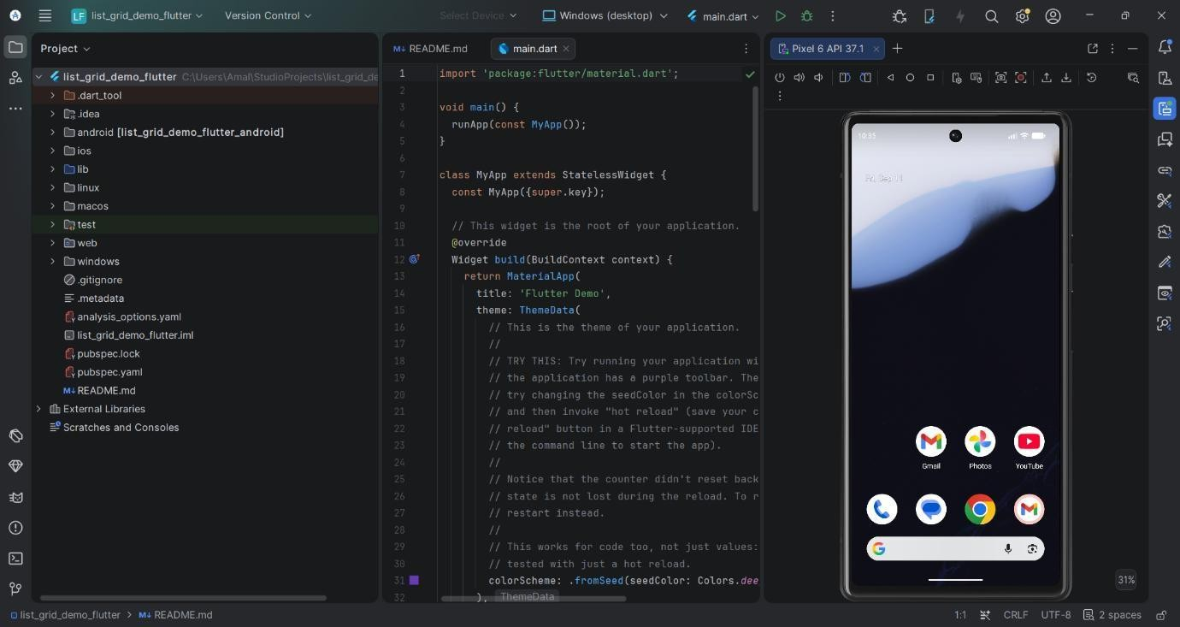

STEP 4: Navigate to main.dart:

- In the Project window on the left, expand the project folder: list_grid_demo > lib.
- Double-click main.dart to open it in the editor.

STEP 5: Replace the default code in lib/main.dart with the following implementation:

import 'package:flutter/material.dart'; void main() {
runApp(const ListGridApp());

}

class ListGridApp extends StatelessWidget { const ListGridApp({super.key});

@override

Widget build(BuildContext context) { return MaterialApp( debugShowCheckedModeBanner: false,
theme: ThemeData(primarySwatch: Colors.blue), home: const ListGridHomeScreen(),
);

}

}

class ListGridHomeScreen extends StatelessWidget { const ListGridHomeScreen({super.key});

final List<String> items = const [ 'Item 1', 'Item 2', 'Item 3', 'Item 4',
'Item 5', 'Item 6', 'Item 7', 'Item 8'

];

@override

Widget build(BuildContext context) { return DefaultTabController( length: 2,

child: Scaffold( appBar: AppBar(
title: const Text('ListView & GridView Demo'), bottom: const TabBar(
tabs: [

Tab(icon: Icon(Icons.list), text: 'ListView'), Tab(icon: Icon(Icons.grid_on), text: 'GridView'),
],

),

),

body: TabBarView( children: [
// Tab 1: ListView Implementation ListView.builder(
itemCount: items.length, itemBuilder: (context, index) { return Card(
margin: const EdgeInsets.symmetric(horizontal: 10, vertical: 5), child: ListTile(
leading: CircleAvatar(child: Text('${index + 1}')), title: Text(items[index]),
subtitle: Text('Subtitle for ${items[index]}'),

trailing: const Icon(Icons.arrow_forward_ios, size: 16),

),

);

},

),

// Tab 2: GridView Implementation GridView.builder(
padding: const EdgeInsets.all(10),

gridDelegate: const SliverGridDelegateWithFixedCrossAxisCount( crossAxisCount: 2,
crossAxisSpacing: 10,

mainAxisSpacing: 10,

),

itemCount: items.length, itemBuilder: (context, index) { return Card(
color: Colors.blue.shade100, child: Center(
child: Column(

mainAxisAlignment: MainAxisAlignment.center, children: [
const Icon(Icons.widgets, size: 40, color: Colors.blue),

const SizedBox(height: 8), Text(
items[index],

style: const TextStyle(fontWeight: FontWeight.bold),

),],),),);},),],),),);}}

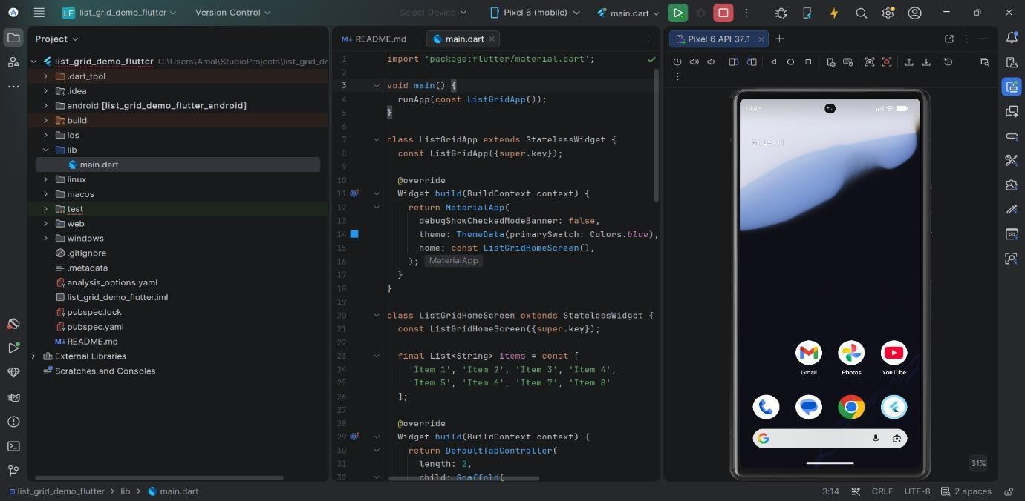

STEP 6: Save the file by pressing Ctrl + S. STEP 7: Run the application:
- Ensure your Android Emulator is selected in the device target dropdown at the top toolbar.
- Click the green Run (▶) button in the top toolbar (or press Shift + F10).

STEP 8: Observe and verify the output:

- Verify the ListView tab rendering on the emulator screen.
- Click on the GridView tab on the emulator and verify the grid layout.

OUTPUT:
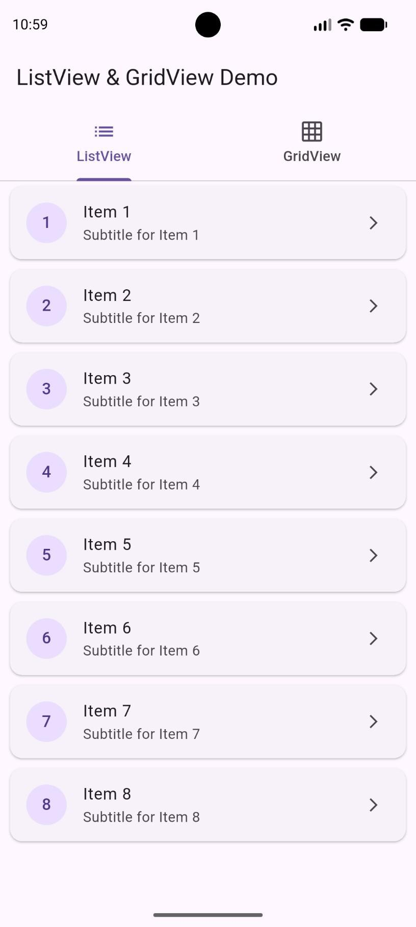

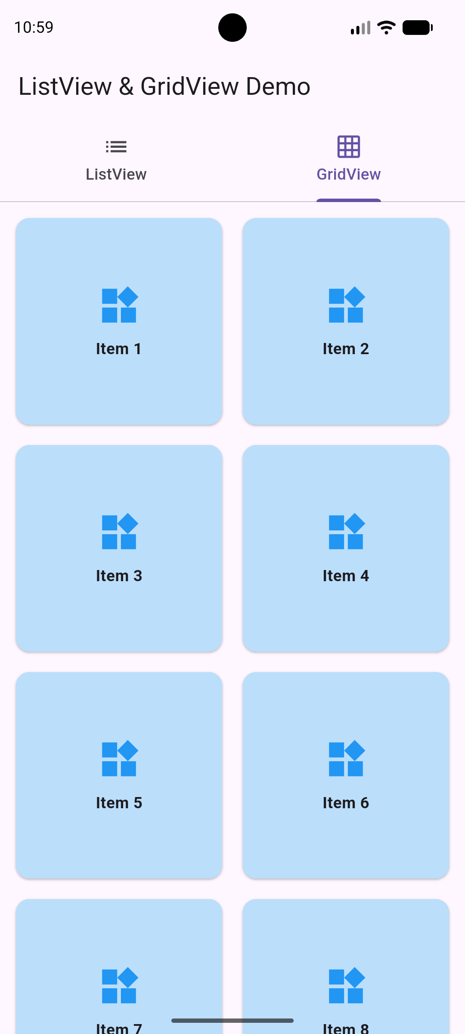

RESULT:

Thus, The Flutter Experiment of Develop applications using Lists and Grid Views was Executed and Completed Successfully.

EX.NO:10.b DEVELOP AND USE CUSTOM WIDGETS DATE:

AIM:

To design, implement, and integrate custom, reusable widgets in Flutter to build modular, maintainable, and scalable user interfaces.

THEORY:

In Flutter, Custom Widgets are developer-defined components built by combining existing core widgets. Creating custom widgets promotes the DRY (Don't Repeat Yourself) principle, improves code readability, and simplifies application maintenance.

Modularity:

  - Breaking complex UIs into smaller, isolated widget components makes testing and debugging easier.

Constructor Parameters:

  - Custom widgets receive external data and event listeners using typed parameters passed through their constructors.

Composition over Inheritance:

  - Flutter encourages building custom UIs by nesting and composing simpler widgets rather than subclassing existing UI components.

PROCEDURE:

STEP 1: Open Android Studio.

STEP 2: Create a new Flutter project using the Android Studio wizard:

- Click File > New > New Flutter Project... from the top menu.
- Select Flutter from the left panel. Verify that the Flutter SDK Path is populated correctly, then click Next.

- Set the Project name to custom_widget_demo.
- Choose your preferred project location directory.
- Click Create and wait for Android Studio to generate the project files.
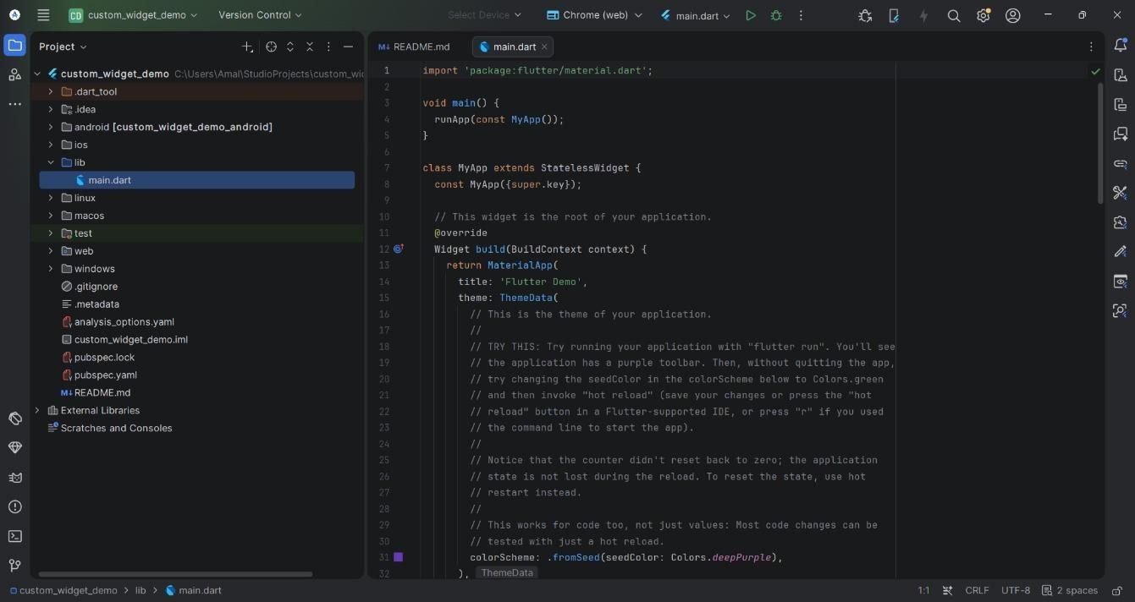

STEP 3: Start the Android Emulator:

- Click on Device Manager in the right toolbar panel of Android Studio.
- Click the green Play (▶) button next to your virtual device to boot up the emulator.

STEP 4: Create the custom widget file:

- In the Project window on the left, expand custom_widget_demo > lib.
- Right-click on the lib folder.
- Go to New > Dart File.
- Type custom_card and press Enter.
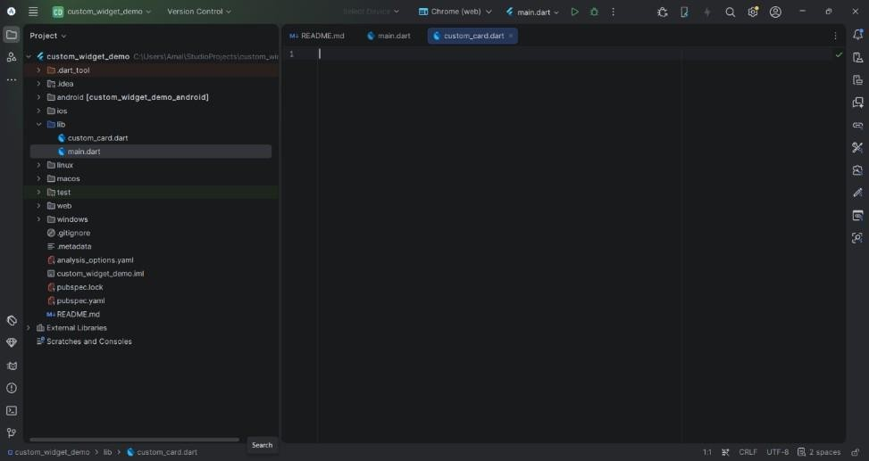

STEP 5: Add code to lib/custom_card.dart: Double-click lib/custom_card.dart to open it in the editor and paste the following code:

import 'package:flutter/material.dart';

class CustomCardWidget extends StatelessWidget { final String title;
final String description; final IconData icon;
final VoidCallback onTap; const CustomCardWidget({ super.key,
required this.title, required this.description, required this.icon, required this.onTap,
});

@override

Widget build(BuildContext context) { return Card(
elevation: 4,

shape: RoundedRectangleBorder(borderRadius: BorderRadius.circular(12)), margin: const EdgeInsets.symmetric(horizontal: 16, vertical: 8),
child: InkWell(

onTap: onTap,

borderRadius: BorderRadius.circular(12), child: Padding(
padding: const EdgeInsets.all(16.0), child: Row(
children: [ Container(
padding: const EdgeInsets.all(12), decoration: BoxDecoration(
color: Colors.deepPurple.shade50, shape: BoxShape.circle,
),

child: Icon(icon, color: Colors.deepPurple, size: 30),

),

const SizedBox(width: 16), Expanded(
child: Column(

crossAxisAlignment: CrossAxisAlignment.start, children: [
Text( title,
style: const TextStyle(

fontSize: 18,

fontWeight: FontWeight.bold,

),

),

const SizedBox(height: 4), Text(
description,

style: TextStyle(color: Colors.grey.shade600),

),

],

),

),

const Icon(Icons.chevron_right, color: Colors.grey),],),),),);}}
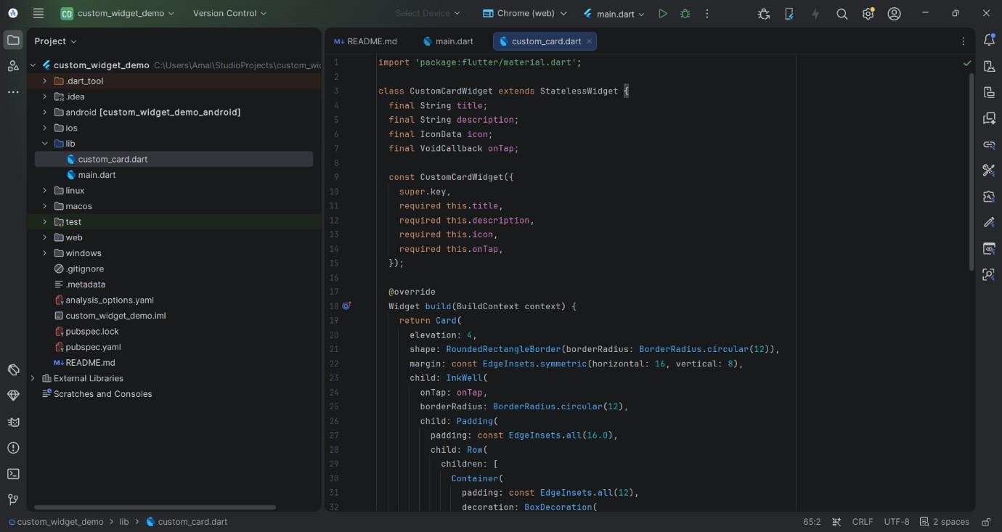

STEP 6: Integrate the custom widget into lib/main.dart: Open lib/main.dart in the editor, clear the default template code, and replace it with:.

import 'package:flutter/material.dart'; import 'custom_card.dart';
void main() {

runApp(const CustomWidgetApp());

}

class CustomWidgetApp extends StatelessWidget { const CustomWidgetApp({super.key}); @override
Widget build(BuildContext context) { return MaterialApp( debugShowCheckedModeBanner: false, title: 'Custom Widgets Demo',
theme: ThemeData(primarySwatch: Colors.deepPurple), home: const CustomWidgetHomeScreen(),);}}
class CustomWidgetHomeScreen extends StatelessWidget { const CustomWidgetHomeScreen({super.key}); @override
Widget build(BuildContext context) { return Scaffold(
appBar: AppBar(

title: const Text('Custom Widgets Exploration'), backgroundColor: Colors.deepPurple,
),

body: ListView(

padding: const EdgeInsets.symmetric(vertical: 10), children: [
CustomCardWidget( title: 'Profile Settings',
description: 'Manage account preferences and info', icon: Icons.person,
onTap: () {},

),

CustomCardWidget( title: 'Notifications',
description: 'Configure push and email alerts', icon: Icons.notifications,
onTap: () {},

),

CustomCardWidget( title: 'Security',
description: 'Update password and authentication', icon: Icons.security,

onTap: () {},

),

CustomCardWidget( title: 'Help & Support',
description: 'Contact customer care and FAQs', icon: Icons.help_outline,
onTap: () {},),],),);}}

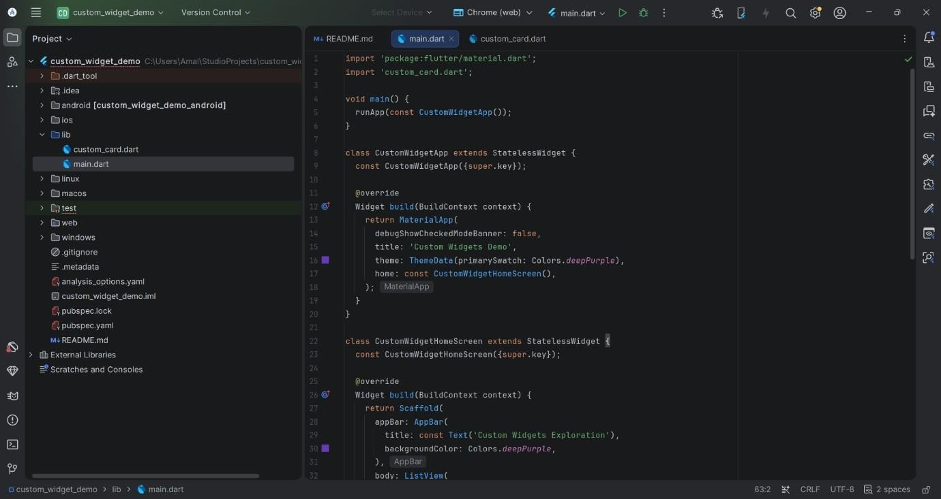STEP
7: Save all files (Ctrl + S).

STEP 8: Run and verify the application:

- Ensure your running Android Emulator is selected in the top device target dropdown menu.
- Click the green Run (▶) button in the main toolbar (or press Shift + F10).
- Verify that the custom cards appear correctly on the emulator screen.

OUTPUT:
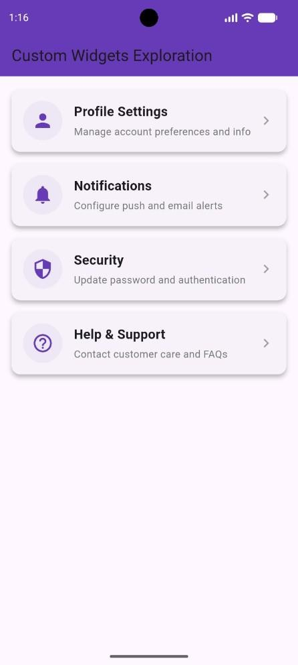

RESULT:

Thus, The Flutter Experiment of Develop and use Custom Widgets was Executed and Completed Successfully.

EX.NO:11.a IMPLEMENT CREATE AND READ OPERATIONS WITH LOCAL DATE: STORAGE

AIM:

To design and implement local data persistence in a Flutter application by performing Create and Read operations using the shared_preferences package.

THEORY:

Local storage allows mobile applications to retain data persistently across user sessions and app restarts without requiring a remote server database.

SharedPreferences:
  - A Flutter plugin providing persistent local storage for key-value pairs (supporting types such as String, int, double, bool, and List<String>). On Android, it uses SharedPreferences, and on iOS, it uses NSUserDefaults.

Async/Await Handling:
  - Because local file read and write operations involve disk I/O, SharedPreferences operations are asynchronous and return Future objects.

LOCAL STORAGE OPERATIONS SUMMARY

Operation | Method Name | Description
Create / Write | prefs.setString('key', value) | Writes a string value into local storage under a specific key name.
Read / Fetch | prefs.getString('key') | Retrieves the value associated with the key (returns null if the key does not exist).

PROCEDURE:

STEP 1: Open Android Studio.

STEP 2: Create a new Flutter project:

- Select File > New > New Flutter Project... from the top menu bar.
- Select Flutter on the left panel, verify your Flutter SDK path, and click Next.
- Enter local_storage_demo as the Project name.
- Click Create.
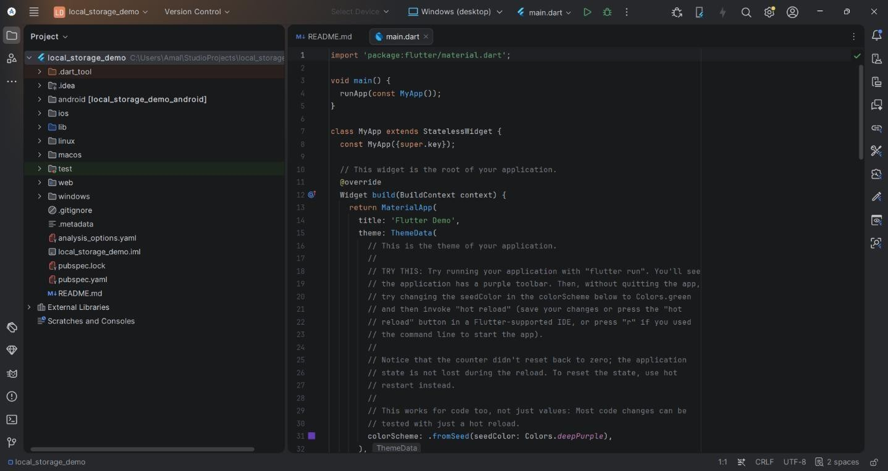

STEP 3: Add shared_preferences dependency to pubspec.yaml:

- In the Project Explorer window on the left, locate and double-click pubspec.yaml.
- Locate the dependencies: block and add shared_preferences: ^2.2.2:

dependencies:

flutter:

sdk: flutter shared_preferences: ^2.2.2
Click the Pub get button located at the top right of the editor toolbar (or press Ctrl + S to save and trigger package fetching automatically).

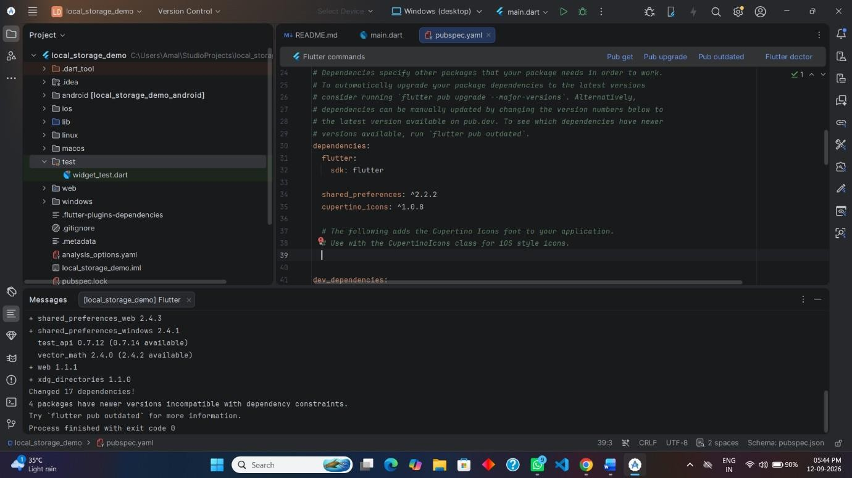

STEP 4: Start the Android Emulator:

- Open Device Manager from the right side panel in Android Studio.
- Click the green Play (▶) button to start your virtual device.

STEP 5: Replace the code in lib/main.dart: Open lib/main.dart in the editor and replace its contents with the following:

import 'package:flutter/material.dart';

import 'package:shared_preferences/shared_preferences.dart'; void main() {
runApp(const LocalStorageApp());

}

class LocalStorageApp extends StatelessWidget { const LocalStorageApp({super.key});

@override

Widget build(BuildContext context) { return MaterialApp( debugShowCheckedModeBanner: false, title: 'Local Storage Demo',
theme: ThemeData(primarySwatch: Colors.teal), home: const StorageHomeScreen(),
);

}

}

class StorageHomeScreen extends StatefulWidget { const StorageHomeScreen({super.key}); @override
State<StorageHomeScreen> createState() => _StorageHomeScreenState();

}

class _StorageHomeScreenState extends State<StorageHomeScreen> { final TextEditingController _controller = TextEditingController(); String _savedData = 'No data saved yet.';
@override

void initState() { super.initState();
_readData(); // READ operation on application startup

}

// READ Operation: Retrieves stored data from local storage Future<void> _readData() async {
final prefs = await SharedPreferences.getInstance(); setState(() {
_savedData = prefs.getString('user_note') ?? 'No data saved yet.';

});

}

// CREATE Operation: Writes user input into local storage Future<void> _saveData() async {
if (_controller.text.trim().isEmpty) return;

final prefs = await SharedPreferences.getInstance(); await prefs.setString('user_note', _controller.text.trim());
_controller.clear();

_readData(); // Update screen UI after writing data if (mounted) { ScaffoldMessenger.of(context).showSnackBar(
const SnackBar(content: Text('Data saved to Local Storage!')),

);

}

}

@override

Widget build(BuildContext context) { return Scaffold(
appBar: AppBar(

title: const Text('Local Storage (Create & Read)'), backgroundColor: Colors.teal,
),

body: Padding(

padding: const EdgeInsets.all(16.0), child: Column(
children: [ TextField(
controller: _controller,

decoration: const InputDecoration( labelText: 'Enter text to save locally', border: OutlineInputBorder(),
),

),

const SizedBox(height: 12), ElevatedButton.icon( onPressed: _saveData,
icon: const Icon(Icons.save),

label: const Text('Save Data (Create)'),

style: ElevatedButton.styleFrom(backgroundColor: Colors.teal),

),

const Divider(height: 40, thickness: 2), const Text(
'Stored Value (Read):',

style: TextStyle(fontSize: 16, fontWeight: FontWeight.bold),

),

const SizedBox(height: 10), Container(
padding: const EdgeInsets.all(16), width: double.infinity, decoration: BoxDecoration( color: Colors.teal.shade50,
borderRadius: BorderRadius.circular(8), border: Border.all(color: Colors.teal),
),

child: Text(

_savedData,

textAlign: TextAlign.center, style: const TextStyle( fontSize: 18,

fontWeight: FontWeight.w600, color: Colors.teal,
),),),],),), );}}
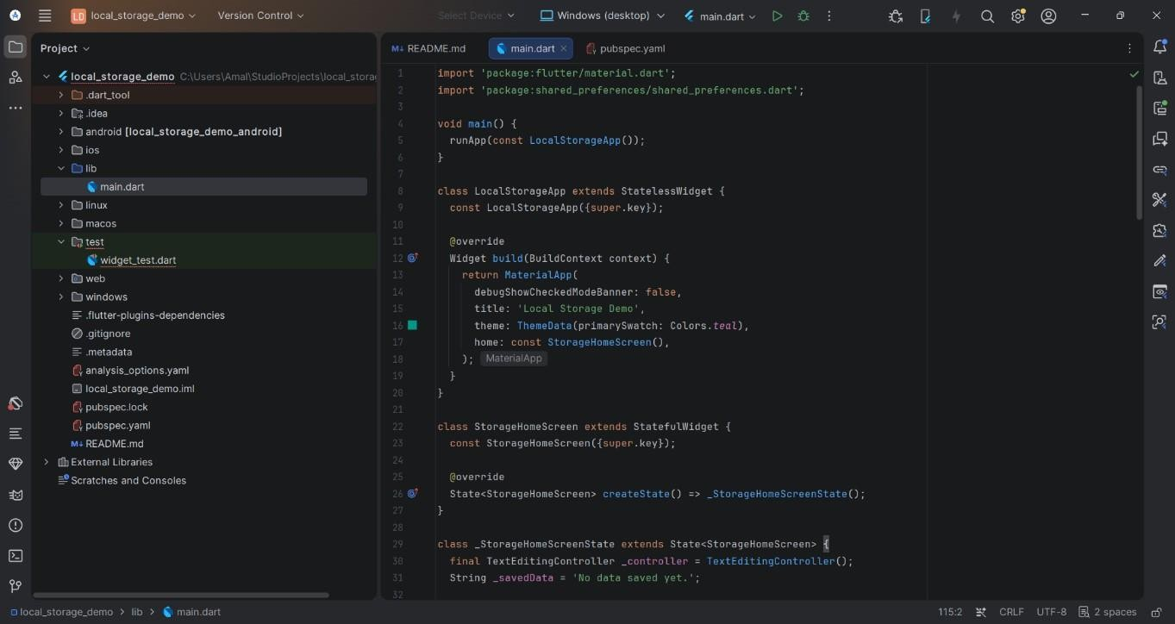

STEP 6: Save the file (Ctrl + S). STEP 7: Run the application:
- Ensure the Android Emulator target is selected in the top dropdown toolbar.
- Click the green Run (▶) button (or press Shift + F10).
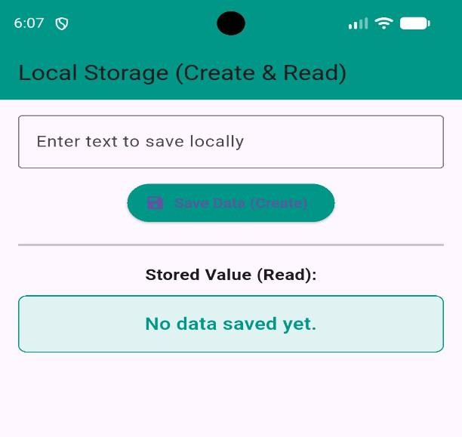

STEP 8: Perform the Create operation and verify:

- Enter text into the text input field on the emulator screen.
- Tap the Save Data (Create) button.
- Verify that the SnackBar message appears and the lower display box updates to render the saved text retrieved from local storage.

OUTPUT:
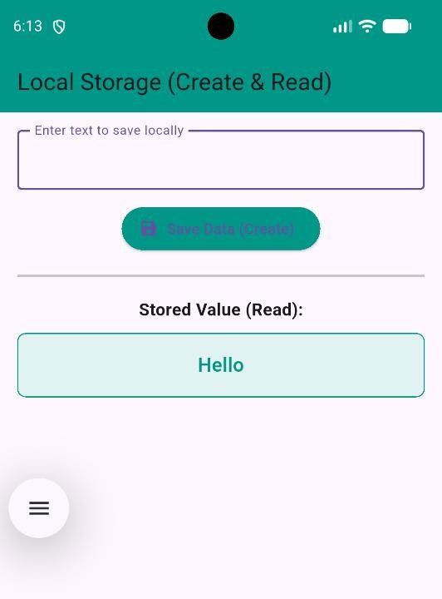

RESULT:

Thus, The Flutter Experiment of Implementing Create, Read Operations with Local Storage was Executed and Completed Successfully.

EX.NO:11.b IMPLEMENT UPDATE AND DELETE OPERATIONS BASED DATE: ON LOCAL STORAGE

AIM:

To design and develop a mobile application in Flutter that performs Update and Delete operations on data stored in local storage using the shared_preferences package, and to persist those changes across application restarts.

THEORY:

Local storage allows a mobile application to save small amounts of persistent data directly on the device, so that the data remains available even after the app is closed and reopened. In Flutter, this is commonly achieved using the shared_preferences package, which stores data as simple key-value pairs backed by the platform's native storage (SharedPreferences on Android, NSUserDefaults on iOS).

- SharedPreferences: A key-value storage system used to persist small pieces of data such as strings, booleans, integers, and JSON-encoded lists or maps.
- Update Operation: Modifies an existing record in the stored data. The item at a given index is replaced with new content, and the entire updated collection is re-encoded and saved back to local storage.
- Delete Operation: Removes an existing record from the stored data. The item is removed from the in-memory list, and the resulting collection is re-encoded and saved back to local storage.
- jsonEncode / jsonDecode: Since SharedPreferences only stores primitive types natively, a list of items is converted to a JSON string with jsonEncode before saving, and converted back to a Dart List with jsonDecode when reading.
- setState(): Notifies Flutter that the in-memory state has changed, prompting the widget tree to rebuild and reflect the updated or deleted data immediately in the UI.

PROCEDURE

STEP 1: Open Android Studio.

STEP 2: Create a new Flutter project:

- Click on New Flutter Project on the Welcome screen (or go to File > New > New Flutter Project...).
- Select Flutter on the left menu, ensure the Flutter SDK path is selected, and click Next.
- Set the Project name as local_storage_demo.
- Choose your project location and ensure Java/Kotlin and Swift/Objective-C are selected if prompted.
- Click Create.
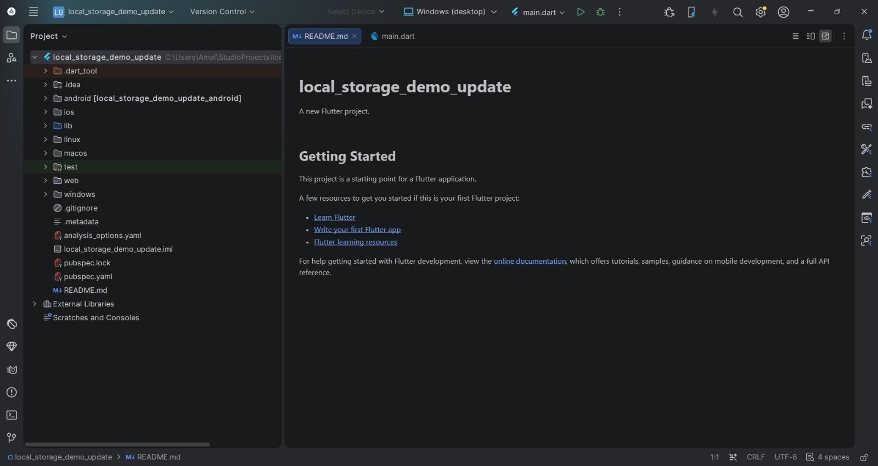

STEP 3: Add the shared_preferences dependency:

- Open the pubspec.yaml file in the project root.
- Under the dependencies section, add: shared_preferences: ^2.2.2
- Save the file and run flutter pub get (or click the Pub get link that appears in Android Studio) to fetch the package.

STEP 4: Start the Android Emulator:

- Open the Device Manager from the right side panel (or go to Tools > Device Manager).
- Select an available virtual device and click the Play (▶) button to launch the emulator.

STEP 5: Navigate to main.dart:

  - In the Project window on the left, expand the project folder: local_storage_demo > lib.
  - Double-click main.dart to open it in the editor.

STEP 6: Replace the default code in lib/main.dart with the following implementation:

import 'package:flutter/material.dart';

import 'package:shared_preferences/shared_preferences.dart'; import 'dart:convert';
void main() {

runApp(const LocalStorageApp());

}

class LocalStorageApp extends StatelessWidget { const LocalStorageApp({super.key}); @override
Widget build(BuildContext context) { return MaterialApp( debugShowCheckedModeBanner: false,
theme: ThemeData(primarySwatch: Colors.teal), home: const NotesHomeScreen(),
);

}

}

class NotesHomeScreen extends StatefulWidget { const NotesHomeScreen({super.key}); @override
State<NotesHomeScreen> createState() => _NotesHomeScreenState();

}

class _NotesHomeScreenState extends State<NotesHomeScreen> { List<String> notes = [];
final TextEditingController controller = TextEditingController(); @override
void initState() { super.initState(); loadNotes();
}

Future<void> loadNotes() async {

SharedPreferences prefs = await SharedPreferences.getInstance(); String? data = prefs.getString('notes_list');
setState(() {

notes = data != null ? List<String>.from(jsonDecode(data)) : [];

});

}

Future<void> saveNotes() async {

SharedPreferences prefs = await SharedPreferences.getInstance();

await prefs.setString('notes_list', jsonEncode(notes));

}

void addNote(String note) { setState(() { notes.add(note);
});

saveNotes();

}

// ---- UPDATE OPERATION ----

void updateNote(int index, String newNote) { setState(() {
notes[index] = newNote;

});

saveNotes();

}

// ---- DELETE OPERATION ----

void deleteNote(int index) { setState(() { notes.removeAt(index);
});

saveNotes();

}

void showNoteDialog({int? index}) { controller.text = index != null ? notes[index] : ''; showDialog(
context: context, builder: (context) { return AlertDialog(
title: Text(index != null ? 'Update Note' : 'Add Note'), content: TextField(
controller: controller,

decoration: const InputDecoration(hintText: 'Enter note text'),

),

actions: [ TextButton(
onPressed: () => Navigator.pop(context), child: const Text('Cancel'),
),

ElevatedButton( onPressed: () {
if (controller.text.trim().isNotEmpty) { if (index != null) {
updateNote(index, controller.text.trim());

} else { addNote(controller.text.trim());
}

}

Navigator.pop(context);

},

child: const Text('Save'),),],);},);} void confirmDelete(int index) { showDialog(
context: context, builder: (context) { return AlertDialog(
title: const Text('Delete Note'),

content: const Text('Are you sure you want to delete this note?'), actions: [
TextButton(

onPressed: () => Navigator.pop(context), child: const Text('Cancel'),
),

ElevatedButton(

style: ElevatedButton.styleFrom(backgroundColor: Colors.red), onPressed: () {

deleteNote(index); Navigator.pop(context);
},

child: const Text('Delete'),

),

],

);

},

);

}

@override

Widget build(BuildContext context) { return Scaffold(
appBar: AppBar(

title: const Text('Local Storage - Update & Delete'),

),

body: notes.isEmpty

? const Center(child: Text('No notes yet. Tap + to add one.'))

: ListView.builder( itemCount: notes.length,
itemBuilder: (context, index) { return Card(

margin: const EdgeInsets.symmetric(horizontal: 10, vertical: 5), child: ListTile(
leading: CircleAvatar(child: Text('${index + 1}')), title: Text(notes[index]),
trailing: Row(

mainAxisSize: MainAxisSize.min, children: [
IconButton(

icon: const Icon(Icons.edit, color: Colors.blue), onPressed: () => showNoteDialog(index: index),
),

IconButton(

icon: const Icon(Icons.delete, color: Colors.red), onPressed: () => confirmDelete(index),
),],),),);},),

floatingActionButton: FloatingActionButton( onPressed: () => showNoteDialog(),
child: const Icon(Icons.add),),);} }

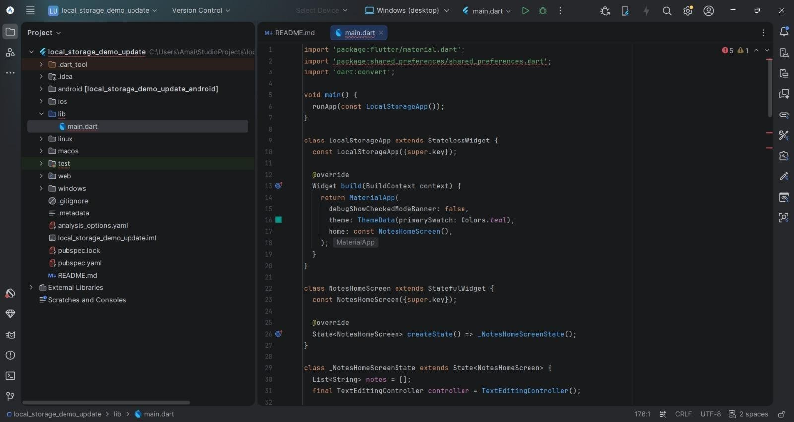

STEP 7: Save the file by pressing Ctrl + S. STEP 8: Run the application:
- Ensure your Android Emulator is selected in the device target dropdown at the top toolbar.
- Click the green Run (▶) button in the top toolbar (or press Shift + F10).

STEP 9: Observe and verify the output:

- Tap the + (add) button, enter some text, and save it — the note appears in the list and is written to local storage.
- Tap the edit (pencil) icon on a note, change its text, and save — verify the UPDATE operation replaces the note's content in the list.
- Tap the delete (trash) icon on a note and confirm — verify the DELETE operation removes it from the list.
- Close and reopen the app (or hot-restart it) to confirm the updated and deleted state persists, since the data is read back from SharedPreferences on startup.

OUTPUT:
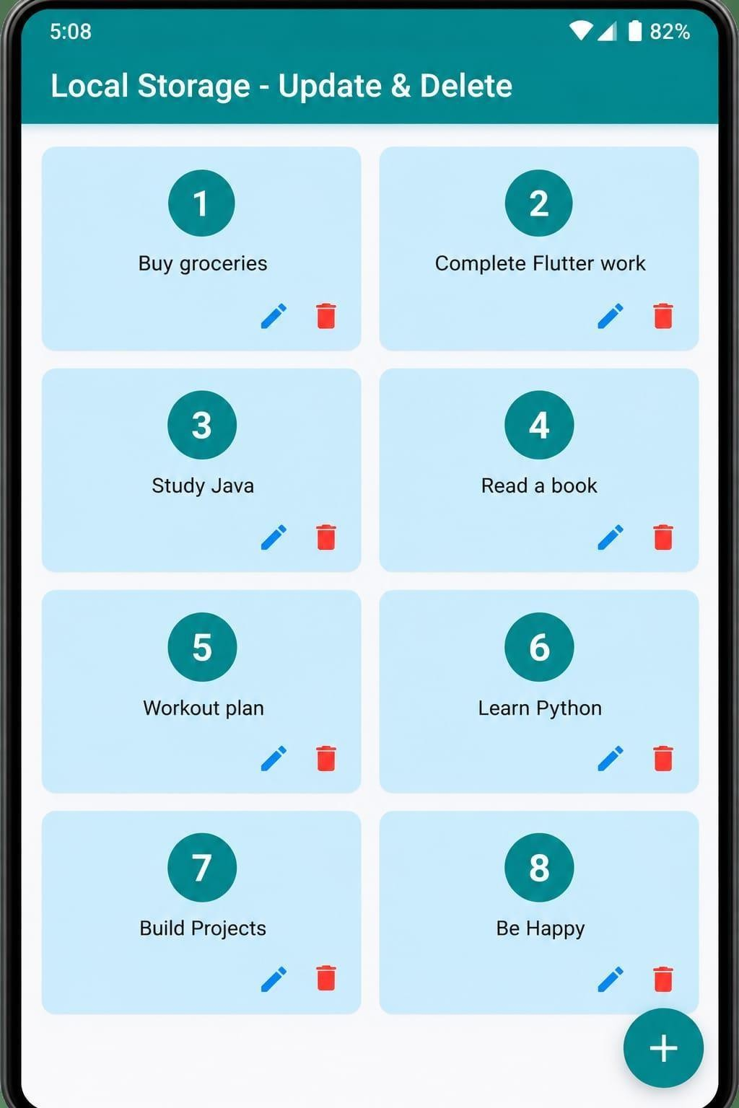

RESULT:

Thus, The Flutter Experiment of Implementation of Update and Delete Operations with Local Storage was Executed and Completed Successfully.

EX.NO:12.a TESTING AND DEBUGGING OF MOBILE APPLICATION DATE:

AIM:

To design and develop a Flutter application and perform testing and debugging using Flutter's built-in testing framework and debugging tools, in order to verify the correctness of the application's behaviour and identify and resolve runtime issues.

THEORY:

Testing and debugging are essential parts of the mobile application development lifecycle. Testing verifies that an application behaves as expected, while debugging helps locate and fix defects in the code during development.

- Unit Testing: Tests a single function, method, or class in isolation, without involving the UI. Written using the test package and executed with flutter test.
- Widget Testing: Verifies the behaviour and appearance of an individual widget by building it in a test environment, simulating user interaction (taps, text entry), and checking the resulting UI, using the flutter_test package's WidgetTester.
- Integration Testing: Tests the complete application or large parts of it, running on a real device or emulator, to verify that multiple components work together correctly.
- debugPrint(): Prints diagnostic messages to the console without truncation issues, commonly used to trace variable values and application flow during debugging.
- Breakpoints: Markers placed on a line of code that pause program execution when reached while running in Debug mode, allowing the current state and variable values to be inspected.
- Flutter DevTools: A suite of performance and debugging tools for Flutter, including the Widget Inspector, timeline view, and memory/CPU profilers, accessible while an app runs in debug mode.
- Hot Reload / Hot Restart: Development features that let code changes be reflected almost instantly in a running app, speeding up the iterative process of testing and fixing bugs.

PROCEDURE:

STEP 1: Open Android Studio.

STEP 2: Create a new Flutter project:

- Click on New Flutter Project on the Welcome screen (or go to File > New > New Flutter Project...).
- Select Flutter on the left menu, ensure the Flutter SDK path is selected, and click Next.
- Set the Project name as testing_debug_demo.
- Choose your project location and ensure Java/Kotlin and Swift/Objective-C are selected if prompted.
- Click Create.
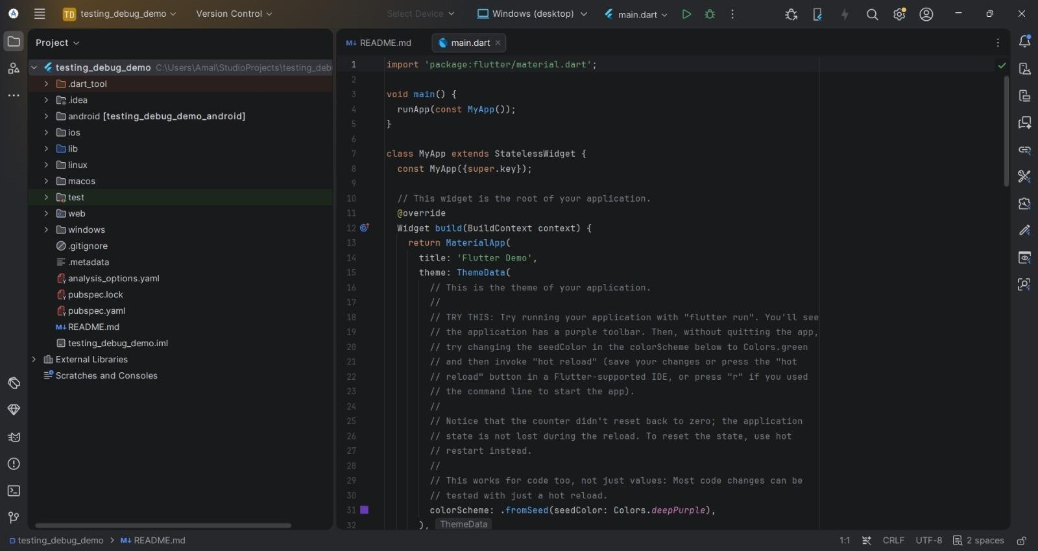

STEP 3: Start the Android Emulator:

- Open the Device Manager from the right side panel (or go to Tools > Device Manager).
- Select an available virtual device and click the Play (▶) button to launch the emulator.
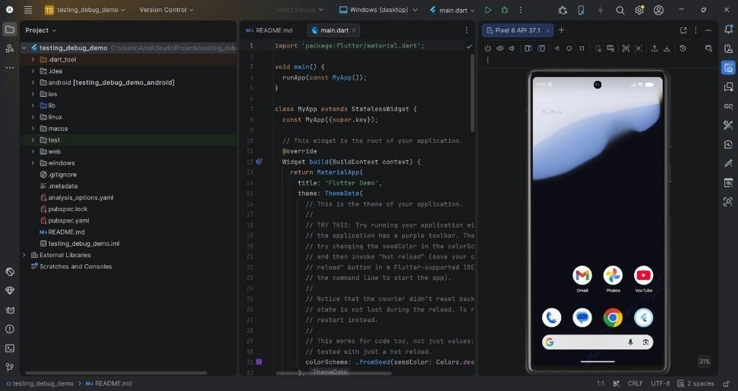

STEP 4: Navigate to main.dart:

- In the Project window on the left, expand the project folder: testing_debug_demo > lib.
- Double-click main.dart to open it in the editor.

STEP 5: Replace the default code in lib/main.dart with the following implementation. Note the debugPrint() statements inside _incrementCounter(), which will be used later for debugging:

import 'package:flutter/material.dart'; void main() {
runApp(const CounterApp());

}

class CounterApp extends StatelessWidget { const CounterApp({super.key}); @override
Widget build(BuildContext context) { return MaterialApp( debugShowCheckedModeBanner: false, title: 'Counter Testing Demo',
home: const CounterHomePage(title: 'Testing & Debugging Demo'),

);

}

}

class CounterHomePage extends StatefulWidget {

const CounterHomePage({super.key, required this.title});

final String title; @override
State<CounterHomePage> createState() => _CounterHomePageState();

}

class _CounterHomePageState extends State<CounterHomePage> { int _counter = 0;
void _incrementCounter() {

debugPrint('Increment pressed. Counter before: \$_counter'); setState(() {
_counter++;

});

debugPrint('Counter after: \$_counter');

}

void _decrementCounter() { setState(() {
if (_counter > 0) {

_counter--;

}

});

}

@override

Widget build(BuildContext context) {

return Scaffold(

appBar: AppBar(title: Text(widget.title)), body: Center(
child: Column(

mainAxisAlignment: MainAxisAlignment.center, children: [
const Text('You have pushed the button this many times:'), Text(
'\$_counter',

key: const Key('counterText'),

style: Theme.of(context).textTheme.headlineMedium,

),

],

),

),

floatingActionButton: Row( mainAxisAlignment: MainAxisAlignment.end, children: [
FloatingActionButton(

key: const Key('decrementButton'), heroTag: 'decrement',
onPressed: _decrementCounter,

tooltip: 'Decrement',

child: const Icon(Icons.remove),

),

const SizedBox(width: 12), FloatingActionButton(
key: const Key('incrementButton'), heroTag: 'increment',
onPressed: _incrementCounter, tooltip: 'Increment',
child: const Icon(Icons.add),

),

],

),

);

}

}

STEP 6: Save the file by pressing Ctrl + S. STEP 7: Create the widget/unit test file:
- In the Project window, expand the test folder that Flutter generated automatically at project creation.
- Open (or rename) the existing widget_test.dart file inside the test folder.
- Replace its contents with the following test code, which contains one widget test and one unit test: import 'package:flutter/material.dart';

import 'package:flutter_test/flutter_test.dart'; import 'package:testing_debug_demo/main.dart'; void main() {
testWidgets('Counter increments and decrements correctly', (WidgetTester tester) async { await tester.pumpWidget(const CounterApp());
expect(find.text('0'), findsOneWidget);

await tester.tap(find.byKey(const Key('incrementButton'))); await tester.pump();
expect(find.text('1'), findsOneWidget);

await tester.tap(find.byKey(const Key('incrementButton'))); await tester.pump();
expect(find.text('2'), findsOneWidget);

await tester.tap(find.byKey(const Key('decrementButton'))); await tester.pump();
expect(find.text('1'), findsOneWidget);

});

test('Unit test: counter logic never goes below zero', () { int counter = 0;
void decrement() {

if (counter > 0) counter--;

}

decrement();

expect(counter, 0);

});

}

STEP 8: Run the tests:

- Open a terminal in Android Studio (View > Tool Windows > Terminal) and run: flutter test
- Alternatively, click the green Run icon that appears next to testWidgets( and test( in the editor gutter to run an individual test.
- Observe the Run window: all tests should complete with a green ✓ and a summary such as “All tests passed!”.

STEP 9: Debug the application using breakpoints:

- In lib/main.dart, click in the left gutter next to the setState(() { line inside _incrementCounter() to set a breakpoint (a red dot appears).
- Click the Debug (bug-shaped) icon in the top toolbar instead of Run, so the app launches in debug mode and is attached to the debugger.
- On the emulator, tap the increment (+) button. Execution pauses at the breakpoint.
- In the Debugger pane at the bottom, inspect the current value of _counter under Variables.
- Use Step Over (F8) to execute the setState() call line by line, and Resume Program (F9) to continue execution.
- Check the Debug Console / Run window for the debugPrint() output showing the counter value before and after the increment.
- Optionally, open Flutter DevTools (from the debug toolbar) and use the Widget Inspector to select and examine the counter Text widget on screen.

STEP 10: Observe and verify the output:

- Confirm that flutter test reports the widget test and the unit test as passed.
- Confirm that the breakpoint correctly pauses execution and that the inspected _counter value updates as expected after stepping through the code.
- Confirm that the debugPrint() statements appear in the console, verifying the counter's before and after values on each increment.
- Verify that the app behaves correctly on the emulator: the counter increments and decrements, and never goes below zero.

OUTPUT:
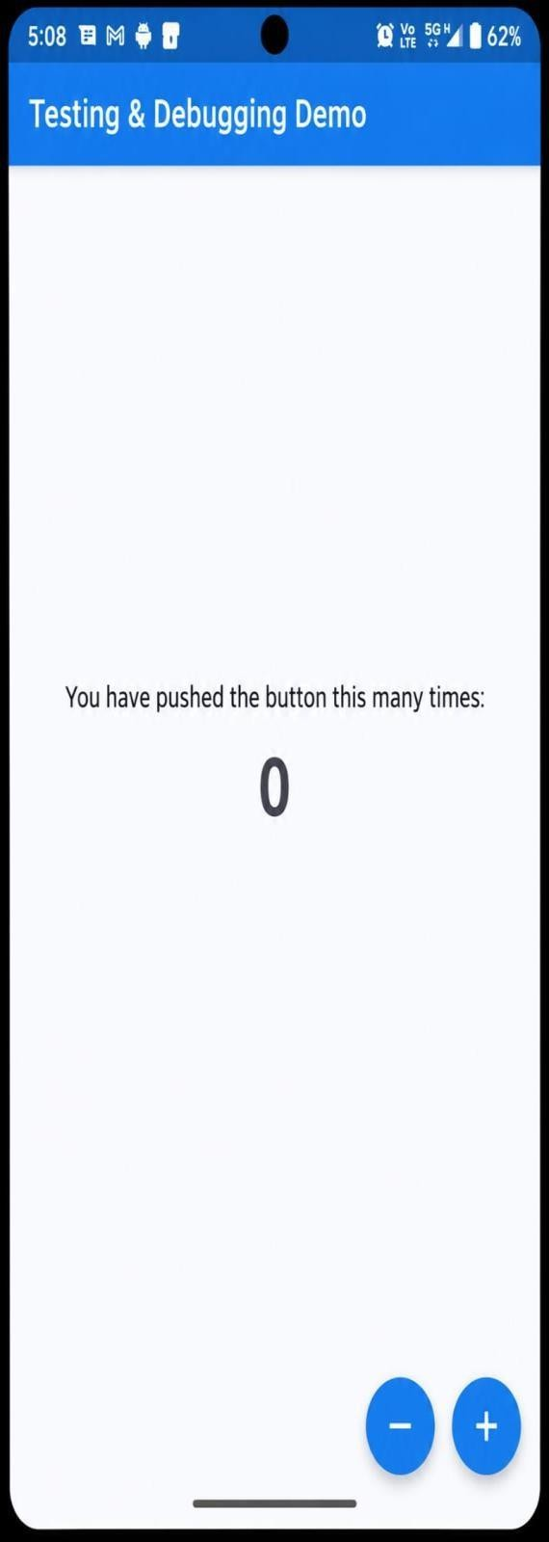

RESULT:

Thus, The Flutter Experiment of Testing and Debugging of Mobile Application was Executed and Completed Successfully.

EX.NO:12.b APPLICATION PERFORMANCE AND DEPLOYMENT DATE:

AIM:

To design and develop a Flutter application, analyse and optimise its runtime performance using Flutter's profiling tools, and build and prepare the application for deployment as a release APK and Android App Bundle.

THEORY:

Delivering a mobile application involves more than writing correct code: the app must run smoothly at 60 frames per second and must be packaged correctly for distribution. Flutter provides dedicated tools for both performance analysis and deployment.

- Build Modes: Flutter apps run in Debug (assertions and hot reload enabled, slower), Profile (near release speed, profiling tools enabled), or Release mode (fully optimised, ahead-of-time compiled, no debugging overhead).
- Performance Overlay: An on-screen graph (enabled via showPerformanceOverlay) that displays UI-thread and raster-thread frame times; green bars indicate frames rendered within the 16ms budget, while red/tall bars indicate jank.
- Flutter DevTools: A suite of tools including the Performance timeline, which records frame-by-frame rendering data so slow frames and their causes can be identified.
- ListView.builder: Lazily builds only the list items currently visible on screen (plus a small cache), instead of building the entire list at once, which greatly improves performance for long lists.
- const Constructors: Widgets created with const are built once and reused across rebuilds instead of being recreated, reducing unnecessary widget-tree work.
- flutter build apk / appbundle: Command-line tools that compile the app in release mode and package it as an installable APK or as an Android App Bundle (the format required by the Google Play Store).
- App Signing: Release builds must be signed with a keystore (a cryptographic key) before they can be installed or published, which uniquely identifies the app's publisher.

PROCEDURE:

STEP 1: Open Android Studio.

STEP 2: Create a new Flutter project:

- Click on New Flutter Project on the Welcome screen (or go to File > New > New Flutter Project...).
- Select Flutter on the left menu, ensure the Flutter SDK path is selected, and click Next.
- Set the Project name as perf_deploy_demo.
- Choose your project location and ensure Java/Kotlin and Swift/Objective-C are selected if prompted.
- Click Create.
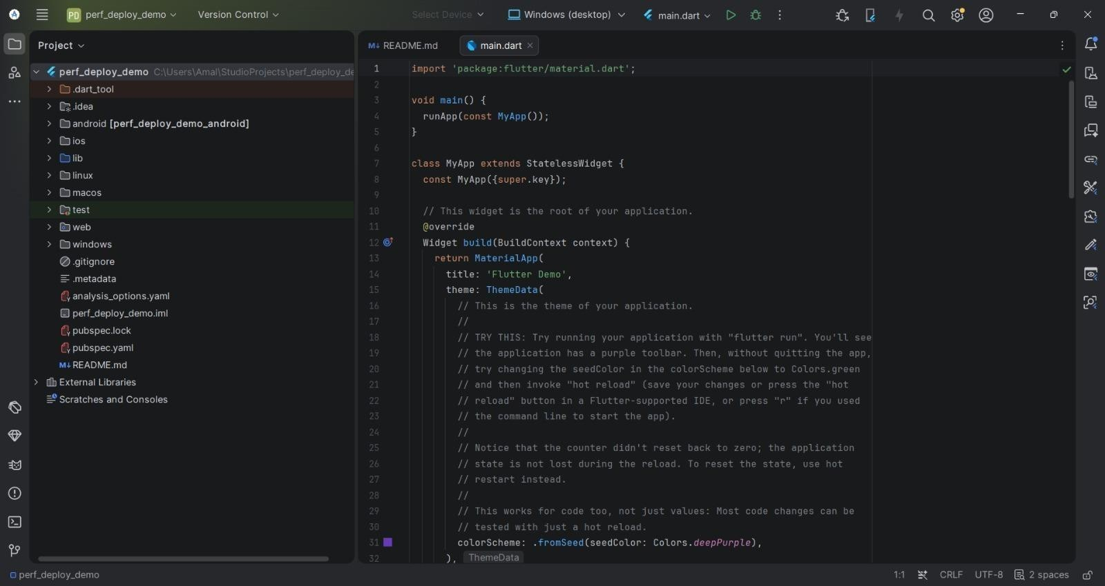

STEP 3: Start the Android Emulator:

- Open the Device Manager from the right side panel (or go to Tools > Device Manager).
- Select an available virtual device and click the Play (▶) button to launch the emulator.

STEP 4: Navigate to main.dart:

- In the Project window on the left, expand the project folder: perf_deploy_demo > lib.
- Double-click main.dart to open it in the editor.

STEP 5: Replace the default code in lib/main.dart with the following implementation, which renders a 1000-item list using ListView.builder and includes a toggle for the performance overlay:

import 'package:flutter/material.dart'; void main() {
runApp(const PerfDemoApp());

}

class PerfDemoApp extends StatefulWidget { const PerfDemoApp({super.key}); @override
State<PerfDemoApp> createState() => _PerfDemoAppState();

}

class _PerfDemoAppState extends State<PerfDemoApp> { bool _showOverlay = false;
void _toggleOverlay() { setState(() {
_showOverlay = !_showOverlay;

});

}

@override

Widget build(BuildContext context) { return MaterialApp( debugShowCheckedModeBanner: false,

showPerformanceOverlay: _showOverlay, title: 'Performance & Deployment Demo', home: PerfHomePage(
showOverlay: _showOverlay, onToggleOverlay: _toggleOverlay,
),

);

}

}

class PerfHomePage extends StatelessWidget { const PerfHomePage({
super.key,

required this.showOverlay, required this.onToggleOverlay,
});

final bool showOverlay;

final VoidCallback onToggleOverlay;

@override

Widget build(BuildContext context) {

return Scaffold( appBar: AppBar(
title: const Text('Performance & Deployment Demo'), actions: [
IconButton(

icon: const Icon(Icons.speed),

tooltip: 'Toggle Performance Overlay', onPressed: onToggleOverlay,
),

],

),

// ListView.builder lazily builds only the visible rows instead of

// creating all 1000 widgets up front, which keeps scrolling smooth. body: ListView.builder(
itemCount: 1000,

itemExtent: 56,

itemBuilder: (context, index) { return ListTile(
// A const leading icon is built once and reused, instead of

// being rebuilt every time this list item rebuilds. leading: const Icon(Icons.check_circle_outline), title: Text('Item #$index'),

);

},

),

);

}

}
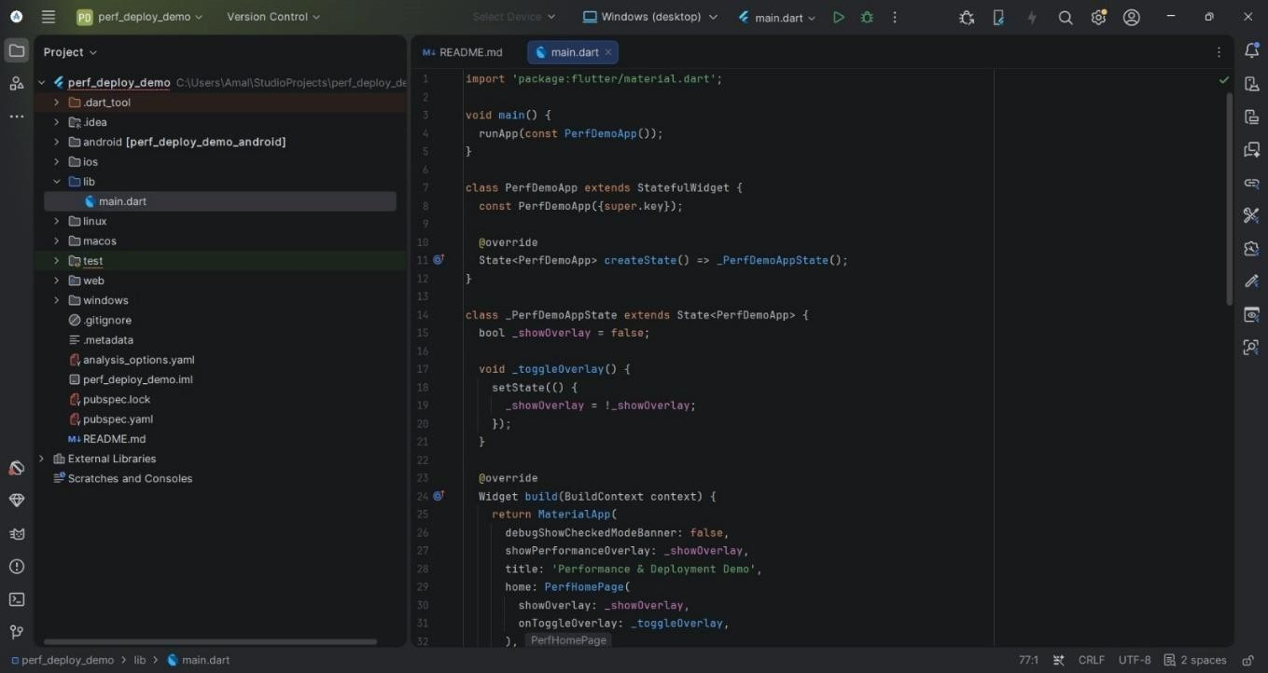

STEP 6: Save the file by pressing Ctrl + S.

STEP 7: Run the app in Profile mode to measure performance close to real-world conditions:

- Open a terminal in Android Studio and run: flutter run --profile
- Alternatively, use the run configuration dropdown in the toolbar to switch from Debug to Profile before clicking Run.
- Note that Profile mode disables debugging overhead and assertions, giving frame times much closer to a real Release build than Debug mode does.

STEP 8: Toggle and read the performance overlay:

- Tap the speed icon in the app bar to enable showPerformanceOverlay.

- Scroll quickly through the list and observe the two graphs at the top of the screen: the upper graph is the UI thread, the lower is the raster (GPU) thread.
- Confirm the bars stay mostly green (within the 16ms frame budget); tall red bars would indicate jank that needs further optimisation.

STEP 9: Profile with Flutter DevTools:

- With the app running, open the DevTools link printed in the Run/terminal console (or Run > Open DevTools in Browser).
- Open the Performance tab and click Record, then scroll the list in the running app.
- Stop recording and inspect the frame chart to identify any individual frames that took longer than 16ms to build or raster.

STEP 10: Build the application for deployment:

- Open a terminal and run: flutter build apk --release to generate an installable release APK.
- Run: flutter build appbundle --release to generate an Android App Bundle (the format required for publishing to the Google Play Store).
- Locate the generated files at build/app/outputs/flutter-apk/app-release.apk and build/app/outputs/bundle/release/app-release.aab.
- For a production release, configure a signing key first: create a keystore with keytool, reference it from a key.properties file, and wire it into android/app/build.gradle under signingConfigs so the release build is properly signed.

STEP 11: Observe and verify the output:

- Confirm both flutter build commands complete successfully and report the final APK/AAB file size in the terminal.
- Install the release APK on the emulator (drag-and-drop the file onto the emulator window, or run flutter install) and confirm the app launches correctly outside of debug mode.
- Re-enable the performance overlay in the release build and confirm scrolling remains smooth, verifying the optimisations (ListView.builder, const widgets) are effective.

OUTPUT:
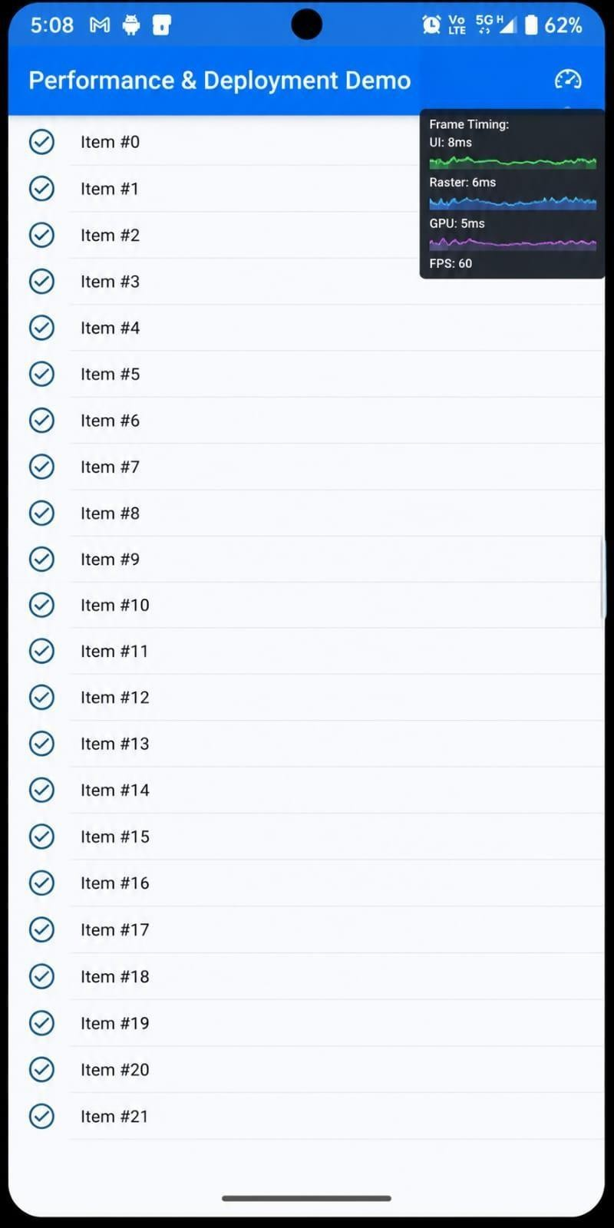

RESULT:

Thus, The Flutter Experiment of Application Performance and Deployment was Executed and Completed Successfully.

